2026-2027 Families Supporting Families:

Grant Option 1
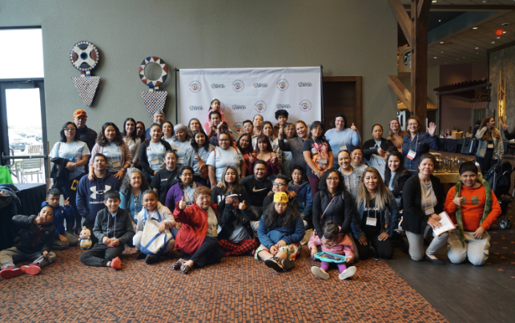
  - Community-based organizations supporting families to live the lives they want

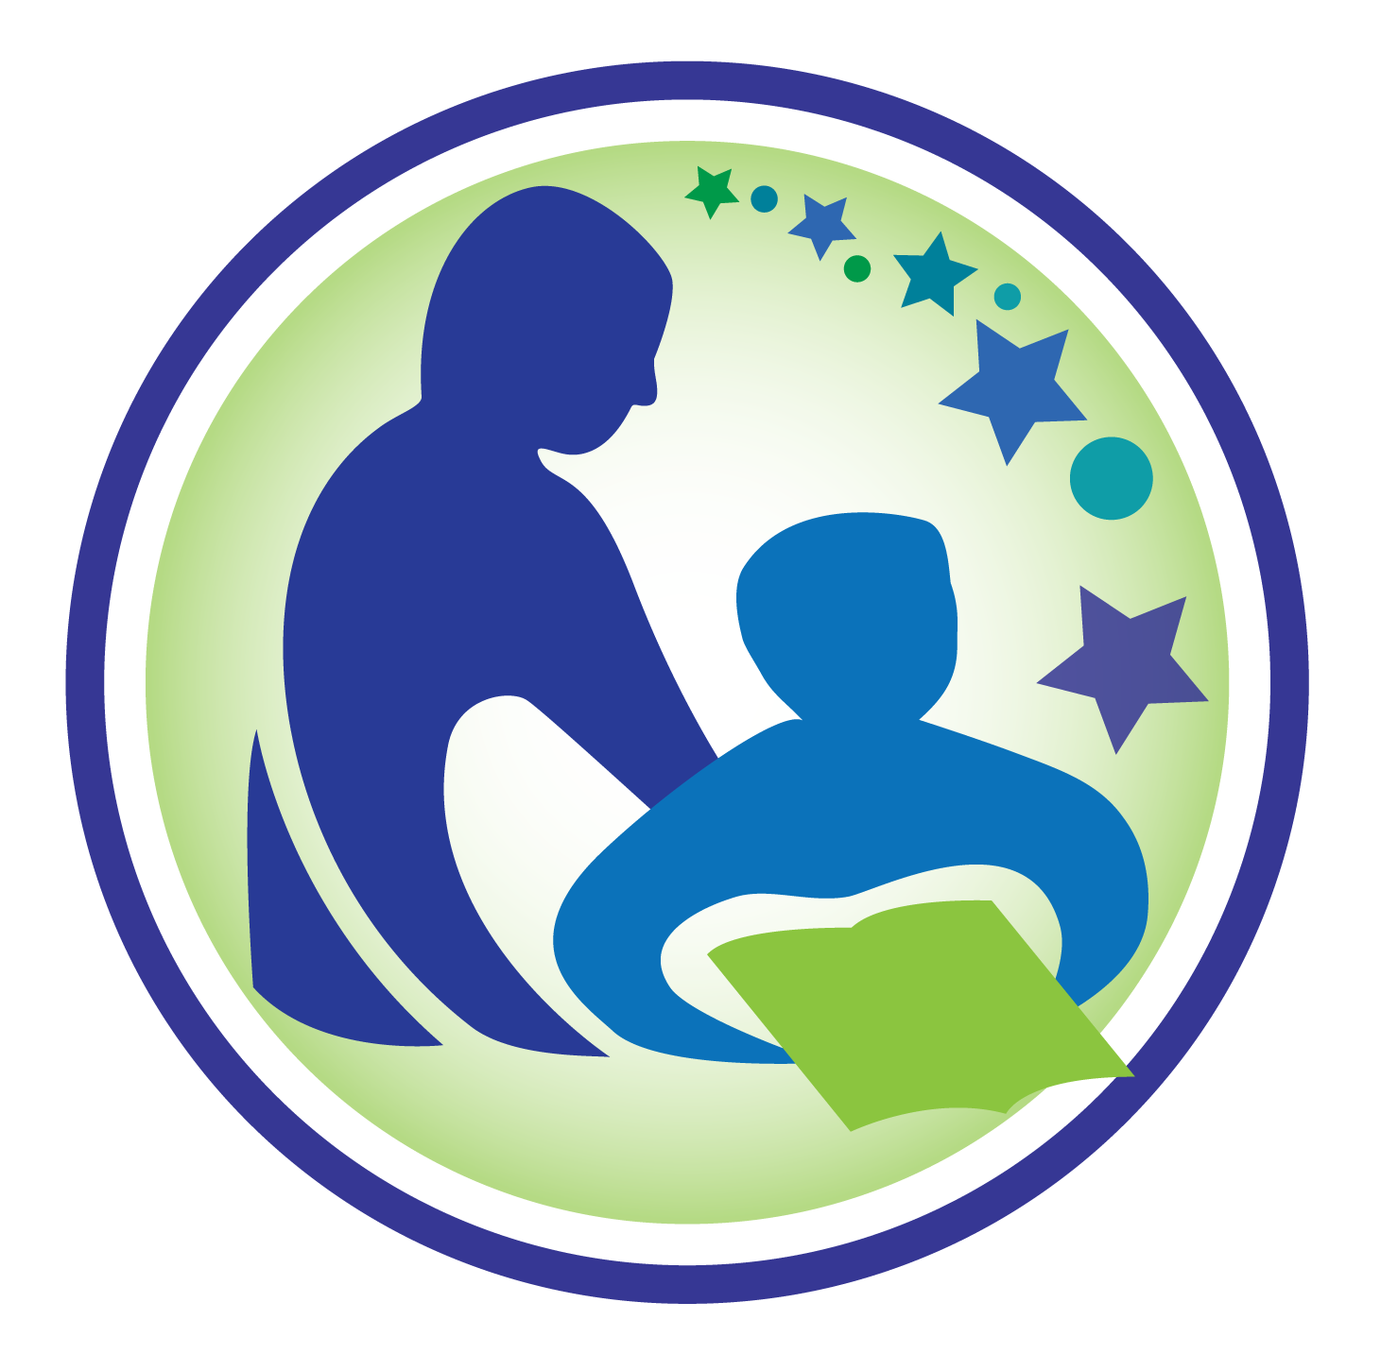

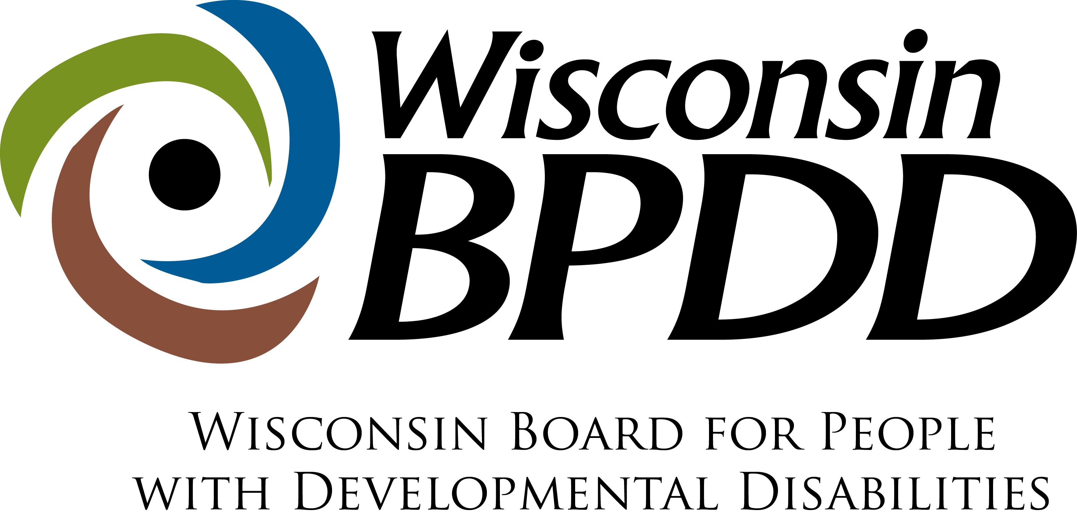

Wisconsin Board for People with Developmental Disabilities acknowledges the support of the Wisconsin Department of Public Instruction in the development of all products or publications and for the continued support of this federally‐funded grant project.

What are Families Supporting Families grants?

The Wisconsin Board for People with Developmental Disabilities (BPDD) and the Wisconsin Department of Public Instruction (DPI) want to strengthen their partnerships with Wisconsin’s underreached communities, including communities of color and communities who speak Spanish or Hmong, to better support families who have school-aged children with intellectual or developmental disabilities. Intellectual and developmental disabilities include autism, Down syndrome, cerebral palsy, Fragile X syndrome, and many others.

- We want all families and their children with disabilities in Wisconsin connected to the people, activities, and community resources they need to live the lives they want.

- We want all people to live with dignity and to have their human rights honored.

- We recognize that people from a community often know best how to support other members of their community.
- We will provide funding to a community-based organization to launch or expand efforts that support families of children with I/DD (from early childhood through young adulthood) to navigate systems and learn about resources that help them meet their needs.

- We will award up to eight (8) grants. You can request up to $20,000 to be used by September 30, 2027.

IMPORTANT!

Two grant options are available. You can only apply for one grant option. Apply for this grant option if your organization mostly serves families who live locally. If your organization mostly serves families who are geographically dispersed (or live around the state) and you’re willing to coordinate overnight events, apply for Grant Option 2.

Examples of what you can do with the grant
- We want to hear your ideas on what might work best to support families of children with disabilities in your community. Your activities should be based on what families ask for and what might be most useful to them. Below are examples of other grantees’ previous activities. You can use these ideas or come up with your own.
  - Brought families together for a fun activity in the community that also shares local resources.
  - Hosted virtual or in-person “Parent Hours” that give parents (or other family members) time to connect, share experiences, and practice self-care, leadership, and mentoring.
  - Brought the broader community together to raise awareness about disability.
  - Hosted workshops for families on topics of interest like building school partnerships, bullying, rights education, and health care.

Focus areas
- While you are free to design your workplan according to what works best for your families, we ask that some activities focus on one or more of the areas below. In the proposal, you’ll select which area(s) is of most interest to your organization and families. We’ll share related resources, if available, and work with you to determine possible ways to provide this information to families.
  - Rights education: Rights are things that people can have or do. People with disabilities should be allowed to have and do all the same things as people without disabilities. When people understand their rights, they have better lives. Check out our Rights Guides and the Self-Determination YouTube channel for videos on each of the human rights. DPI also has rights resources related to education for both students and families. You can use these materials to support people to learn more about their rights.

  - Supported Decision-Making: Supported decision-making empowers people with disabilities to make informed decisions about their life in ways that protect their rights and ensure their safety and privacy. It involves family and friends working together to help them make complex decisions. Check out this toolkit and webinar recording and DPI’s Information Bulletin for more information.
  - Youth advocacy and leadership: If your organization works with high school students with disabilities interested in advocacy and leadership, BPDD and DPI will share possible opportunities. One option is to connect with your local People First Wisconsin chapter. Or if there is no chapter, consider helping to start one in your area. People First Wisconsin is a statewide self-advocacy organization for people with disabilities.
  - ABLE accounts: ABLE (Achieving a Better Life Experience) accounts are a savings and investment option for people with disabilities that allows them to save money without losing eligibility for most federally funded benefits like Medicaid and SSI. If you are interested, BPDD staff would work with you to talk with a financial advisor about ABLE accounts and explore ideas for sharing information with families.
  - Mental health education: Support families and people with disabilities to strengthen their well-being and navigate finding mental health resources.
Optional opportunity: BPDD is one of many organizations partnering with the WI Department of Health Services (DHS) to provide user feedback on select DHS materials (brochures, webpages, initiatives, etc.). If BPDD is asked to recruit family members or people with disabilities to give feedback on DHS materials, we may ask if any of the people you serve are interested in this opportunity.

Who is eligible to apply?
- Any community-based organization that serves communities of color including, but not limited to, Asian, Black, Latino, Spanish-speaking, Hmong-speaking and Tribal communities, and is interested in supporting families who have school-aged children with disabilities.
- Ideally, the applicant is a person who identifies as being a member of that community. Or, if an organization is applying, the organization is ideally led by a person who identifies as being a member of that community.

How do I apply?
- Attend an optional information session on Monday, September 28, 2026, from 12-1pm to learn about this grant opportunity and to get answers to your questions. Register to get the Zoom link (English registration; Spanish registration).

- Complete the Proposal and Budget by October 9, 2026, at 5:00pm: Email them to Molly Cooney at molly.cooney@wisconsin.gov. You will receive a reply confirming receipt of your proposal. If you don’t get an email within 2 business days, please follow up.

- If you would prefer to complete the proposal through an interview process with a BPDD staff member typing your responses, please contact Molly Cooney at molly.cooney@wisconsin.gov or (608) 266-0266.

- We will notify applicants about their status the week of October 26, 2026. Projects begin November 1, 2026.

- Availability of Funds Disclaimer: The Wisconsin Board for People with Developmental Disabilities’ obligation to grant out these funds and to make payments is conditioned upon the availability of these government funds. Funds can be limited for any reason including, but not limited to, congressional, legislative, gubernatorial, or administrative action. BPDD may terminate a contract in the case of non-appropriation of funds or the government’s withholding of appropriated funds.
- We can translate this into other languages. Please let us know what language you need.

Podemos traducir esto a otros idiomas. Por favor, indíquenos qué idioma necesita.

Peb muaj peev xwm txhais qhov no ua lwm hom lus. Thov qhia rau peb paub tias koj xav tau hom lus twg.

हम इस आवेदन का अन्य भाषाओं में अनुवाद कर सकते हैं। कृपया हमें बताएं कि आपको यह किस भाषा में चाहिए।
我们可以将此申请翻译为其他语言。请让我们知晓您需要哪种语言。
我們可以將此應用程式翻譯成其他語言。請告訴我們您需要的語言。

What do I need to do if my proposal is selected?
- Kick-off Meeting: Attend a virtual kick-off meeting on November 10, 2026, from 1-3pm to get information about the grant agreement, how to submit a reimbursement request, learn about the other organizations involved, further develop your workplan, brainstorm outcomes you would like to achieve, and meet DPI and BPDD staff.

- Grant agreement paperwork: Review and sign a grant agreement with BPDD.

- Background checks: Make sure state criminal background checks are conducted on all staff, volunteers, and/or other partners who have contact with students when their parents or caregivers or other adult family members are not present. If any of these people have lived, worked, or attended school in the last ten (10) years outside of Wisconsin, the criminal background check must also include a Federal Bureau of Investigation fingerprint check, or equivalent. Grant funds may be used to cover these costs ($7 for a Standard Online Criminal Check; $40.75 for a Federal Bureau of Investigation fingerprint check). BPDD staff can provide support to complete this process. The actual state or federal records do not have to be submitted.

- Quarterly Check-ins: Meet quarterly by phone, Zoom or in-person to check-in with DPI and BPDD staff. During these check-ins, we will go through a list of questions to:
  - Hear how things are going,
  - Problem solve any barriers to moving forward with grant activities,
  - Learn if there are actions we can take in our organizations to improve the way services are working for your families,
  - Gather data on outcomes and stories, and
  - Support you in any way we can.

These check-ins take the place of written reports.

- End-of-Project Outcomes data: To learn about the impact of your efforts, we will combine the outcomes you’re hoping families achieve with advocacy measures we collect. We will work together to find ways to collect this information easily and in a culturally responsive way. We will not collect contact information about the people participating in your activities. Here’s an example of the template.
- Reimbursement requests: Submit reimbursement requests monthly using our template.

Grant Proposal

The completed proposal and budget are due October 9, 2026, by 5:00p.m.
If you have questions, contact Molly Cooney at 608-266-0266 or molly.cooney@wisconsin.gov

Your Name:

Address:

Phone number:

Email address:

______________________________________________________________________________

- Tell us a little about yourself and your organization.

- Why are you applying for this funding? (justification)

- Please check one or more focus areas you are interested in including in your activities. You are only required to check one box. If you are interested in more than one, you can check more. You will not score additional points for checking more than one box. (focus areas)

☐ Rights education

☐ Supported Decision-Making

☐ Youth advocacy and leadership

☐ ABLE accounts

☐ Mental health education

Why did you select this area?

- How will you use the funding to support families and their children with disabilities? Explain your activities including ideas for one of the focus areas. (statement of work)

- How many families will be served by this grant? (impact)

- What will families achieve by participating in your grant activities? How will they benefit? (impact)

- What community or communities of color including, but not limited to, Asian, Black, Latino, Spanish-speaking, Hmong-speaking and Tribal communities, will you serve? (target community)

- Why will you or your organization be effective at serving this community? Are you already connected to this community, and, if so, how? (effectiveness)

- How much funding are you requesting? You can ask for up to $20,000.

- BPDD shares the State of Wisconsin's goal to partner more with Minority-Owned Businesses and Service-Disabled Veteran-Owned Businesses. We strive to partner with other traditionally underrepresented communities as well. Is your organization at least 51% owned, managed, or controlled by a person who identifies as American Indian, Asian, Black, Hispanic or Latino, Native Hawaiian, LGBTQ+, or disabled?

☐Yes ☐No

- Are you interested in an optional opportunity to help BPDD find family members and/or people with disabilities who are interested in giving feedback on WI Department of Health Services materials? These opportunities are sporadic. If you help us find family members and/or people with disabilities to review materials, you will receive additional compensation for your efforts.
Your answer to this question will NOT impact whether your proposal is funded.

☐Yes ☐No ☐Unsure – I’d like to learn more

- Background Checks: Check the box if this statement is true.
☐ I will make sure that state criminal background checks (or FBI fingerprint checks, if needed) are conducted on all staff, supervisors, volunteers, and/or other partners who have contact with students when their parents or caregivers or other adult family members are not present.

Budget Worksheet

You can use the funds in many ways. If you have questions about using grant funds, please contact Molly Cooney at 608-266-0266 or molly.cooney@wisconsin.gov.

Funds can be used to:
- pay yourself or staff for time spent working with families,
- pay for event space, food, or materials for meetings or events,
- pay for registration to disability-specific conferences for staff and/or families, and
- pay for a speaker to present to your group.

Funds cannot be used:
- for vehicles or technology (like computers or phones or other equipment),
- to pay for services or supports another agency/organization provides such as direct services to people with disabilities, and
- staff time already covered by another agency, organization, or grant.

Funds for travel, including lodging and meals, must be pre-approved by BPDD and DPI staff.

SAMPLE BUDGET
ITEM (be as specific as possible) | COST
Staff fees (12 hours/week for 40 weeks @ $30/hour = $8,640) | $14,400
Meeting space rental for 4 events ($100 per event x 4 events = $400) | $400
Refreshments for 4 events ($100 x 4 events = $400) | $400
Speaker fee for one event | $250
Stipends for family participation (10 families x $50 stipend = $500) | $500
Staff training/conference (2 staff x $400 registration and lodging = $800) | $800
Materials (wall board, markers, post-it notes, copies) | $200
Total | $16,950
YOUR PROJECT’S BUDGET
ITEM (be as specific as possible) | COST
TOTAL

Project Workplan

Primary Project Contact Person:  Project Title: |  | Contact Info (address, phone number, email):
Project Goal(s):

Work Plan
Project Objectives/Activities:  (What will you do?) | Outcomes:  (What will you achieve?) |  | Deliverables/Products:  (What will you develop/create?) | Target Date:  (When will it be done?)
EXAMPLE: Coordinate a workshop for families on IEPs and advocacy strategies. | EXAMPLE: Participating families better understand the IEP process and feel more comfortable voicing ideas and concerns. |  | EXAMPLE: Tip sheets and other materials for families on IEPs. | EXAMPLE: 12/15/26

