Partners with Business Statewide Initiative
--
Grant Proposal for Supported Employment Service Providers

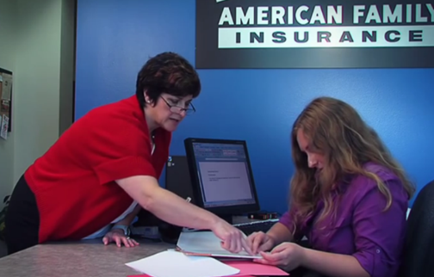
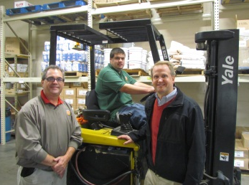
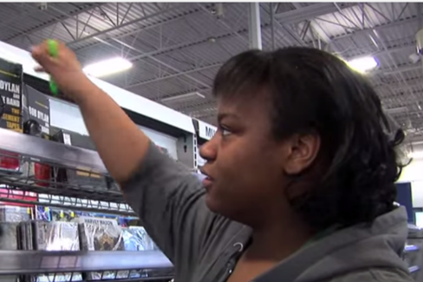

Proposals are due 5:00 p.m. on Friday, May 1, 2026.

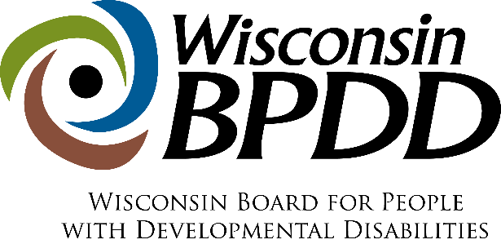

Partners with Business Grant Timeline

Activity: | Date:
Proposals due | 5/1/2026
Notice of award | 6/1/2026
Contract start date | 7/1/2026
End date of contract | 6/30/2027

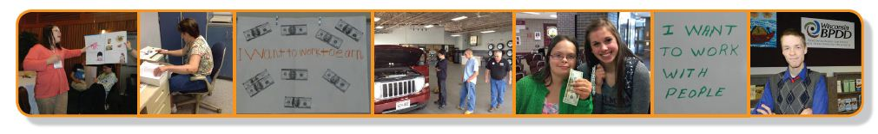

What is Partners with Business?
Partners with Business is both:
- The name of a statewide initiative carried out by the Wisconsin Board for People with Developmental Disabilities (BPDD) with schools, employment service agencies, and employers to use best practices to hire and support people with disabilities in employment, and
- The name of an employment service model where on-the-job support is provided by coworkers instead of job coaches.
Here’s more information on each:
- Partners with Business Statewide Initiative
The Wisconsin Legislature passed Wisconsin Act 323 in 2018 to assist businesses to hire and support workers with disabilities. The act appropriated funds to BPDD to carry out the initiative through grants to schools, employment service agencies, and employers. Grantees get training and technical assistance to learn how to use best practices with Supported Employment service provision, as well as organizational capacity building and workforce retention strategies. They also learn how to implement the Partners with Business paid coworker service model. Each spring BPDD selects grantees through an application process. You’ll find the application below. To learn more about the Partners with Business initiative, visit https://wi-bpdd.org/index.php/partners-with-business/
- The Partners with Business Paid Coworker Service Model
The Partners with Business paid coworker service model is an option for on-the-job support. This service option is available through the Wisconsin Department of Workforce Development's Division of Vocational Rehabilitation (DVR), Family Care, Family Care Partnership, and IRIS. With this service model, an employment service agency works with an employer to designate specific coworkers to provide formal on-the-job support to an employee with a disability. This support is “above and beyond” what is typically, and naturally, provided by supervisors and coworkers in that business. The employer is reimbursed for the time coworkers spend providing this extra support. The employment service agency receives a monthly payment from DVR, Family Care, Family Care Partnership, or IRIS to provide the follow-along component of the Partners with Business service model. To learn more about the service model, read the Partners with Business overview here: https://wi-bpdd.org/wp-content/uploads/2025/08/PWB-Overview-Updated-2025-Final.pdf
Partners with Business Statewide Initiative Grants
To carry out the initiative, the Wisconsin Board for People with Developmental Disabilities (BPDD) seeks to partner with Supported Employment service providers interested in improving employer engagement practices and reducing Medicaid-funded job coaching support for adults with disabilities.
- Grant funds and technical assistance are available for up to three Supported Employment service providers to implement capacity building strategies internally and with employers.
These strategies provide an opportunity to take new or creative approaches to reduce the need for ongoing, intensive job coaching through better job matching and customization, employer engagement, systematic instruction, natural supports, and paid coworker support options.

These capacity-building efforts can improve employment outcomes for people with disabilities and meet the needs of community businesses. Since many Supported Employment service providers are struggling to hire job coaches, these strategies can also maximize the use of job coaches and build the agencies’ overall capacity.
- Awardees can receive up to $6,500 to carry out specific capacity building activities that align with the Act 323/Partners with Business initiative’s goal to reduce publicly funded job supports by at least 25% over the course of the grant cycle. There are eight required activities and one optional activity:

- Participate in an initial orientation and work planning virtual meeting with BPDD project lead and grant coach.
- Engage with grant coach and identified self-advocate leaders with People First WI to provide peer-led virtual education sessions for Supported Employment program participants on employment related topics.
- Capture de-identified baseline data on all individuals the agency currently supports in long-term support (Family Care or IRIS) Supported Employment services. Data includes number of hours worked and job coach hours provided each month.
- Identify at least three Family Care or IRIS funded Supported Employment job sites with potential for fading job coaching supports and/or transitioning to paid coworker support.
- Designate at least two employment specialists to complete the DHS Partners with Business online training modules.
- Designate at least two staff (ideally Supported Employment program manager and lead employment specialist) to attend four 90-minute virtual Community of Practice meetings (August 2026, October 2026, January 2027, April 2027).
- Conduct workplace support analyses at identified job sites and implement job coach fading strategies and/or coworker support plans with technical assistance from the grant coach.
- Near the end of the grant period, capture de-identified data on all individuals the agency currently supports in long-term support (Family Care or IRIS) Supported Employment services to demonstrate a 25% or more reduction in job coaching support as a result of the strategies implemented during the grant period.
- Optional activity: Engage in a systematic review of the organization’s current recruitment, onboarding and training processes for job developers and job coaches to identify and implement strategies for improvement.
- Please refer to the Partners with Business Grantee Timeline, Milestones, and Payment Schedule below.
- Awardees will receive technical assistance from the Partners with Business grant coach to complete their project activities and milestones.

- The project period is July 1, 2026 – June 30, 2027.
What are the requirements for agencies that are awarded a grant?
- Ensure leadership, program management, and other departments within your organization (e.g. human resources, finance, training) are aware of and in agreement with the intent and activities of this grant opportunity.
- Sign a contract with BPDD by June 15, 2026.
- Commit to completing project activities and milestones in the expected timeline, including capturing baseline data on all individuals the agency currently supports in long-term support Supported Employment services.
- Receive technical assistance and support to implement your project activities.
- Meet quarterly by Zoom with BPDD staff to report on progress and outcomes. These meetings will serve as your grant reports.
- Share job coaching data and any relevant outcomes/success stories for the annual Partners with Business report BPDD provides to the legislature.
- Invoice monthly or quarterly for milestones achieved per the Milestone Payment Schedule.
Who can apply?
- Agencies that provide Family Care and/or IRIS Supported Employment services.
- Agencies that have already received a Partners with Business grant twice are not eligible to apply.
- If you have questions about whether your organization is eligible to apply, please contact Molly Cooney at 608-266-0266 or molly.cooney@wisconsin.gov
How do you apply?
- Answer the questions below.
- We understand that some applicants may use artificial intelligence (AI) tools to assist with editing or improving clarity. This is permitted, but we ask that the ideas and content reflect your own experience and perspective. If AI was used to generate significant parts of the narrative, we require you to note this in the application.
- Submit a completed proposal by e-mail to Molly Cooney at molly.cooney@wisconsin.gov by 5:00 pm on May 1, 2026.
How do we review applications?
- All applications are reviewed and scored by our staff and board members using a rubric.
- We do not use artificial intelligence (AI) to score, rank, or filter applications. Each application is read carefully and evaluated on alignment with the initiative’s mission, clarity of ideas, and potential impact.

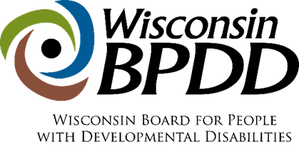
Partners with Business
Grant Proposal

The completed proposal is due by 5:00 p.m. on May 1, 2026.

Applicant(s) Name and Professional Title:

Organization Name:

Address:

Telephone:

Email address:

Lead contact name and email address, if different from applicant:

____________________________________________________________________________
Please answer the questions below (not to exceed 4 single-spaced pages total). If you are unsure if your organization is eligible, please contact Molly Cooney before completing the application.

- Share a little about your organization and the Family Care and/or IRIS Supported Employment Services that you provide. Please include your Supported Employment service area and number of people your organization provides long-term Supported Employment services to.

- Why are you applying for funding and technical assistance? Please describe your organization’s current need and reason for applying for this grant opportunity. (justification)

- Describe how organizational leadership, program management, and other relevant departments (such as human resources, finance, and training) have been informed of and support the intent and expectations of this grant opportunity?
(internal commitment)

- Awardees are expected to implement the required activities listed above with grant coach support. How will these activities positively impact your organization and the people you serve?
(impact)

- Act 323 requires that grantees demonstrate a 25% reduction in publicly funded job coaching support. By implementing the capacity building activities previous grantees have easily demonstrated this reduction. Why do you feel your organization will be successful in implementing the activities and achieving this required outcome? (feasibility)

- Did you use any artificial intelligence (AI) tools (for example, ChatGPT, Grammarly, Copilot) to help prepare this application?
☐ No
☐ Yes (please briefly describe how AI was used):

If chosen for the grant, as a Partners with Business Grantee, my organization agrees to the project milestones and timelines outlined below.
Yes No

If chosen for the grant, my organization plans to do the optional activity (systematic review of the organization’s current recruitment, onboarding, and training processes for job developers and job coaches) listed below.
Yes No

Partners with Business Grantee Milestones, Timeline, and Payment Schedule

Required Project Milestones | Timeline | Grant Payment
Participate in an initial orientation and work planning virtual meeting with BPDD lead and grant coach. | July 2026 | $200
Engage with grant coach and members of People First Wisconsin to provide peer-led virtual education sessions for Supported Employment program participants on employment related topics. | Initial planning meeting in September 2026. Implementation November 2026 – April 2027 | $500
Capture de-identified baseline data on all individuals the agency currently supports in long-term support (Family Care or IRIS) Supported Employment services. Data to include hours worked and job coach hours provided each month. | By August 15, 2026 | $500
Identify at least three Family Care or IRIS funded Supported Employment job sites with potential for fading job coaching and/or transitioning to paid coworker support. | By August 31, 2026 | $500
Designate at least two employment specialists to complete the DHS Partners with Business training modules. | By August 31, 2026 | $600 (after completion of training)
Designate at least two staff (ideally program manager and lead employment specialist) to attend four 90-minute Community of Practice meetings | August 2026 October 2026  January 2027  April 2027 | $200 per CoP Meeting = $800 total
Conduct workplace support analyses at identified job sites and implement job coach fading strategies and/or coworker support plans with technical assistance from the grant coach. | Analysis completed by October 15, 2026. Implementation strategies November 15, 2026 – May 30, 2027 | $1,300 (after implementing fading or paid coworker support strategies at all identified job sites)
Near the end of the grant period, capture de-identified data on all individuals the agency currently supports in long-term support (Family Care or IRIS) Supported Employment services to demonstrate a 25% or more reduction in job coaching support as a result of the strategies implemented during the grant period. | May 2027 | $500
Share job coaching data and any relevant outcomes/success stories for the annual Partners with Business report to the legislature. | June 2027 | $200
Meet quarterly by Zoom with BPDD staff to report on progress and outcomes. These meetings will serve as your grant reports. | October 2026  January 2027  April 2027  June 2027 | $100 each meeting = $400 total
Total |  | $5,500

Optional Activity: Engage in a systematic review of the organization’s current recruitment, onboarding, and training processes for job developers and job coaches to identify and implement strategies for improvement. Note: an assessment tool for this activity will be provided. | Systematic review complete by December 15, 2026. Implementation of strategies January – June 2027 | $1,000

