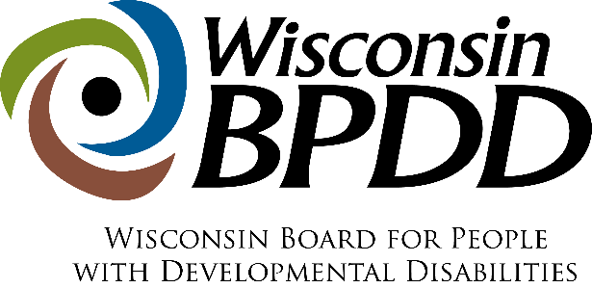

WI BPDD Competitive Integrated Employment (CIE) Outreach
Mini Grant Application

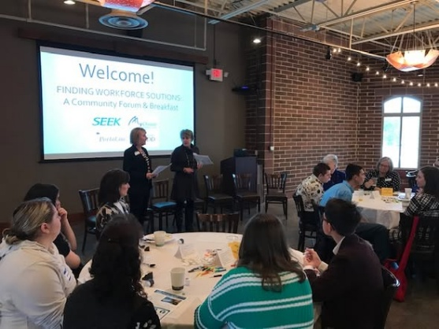
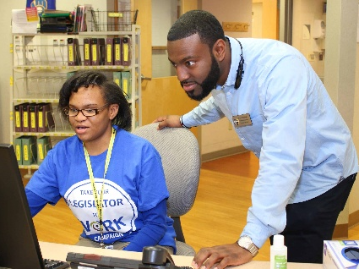
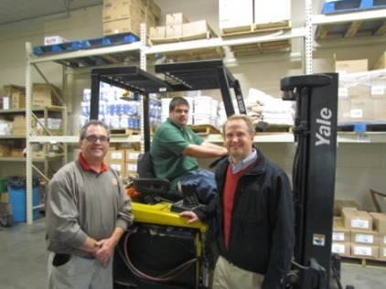

Proposals are due 5:00 p.m. on Friday, May 22, 2026.

CIE Outreach Mini-Grant Timeline

Activity: | Date:
Proposals due | 5/22/2026
Notice of award | 6/8/2026
Contract start date | 7/1/2026
Virtual, Kick-off Meeting | 7/8/2026 from 12-1pm
End date of contract | 6/30/2027

Competitive Integrated Employment Outreach Mini-Grants
The Wisconsin Board for People with Developmental Disabilities (BPDD) seeks partners to raise awareness about competitive integrated employment (CIE) for people with intellectual and developmental disabilities (IDD) through outreach activities in their community. CIE means jobs in the community alongside people without disabilities for minimum wage or higher and with the same benefits and advancement opportunities as employees without disabilities.

Funding for this effort comes from Wisconsin Act 323 which charges BPDD to carry out the Partners with Business statewide initiative. This initiative includes efforts to expand awareness about hiring people with IDD so that businesses and the broader community recognize the value and contribution employees with disabilities can bring to the workplace. Through these awareness building efforts, more people with IDD will get jobs in their communities and businesses will be better able to meet their workforce needs.

BPDD will partner with up to 8 grant recipients. Each recipient will receive up to $2,500, plus technical assistance and support, to plan and complete the following three outreach activities:
- Gathering a team of internal and external partners to plan and host a Community Conversation focused on increasing CIE for people with IDD. For more information about community conversations, see page 119 of the Let’s Get to Work Quick Guide.
- Presenting to civic and service groups, whose members include people from the business community, such as the Kiwanis, Rotary, Lions, Chamber, etc. about the business case for hiring people with IDD.
- Engaging local legislators in Take Your Legislator to Work to see firsthand how people with disabilities contribute to the local economy. You’ll find an employee with an IDD who is interested in inviting their legislator to visit them at work. Learn more about Take Your Legislator to Work.
The project period is July 1, 2026 – June 30, 2027. Awardees must agree to complete all three outreach activities according to this milestone and payment schedule:

Required Outreach Milestones | Timeline | Grant Milestone Payment
Gather a team of internal and external partners to plan and host a Community Conversation focused on increasing opportunities for CIE outcomes for people with IDD | Planning to begin 3 months prior to event. Event to occur no later than May 31, 2027 | $1,500 total (covers event costs and planning time)
Present to at least one employer group about the business case for hiring people with IDD | No later than June 30, 2027 | $500 total
Complete at least one Take Your Legislator to Work visit (TYLTW) | Before April 2027 | $500 total
Total Milestone Payments |  | $2,500

What are the requirements for agencies that are awarded a grant?
- Review and agree to the CIE Outreach Commitments below.
- Complete a grant agreement with InControl Wisconsin, Inc. by June 15, 2026.
- Attend the Virtual Kick Off meeting on July 8, 2026, from 12-1pm.
- Receive technical assistance and support to implement your outreach activities.
- Keep BPDD project consultant updated on progress, event dates, and outcomes.
- Meet quarterly by Zoom with the project consultant and BPDD staff to report on progress and outcomes. These meetings will serve as your grant reports.
- Use agreed upon materials provided by BPDD (or materials you create that are reviewed by the project consultant/BPDD) for your outreach activities.
- Notify BPDD no less than 30 days prior to the date of an event and provide electronic copies of the marketing and presentation materials to be used for review.
- Share information about any media cover/press releases that occur leading up to, during, or after the event with BPDD.
- Take photos at events and send to BPDD during or right after the event for BPDD to use on social media. BPDD can help with seeking media coverage as desired by your group.
- Invoice monthly or quarterly for milestones achieved per the Milestone Payment Schedule.

Who can apply?
- Any school, organization, association, or business committed to raising awareness about and expanding CIE opportunities for people with disabilities with local employers.
- Previous Partners with Business grantees are eligible to apply.
- If you have questions about whether your organization is eligible to apply, please contact Molly Cooney at 608-266-0266 or molly.cooney@wisconsin.gov

How do you apply?
- Answer the questions below.
- We understand that some applicants may use AI tools to assist with editing, brainstorming, or improving clarity. This is permitted, but we ask that the ideas and content reflect your own experience and perspective. If AI was used to generate significant parts of the narrative, we require you to note this in the application.
- Submit a completed proposal by e-mail to Molly Cooney at molly.cooney@wisconsin.gov by 5:00 pm on May 22, 2026.

How do we review applications?
- All applications are reviewed and scored by a group of at least three people using a rubric.
- We do not use artificial intelligence (AI) to score, rank, or filter applications. Each application is read carefully and evaluated on alignment with our mission, clarity of ideas, and potential impact.

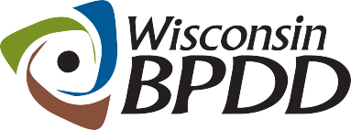  A Project of | CIE Outreach Mini-Grant Proposal

The completed proposal is due by 5:00 p.m. on May 22, 2026.

Applicant(s) Name and Title:

Organization Name:

Address:

Telephone:

Email address:

Lead contact name and email address, if different from applicant:

____________________________________________________________________________
Please answer the questions below (not to exceed 4 single-spaced pages total). If you are unsure if your organization is eligible, please contact Molly Cooney before completing the application.

- Share a little about your organization (i.e. purpose, services and service area (if relevant), connection to competitive integrated employment).

- Why are you applying for the CIE Outreach Mini-Grant? Please describe your interest and reason for applying for this grant opportunity. (justification)

- Describe how your organizational leadership and other relevant departments (such as finance for invoicing) have been informed of and support the intent and expectations of this mini-grant opportunity? (internal commitment)

- Describe the current community partners you plan to involve in planning your community conversation, employer presentation, and Take Your Legislator to Work event and how you will engage with them? (existing partnerships)

- Describe the new community partners you plan to engage with your community conversation, employer presentation, and Take Your Legislator to Work events and how you plan to engage with them? (future partnerships)

- Describe how the three outreach activities will increase awareness of and expand CIE opportunities for people with IDD in your community? (impact)

- Did you use any artificial intelligence (AI) tools (for example, ChatGPT, Grammarly, Copilot) to help prepare this application?
☐ No
☐ Yes (please briefly describe how AI was used):

If chosen for the grant, my organization agrees to the following commitments:

Carryout activities with the goal of increasing competitive integrated employment for people with I/DD. CIE means jobs in the community alongside people without disabilities for minimum wage or higher and with the same benefits and advancement opportunities as employees without disabilities. These funds cannot be used to expand social enterprises or businesses created or run by employment service provider agencies. | Yes No
Attend a CIE Outreach Grant Virtual Kick Off meeting on July 8, 2026, from 12-1pm. | Yes No
Gather a team of internal and external partners to plan and host a Community Conversation focused on increasing opportunities for CIE outcomes for people with IDD by May 31, 2027. | Yes No
Present to at least one civic or service group such as the Kiwanis, Rotary, Lions, Chamber, etc. about the business case for hiring people with IDD. | Yes No
Participate in the BPDD Take Your Legislator to Work Campaign (TYLTW) with an employee with disabilities in your area. | Yes No
Receive technical assistance and support to implement your outreach activities. | Yes No
Keep BPDD project consultant apprised of progress, event dates, and outcomes. | Yes No
Meet quarterly by Zoom with the grant coach and BPDD staff to report on progress and outcomes. | Yes No
Use agreed upon event materials provided by BPDD (or materials you create that are reviewed by project consultant/BPDD) for your outreach activities and events. | Yes No
Notify BPDD no less than 30 days prior to the date of an event and provide electronic copies of the marketing and presentation materials to be used for review. | Yes No
Share information about any media cover/press releases that occur leading up to, during, or after the event with BPDD. | Yes No
Take photos at the events and send to BPDD during or right after the event for BPDD to use on social media. BPDD can help seeking media coverage as desired by your group. | Yes No
Invoice monthly or quarterly for milestones achieved per the Milestone Payment Schedule. | Yes No

