2026 WI Youth

Leadership Forum
June 28 – July 3, 2026
Edgewood College Campus, Madison, WI

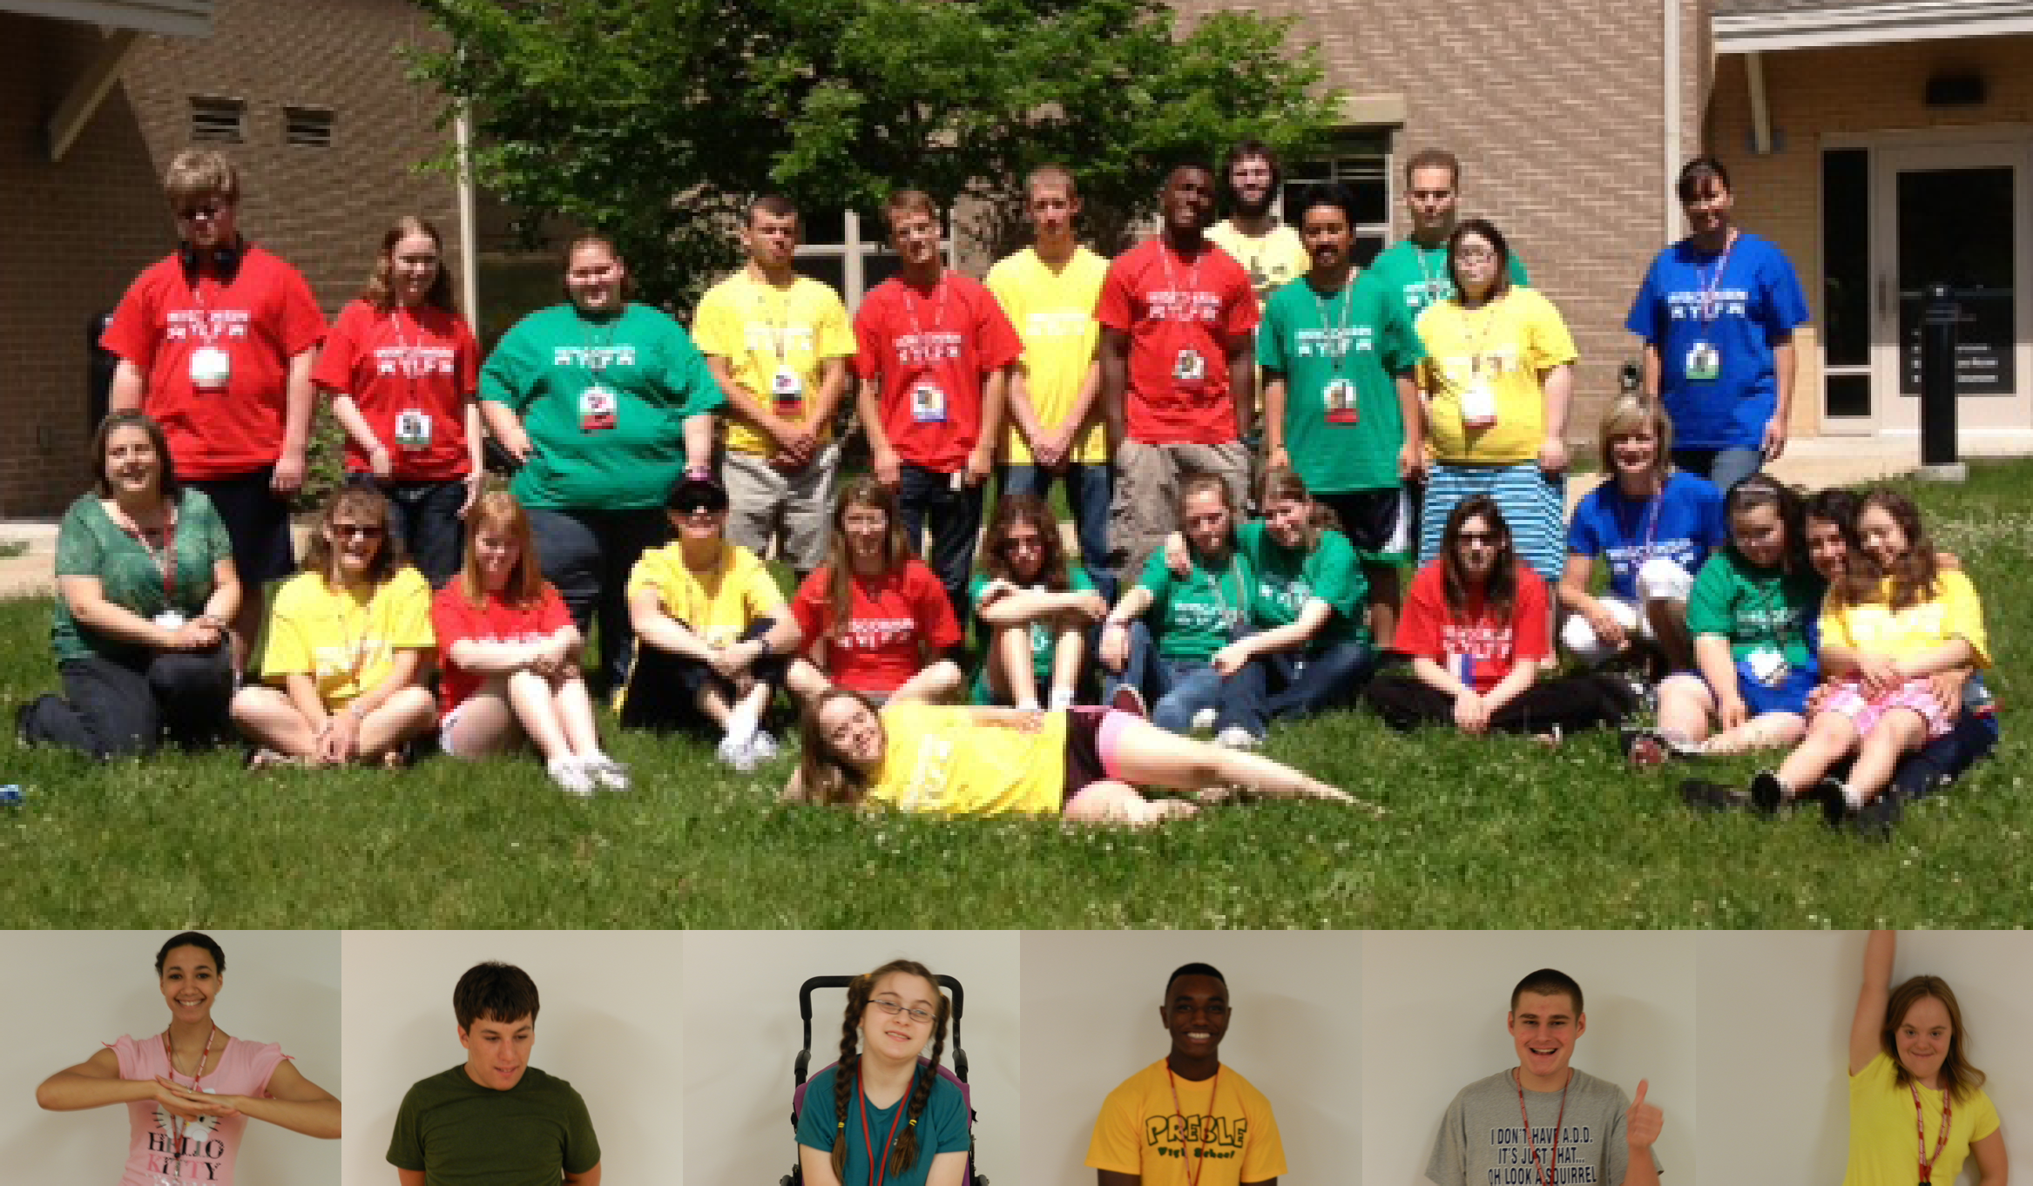
Leadership training and career awareness program for
high school students with disabilities
Application Deadline: March 13, 2026

A Project of

Wisconsin Board for People with Developmental Disabilities

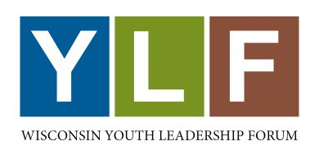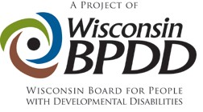

The Wisconsin Youth Leadership Forum (YLF) is a week-long, overnight leadership training and career awareness program for high school sophomores, juniors and seniors with disabilities. It provides training in leadership, self-advocacy skills, and career awareness to approximately 25 students with disabilities from throughout the state of Wisconsin. YLF is a project of the Wisconsin Board for People with Developmental Disabilities.

The Wisconsin Youth Leadership Forum is for:
- Students who show leadership potential by being active in their school and community
- Students with a disability (physical, learning, intellectual, emotional, sensory, etc.)
- Wisconsin residents
- Students who are currently sophomores, juniors, or seniors

Why Attend the Youth Leadership Forum?
- To give you a place to meet other students your age who are experiencing similar issues and concerns.
- To help you increase your leadership skills so you can further your future goals and reach them.
- To assist you in becoming a leader in your school and community.

WHERE: Edgewood College, Madison, WI
WHEN: June 28 – July 3, 2026
COST: FREE to students*
- There is NO CHARGE to attend the YLF. General program expenses are paid for by the Wisconsin Board for People with Developmental Disabilities (WI-BPDD), the Division of Vocational Rehabilitation (DVR), and other sponsors.

If I’m interested, what do I do next?
- Complete the application
- Get 3 letters of recommendation that highlight your leadership skills
- Complete two essay questions

Application Deadline is March 13, 2026

If you have questions or need more information about YLF, contact wisconsinylf@gmail.com.

To find out more information about YLF go to: http://wi-bpdd.org/index.php/wisconsin-youth-leadership-forum/

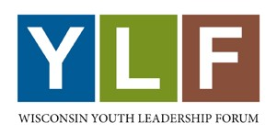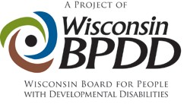

Frequently Asked Questions
(Keep this page for your information)

When is the application due?
Your application must be postmarked no later than March 13, 2026.
Email your application to wisconsinylf@gmail.com or mail it to:
WI BPDD – YLF
101 E. Wilson St., Room 219
Madison, WI 53703

What should I do if I need help filling out the application?
Ask a friend, sibling, parent/guardian, or teacher.

How do you decide who is invited to attend?
A panel of judges will score applications. The scores will be averaged, and the top 25 to 30 students will be invited to attend the Forum.
When will I know if I was selected?
All applicants will be notified by email whether they were selected to attend the Forum in early May 2026.
What happens if I’m selected?
You must provide additional information to the Forum, such as your health insurance and accommodations.
Do I have to pay to attend the YLF?
No, the cost of attending YLF is covered by donations and sponsors. Your food, lodging, and materials will be provided through the program.

Being selected to attend the YLF is a distinct honor you can be very proud of. Please take the time to apply – you’ll have the time of your life!

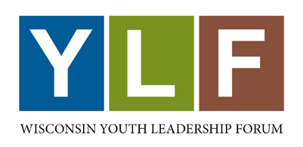 | 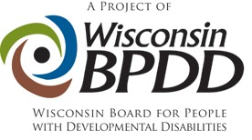

Wisconsin Youth Leadership Forum (YLF) Application

For High School Students with Disabilities
June 28 – July 3, 2026 at Edgewood College, Madison, WI

Applicant
Student’s Full Name: |  |  |  |  |  | Birth Date:
 | Last |  |  | First | M.I.
Residence Address:
 |  | Street Address |  |  |  |  |  | Apartment/Unit #

 | City | State | ZIP Code

Mailing Address
(if different from above):

 |  |  | Street Address |  |  | Apartment/Unit #

 | City |  |  | State | ZIP Code
Student Phone: |  | Student *Email:
Parent Phone: |  | Parent *Email:

I check my email regularly. | YES ☐ | NO ☐
*All information about the YLF, including whether or not you were selected, will go to the email addresses entered above.

School
Name of High
School:
 | City & State
School  Counselor’s Name: |  | School Counselor’s Email:

Grade Level on January 1, 2026: |  | Expected Graduation Date (Month/Year):

Please tell us about your plans after you graduate from high school:

Other

If you are currently a client of the Division of Vocational Rehabilitation (DVR), please list:
Rehabilitation Counselor’s Name:
Rehabilitation Counselor’s Email:

State Senate Representative’s Name:
District Number:

State Assembly Representative’s Name:
District Number:

School and Community Involvement

Below, please briefly list your involvement with your school and community. This may include:
- club memberships | - offices you held
- work or volunteer experiences | - after school activities

List the name of the activity, the dates you were involved, the name of an adult you worked with, and the grade level you were in at the time of participation (use additional pages if necessary).

School Activities:
Name of  Activity 1: |  | Dates:

Adult Contact: |  | Grade Level:

Name of  Activity 2: |  | Dates:

Adult Contact: |  | Grade Level:

Name of  Activity 3: |  | Dates:

Adult Contact: |  | Grade Level:

Community Activities:

Name of  Activity 1: |  | Dates:

Adult Contact: |  | Grade Level:

Name of  Activity 2: |  | Dates:

Adult Contact: |  | Grade Level:

Name of  Activity 3: |  | Dates:

Adult Contact: |  | Grade Level:

Letters of Recommendation

Please provide three letters of recommendation from individuals who can describe your leadership skills and leadership potential.

- At least two letters must be from persons NOT related to you

Please list those individuals' contact information below.

Name: |  | Position or Title:

Phone: |  | Email:

Relationship to applicant:

Name: |  | Position or Title:

Phone: |  | Email:

Relationship to applicant:

Name: |  | Position or Title:

Phone: |  | Email:

Relationship to applicant:

Required Essays

Your answers to the following two questions will be used to assess your readiness to participate in this leadership and career awareness forum.

  - Write or type your responses in a separate document and attach it to your completed packet.
  - Your response should be a minimum of 100 words per question.
- Alternative formats are welcome. Please limit video or audiotapes to no more than 5 minutes per question.

- The Youth Leadership Forum is designed to teach you skills to increase the leadership potential you already possess. If you are selected to represent your school and community at the YLF, what is one community or educational issue you would like to see improved or put into action in your hometown? Examples of such issues could include accessibility barriers, creating disability awareness, school bullying, or providing better services for students with disabilities.

- What is one thing you have done in your life that you are really proud of? What did this experience teach you about leadership?

Finish

How or from whom (name and title) did you obtain this application?

* I understand the YLF may be postponed or canceled depending on the status of our federal funding.
Applicant Signature: | X | Date:

Please keep a photocopy for your records. Application materials and applications using alternative formats will not be returned.

Application Deadline is March 13, 2026.

Mail or email completed applications to:

wisconsinylf@gmail.com (preferred method)

BPDD - YLF
101 East Wilson St., Rm. 219
Madison, WI 53703

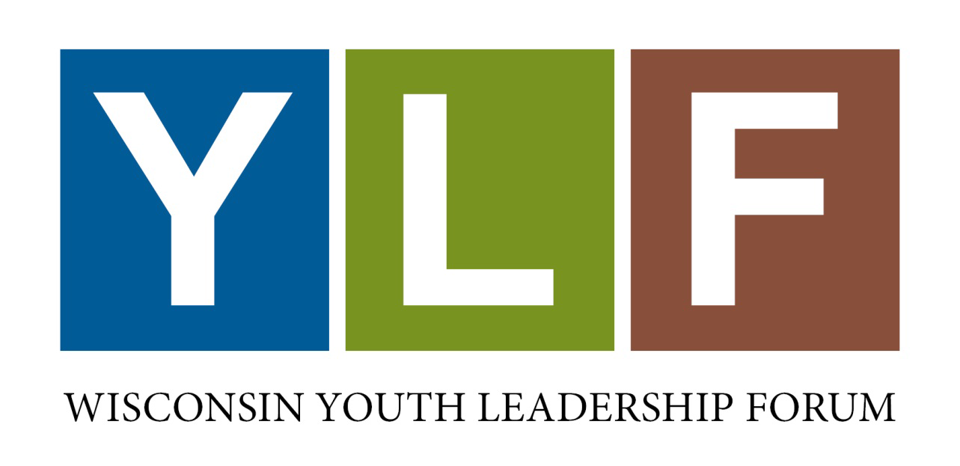

For more information, see https://wi-bpdd.org/index.php/wisconsin-youth-leadership-forum/

