**Partners with Business   
--**

**Grant Proposal for Supported Employment Service Providers**

*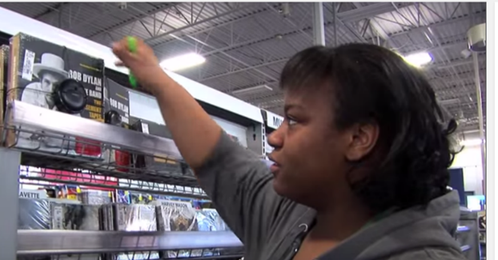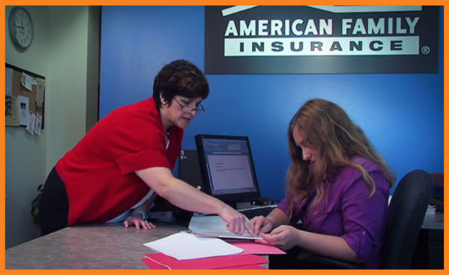****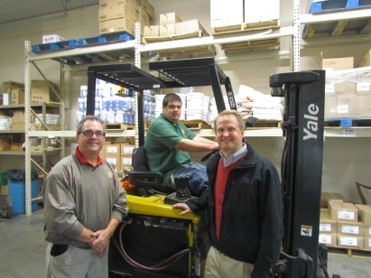***

*Proposals are due* ***5:00 p.m. on Friday, September 19, 2025.***

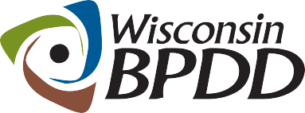

A Project of

**Partners with Business Grant Timeline**

|  |  |
| --- | --- |
| **Activity:** | **Date:** |
| **Proposals due** | **9/19/2025** |
| **Notice of award** | **9/29/2025** |
| **Contract start date** | **10/1/2025** |
| **End date of contract** | **6/30/2026** |

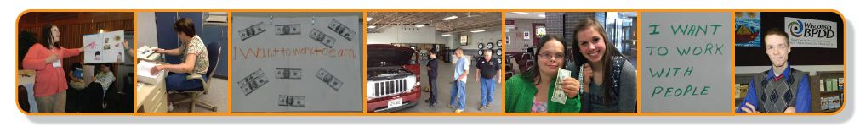

|  |  |
| --- | --- |
| A Project of |  |

**What is a Partners with Business grant?**   
The Wisconsin Board for People with Developmental Disabilities (BPDD) seeks to partner with Supported Employment service providers **interested in improving employer engagement practices and reducing Medicaid-funded job coaching support for adults with disabilities.** Grant funds and technical assistance are available.

* These grant funds are provided by the State of Wisconsin ([Wisconsin Act 323](https://docs.legis.wisconsin.gov/2017/related/acts/323)) through a project with the BPDD called “[Partners with Business](https://wi-bpdd.org/index.php/partners-with-business/).” The goal of Partners with Business is to support businesses to tap into new talent and learn best practices for finding, hiring, and supporting workers with intellectual and developmental disabilities (IDD). This helps businesses fill workforce shortages and reach diversity and inclusion goals.
* BPDD is making grant funds available for up to three Supported Employment service providers to implement capacity building strategies with employers. Many Supported Employment service providers are struggling to hire job coaches. These grant funds provide an opportunity to take new or creative approaches to reduce the need for job coaching through better job matching and customization, employer engagement, systematic instruction, natural supports, and paid coworker support options. These capacity building efforts can improve employment outcomes for people with disabilities and meet the needs of community employers.
* Awardees can receive up to $8,000 to carry out specific capacity building activities that align with the Act 323/Partners with Business initiative’s goal *to reduce publicly funded job supports by at least 25% over the course of the grant cycle*. These activities include:

1. Participate in an initial orientation and work planning virtual meeting with BPDD project lead and grant coach.
2. Engage with grant coach and identified self-advocate leaders with People First WI to provide peer-led virtual education sessions for Supported Employment program participants on employment related topics.
3. Capture de-identified baseline data on all individuals the agency currently supports in long-term support (Family Care or IRIS) Supported Employment services. Data to include hours worked and job coach hours provided each month.
4. Identify *at least three* Family Care or IRIS funded Supported Employment job sites with potential for fading job coaching supports and/or transitioning to paid coworker support.
5. Designate at least two employment specialists to complete the DHS Partners with Business online training modules.
6. Designate *at least two* staff (ideally Supported Employment program manager and lead employment specialist) to attend four 90-minute virtual Community of Practice meetings (November, January, March, and May)
7. Conduct workplace support analyses at identified job sites and implement job coach fading strategies and/or coworker support plans with technical assistance from the grant coach.
8. Engage in a systematic review of the organization’s current recruitment, onboarding and training processes for job developers and job coaches to identify and implement strategies for improvement.
9. Near the end of the grant period, capture de-identified data on all individuals the agency currently supports in long-term support (Family Care or IRIS) Supported Employment services to demonstrate a 25% or more reduction in job coaching support as a result of the strategies implemented during the grant period.

* Please refer to the Partners with Business Grantee Timeline, Milestones, and Payment Schedule below.
* Awardees will receive technical assistance from the Partners with Business grant coach to complete their project activities and milestones.
* The project period is October 1, 2025 – June 30, 2026.

**What are the requirements for agencies that are awarded a grant?**

* Complete a MOU grant agreement with inControl Wisconsin by October 10, 2025.
* Commit to completing project activities and milestones in the expected timeline, including capturing baseline data on all individuals the agency currently supports in long-term support Supported Employment services.
* Receive technical assistance and support to implement your project activities.
* Meet quarterly by Zoom with BPDD staff to report on progress and outcomes. These meetings will serve as your grant reports.
* Share job coaching data and any relevant outcomes/success stories for the annual Partners with Business report BPDD provides to the legislature.
* Invoice monthly or quarterly for milestones achieved per the Milestone Payment Schedule.

**Who can apply?**

* Any agencies that provide Family Care and/or IRIS Supported Employment services.
* If you have questions about whether your organization is eligible to apply, please contact Molly Cooney at 608-266-0266 or [molly.cooney@wisconsin.gov](mailto:molly.cooney@wisconsin.gov)

**How do you apply?**

* Submit a **completed proposal by e-mail** to Molly Cooney at [molly.cooney@wisconsin.gov](mailto:molly.cooney@wisconsin.gov) by **5:00 pm on September 19, 2025.**

|  |  |
| --- | --- |
| A Project of | **Partners with Business Grant Proposal** |

**The completed proposal is due by 5:00 p.m. on September 19, 2025.**

**Applicant(s) Name and Professional Title:**

**Organization Name:**

**Address:**

**Telephone:**

**Email address:**

**Lead contact name and email address, if different from applicant:**

____________________________________________________________________________

**Please answer the questions below (not to exceed 4 single-spaced pages total).** If you are unsure if your organization is eligible, please contact Molly Cooney before completing the application.

1. Share a little about your organization and the Family Care and/or IRIS Supported Employment Services that you provide. Please include your Supported Employment service area and number of individuals your organization provides long-term Supported Employment services to.
2. Why are you applying for funding and technical assistance? Please describe your organization’s current need and reason for applying for this grant opportunity. (justification)
3. Awardees are expected to implement the nine activities listed above with grant coach support. How will these activities positively impact your organization and the people you serve?

(impact)

1. Act 323 requires that grantees demonstrate a 25% reduction in publicly funded job coaching support. By implementing the capacity building activities previous grantees have easily demonstrated this reduction. Why do you feel your organization will be successful in implementing the activities and achieving this required outcome? (feasibility)

***If chosen for the grant, as a Partners with Business Grantee, my organization agrees to the project milestones and timelines outlined below.***

***Yes***  ***No***

**Partners with Business Grantee Milestones, Timeline, and Payment Schedule**

|  |  |  |
| --- | --- | --- |
| **Project Milestone** | **Timeline** | **Grant Payment** |
| Participate in an initial orientation and work planning virtual meeting with BPDD lead and grant coach. | October 2025 | $200 |
| Engage with grant coach and members of People First Wisconsin to provide peer-led virtual education sessions for Supported Employment program participants on employment related topics. | Initial planning meeting in October 2025. Implementation November 2025 – June 2026. | $1,000 |
| Capture de-identified baseline data on all individuals the agency currently supports in long-term support (Family Care or IRIS) Supported Employment services. Data to include hours worked and job coach hours provided each month. | By November 15, 2025 | $500 |
| Identify *at least three* Family Care or IRIS funded Supported Employment job sites with potential for fading job coaching and/or transitioning to paid coworker support. | By November 30, 2025 | $500 |
| Designate *at least two* employment specialists to complete the DHS Partners with Business training modules. | By December 2025 | $800 (after completion of training) |
| Designate at least two staff (ideally program manager and lead employment specialist) to attend four 90-minute Community of Practice meetings | November 2025, January 2026, March 2026, and May 2026 | $500 per CoP Meeting = $2,000 total |
| Conduct workplace support analyses at identified job sites and implement job coach fading strategies and/or coworker support plans with technical assistance from the grant coach. | Analysis completed by January 15, 2025. Implementation strategies January 15 – May 30, 2026. | $1,000 |
| Engage in a systematic review of the organization’s current recruitment, onboarding, and training processes for job developers and job coaches to identify and implement strategies for improvement. | Systematic review complete by February 28, 2026. Implementation strategies March – June 2026. | $1,000 |
| Near the end of the grant period, capture de-identified data on all individuals the agency currently supports in long-term support (Family Care or IRIS) Supported Employment services to demonstrate a 25% or more reduction in job coaching support as a result of the strategies implemented during the grant period. | May 2026 | $500 |
| Share job coaching data and any relevant outcomes/success stories for the annual Partners with Business report to the legislature. | June 2026 | $200 |
| Meet quarterly by Zoom with BPDD staff to report on progress and outcomes. These meetings will serve as your grant reports. | January 2026  April 2026  June 2026 | $100 each meeting = $300 total |
| **Total** | | **$8,000** |