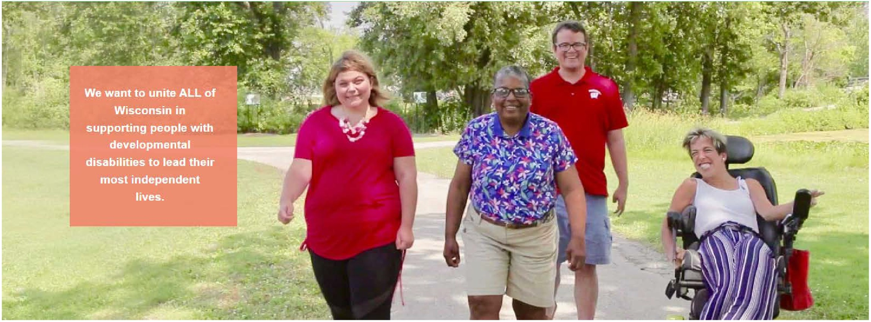

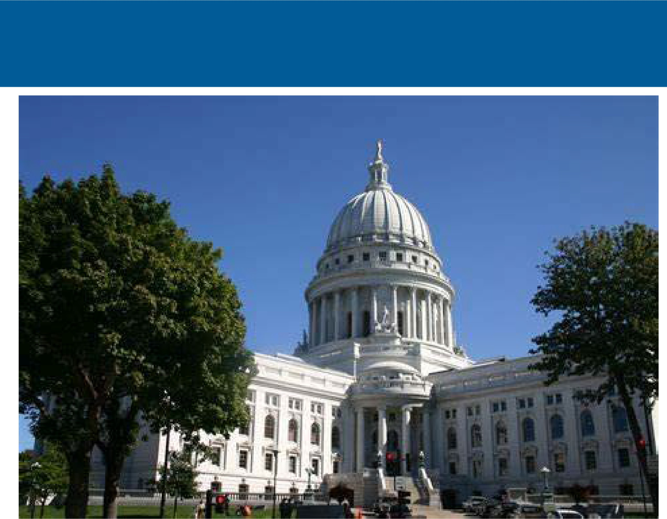2025-Wisconsin Disability Policy Fellowship

Application Packet

**Become** **A** **Leader** **in** **Disability Policy in Wisconsin**

**Application** **deadline** **June 27,** **2025, at 5pm**

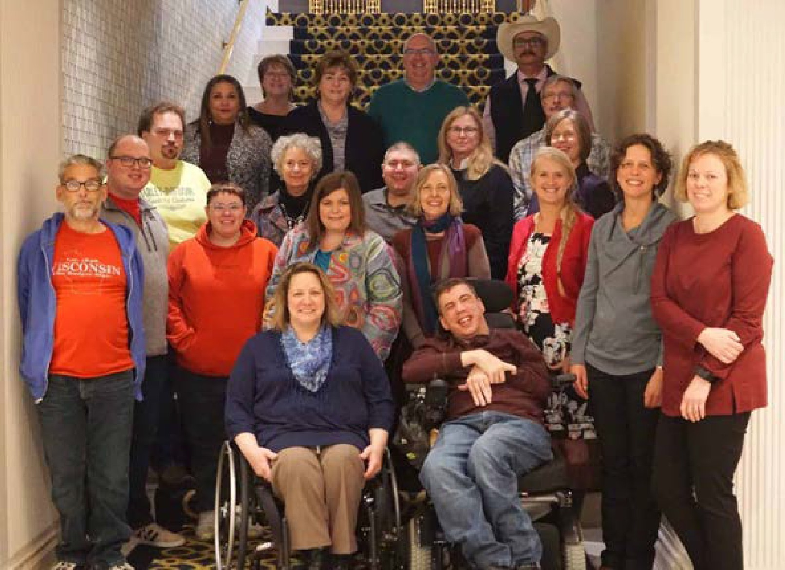The Wisconsin Disability Policy Fellowship is a one-year, paid full-time integrated experience designed to develop future leaders in disability policy. Fellows will work within key Wisconsin policy divisions, state agencies, or disability organizations.

The fellowship focuses on understanding how laws are developed, how program policies are created, and how public policy impacts people’s lives. Fellowships will have a particular focus on impacting people using the long-term care system in Wisconsin. This is a BPDD project funded through a grant from the Inclusa Foundation.

BPDD is committed to encouraging a wide group of applicants to participate in the Wisconsin Disability Public Policy Leadership Fellowship. If you require any accommodations to complete your application or to participate in the fellowship, please let us know. We are here to provide the support you need to succeed.

# Who can apply?

Required to Apply

* Identify as a person with a developmental disability or a family member of a person with a developmental disability.
* Demonstrate commitment to disability advocacy and policy.
* Have previous involvement in state or local level advocacy with a focus on long-term care, employment, education, community organizing, or related ﬁelds.
* Strong communication skills and ability to work as a team and get along with others.
* Ability to work independently and collaboratively in a fast-paced environment. Proven problem-solving and critical thinking abilities.
* Be available for full-time Fellowship from September 2025 through August 2026.

Preferred to Apply

* Experience working with individuals with intellectual and developmental disabilities.
* Knowledge of Wisconsin’s legislative and state programs.
* Knowledge of Wisconsin’s long-term care system.
* Previous experience in a leadership role in a volunteer or paid position.



2

# What are the activities of the Fellowship?

**"The Wisconsin Disability Public Policy Leadership Program is an exciting opportunity for BPDD to develop new leaders in disability policy. We are thrilled to support passionate individuals who will drive positive change and advocate for the rights of people with disabilities in Wisconsin"**

-Beth Swedeen

BPDD Executive Director

* Participate in orientation and public policy training.
* Engage in legislative and state programs processes to identify, develop, and advocate for disability-related policies.
* Build and maintain relationships with

policymakers, state agencies, and advocacy organizations.

* + Attend and contribute to events, workshops, and

networking opportunities inside and outside the agency.

* + Receive coaching and mentoring from

experienced disability policy professionals.

* + Work on plain language resources for the individual agency or organization.
  + Provide help and support to people with disabilities interacting with the agency or organization.

# Picture of self-advocates Who are the possible placement agencies?

* + - Department of Health Services-Division of Medicaid

Services-Long Term Care

* + - Department of Health Services Division of Quality Assurance
    - Department of Health Services Children’s Long-Term Waiver
    - Department of Health Services Adult Protective Services
    - Department of Workforce Development-Division of Vocational Rehabilitation
    - Department of Public Instruction-Transition Services
    - Department of Justice-Medicaid Fraud
    - Department of Transportation- Division of Budget and Strategies
    - Wisconsin Legislative Offices
    - Governor’s Oﬀice

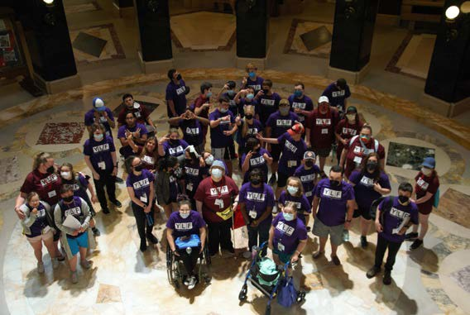

# What are the benefits of the program?

* Annual stipend $63,000
* Transportation stipend
* Health insurance stipend

Submit your application by June 27th, 2025, at 5pm

Online Application Link: [Application Link](https://www.surveymonkey.com/r/WIDisabilityPolicyFellowship25)

Scan QR Code for Application:

If you have questions or need assistance with

the application, please contact Sally Flaschberger at [Sally.flaschberger@wisconsin.gov](mailto:Sally.flaschberger@wisconsin.gov) or

call at 608-266-5038.