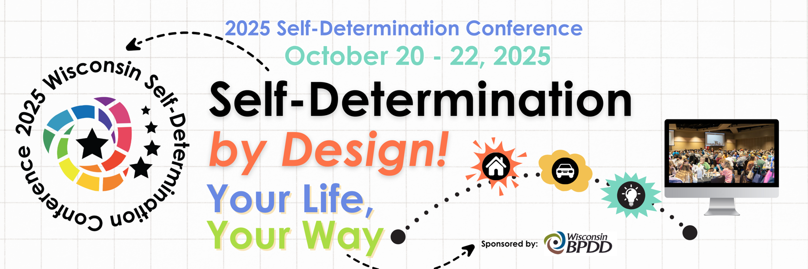

**Conference Presentation Proposal Announcement**

Are you interested in presenting at the **2025 Self-Determination Conference**? We are seeking session proposals for Tuesday, October 21 & Wednesday, October 22, 2025.

**This year’s theme: Self-Determination by Design: Your Life, Your Way will help people with disabilities lead more Self-Determined lives by offering tools to plan the life they want to live in the communities they choose!**

**Things to know when submitting a proposal:**

* Proposals **must** include a self-advocate(s) as a lead or co-presenter.
* Panels should be limited to no more than 3 people.
* Conference sessions must support Self-Determination and Self-Directed principles.
* Sessions will be all in-person. **Presenters must attend the conference   
   in-person.**
* Presentations should focus on practical, take-home strategies that people can implement in their lives.
* Sessions should not promote specific agencies or products.
* Repeat or similar sessions from previous conferences will not be considered.
* Sessions will be 1.25 hours in length. Self-Advocate sessions will be 30 minutes in length.
* A typical session has an audience of 50-75 attendees.

**If your session is accepted:**

* **Handouts:** Presenters agree to submit the PowerPoint and other materials through the online portal by **September 23, 2025**. You are responsible for providing 50-75 copies of your materials for your in-person session. Please use plain language.
* **Equipment:** A screen, A/V cart, LCD projector, laptop, and microphone will be provided in each breakout room. Bring your presentation on a flash drive or use your own laptop.
* **Presenters must register for the conference.** **Presenters must attend the conference in-person.**

***\*By completing this form, presenters agree to turn in all materials and information by September 23, 2025.***

**Conference Presentation Proposal Form**

Please complete the form and return ASAP- until sessions are full**.   
*A self-advocate(s) must be included.***

|  |  |  |  |  |
| --- | --- | --- | --- | --- |
| **Lead Presenter:** | Click or tap here to enter text. |  | | |
|  | First | Last | |  |
| **Co-Presenter:** | Click here to enter text. | Click here to enter text. | | |
|  | First | Last | |  |
| **Other(s):**  **Organization:** | Click here to enter text. ______________________________________________________________________________ Name(s)  Click here to enter text. | | | |
| **Address:** | Click or tap here to enter text. | | | |
|  | Click here to enter text. | |  |  |
|  | City: Click here to enter text. | | State: Click here to enter text. | ZIP: Click here to enter text. |
| **Email:** Click here to enter text. **Phone:** Click here to enter text. | | | | |

**Learning topics will support Self-Determination** **and all aspects of inclusive living in the community.**

**I would like to apply to present a full session. (75 minutes)**

**I would like to apply to present a 30 minute Self-Advocate (only) session.**

**Please Select one**

|  |  |
| --- | --- |
| **New & Innovative Ideas in Self-Determination:** | |
| Transition (high school to adulthood) | Technology |
| Transportation | Aging |
| Support Brokers/Supporting Caregivers | Diversity |
| Community Living/Employment | Health/ Fitness |
| Housing/roommates | Voting |
| Advocacy | Self-esteem/Courage/Mindfulness |
| Circles of Support, Community   and Social Resources | Navigating the Long-Term Care   System/ Self Direction |
| Supported Decision-Making | Futures Planning/ Person-Centered   Planning |
| Financial Planning and Literacy | Friendships/Relationships |
| Story Telling | Mental Health/self-care |
| **Title of Presentation**  (Please limit to 8 words or less): | |
| **Presentation Description** 100 words max, to be included in the program. Be as specific and detailed as possible **and include a plain language description of the interactive activity you will do in your session**. | |
| **Please list 3 specific things participants will learn or take away from your session.**  1.  2.  3. | |

**Bios:** (Please remember, at least one presenter must be a self-advocate. Bios may be revised due to limited space in the program.)

|  |  |
| --- | --- |
| Lead Presenter: (include email address) | (50 words max.): |
| Co-Presenter(s):  or Other Presenters  (include email address) | (50 words max.): Click or tap here to enter text. |

**All proposals are due ASAP until sessions are full.**

|  |  |
| --- | --- |
| **Scoring Criteria** | **Points possible** |
| 1. **Session description/theme/ originality/creativity** | **20** |
| 1. **Team make up (self-advocate lead)** | **20** |
| 1. **Interactive Activity** | **10** |
| 1. **Take away info/tools** | **10** |
| **Total possible points:** | **60** |



101 East Wilson Street, Room 219, Madison, WI 53703 Office: 608-266-7826