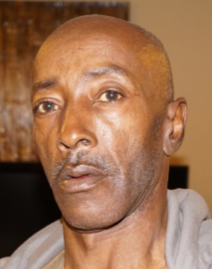
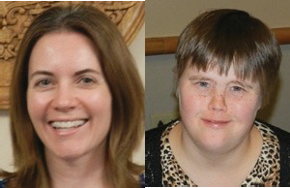
2024-2025 Wisconsin Partners in Policymaking
Application Packet

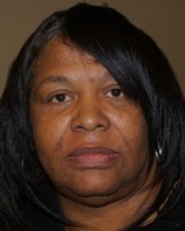

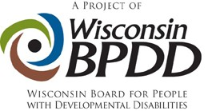

Become A Leader in Changing State Policies and Practices!
Application deadline October 4, 2024.

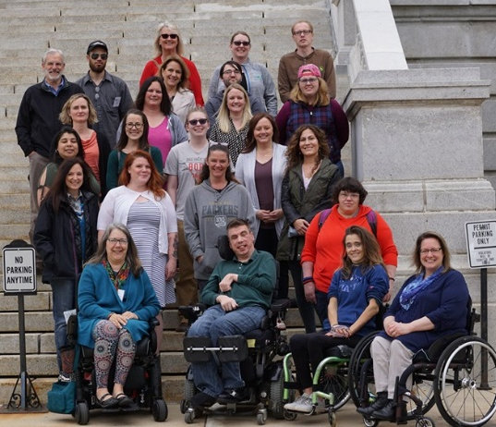
Wisconsin Partners in Policymaking is a six‐session advocacy and systems change training program that develops future leaders across the state who can work with legislators and communities on policies and initiatives that will support the full participation and inclusion of people with developmental disabilities in all aspects of life.

Become part of a nationwide network of nearly 27,000 graduates who are community leaders and decision-makers serving on policymaking committees, commissions, and boards at all levels.

Who can apply?
Individuals who are highly motivated to create more inclusive communities AND are:
- Parents or primary caregivers of children under the age of 21 who have developmental disabilities
- Adults with developmental disabilities
- Adult siblings or family members of individuals with developmental disabilities
We are seeking cultural and geographic diversity within the guidelines above. The selection of participants is made by a team of parents, self‐advocates, and professionals.

What are some of the topics covered in Partners?
“Partners educated me regarding issues affecting people with disabilities and how I can have an impact on public policy.”
- Partners Graduate
- History of the disability rights movement
- Self‐determination and self‐advocacy
- Disability policy and systems change
- Community engagement and grassroots advocacy
- School inclusion, integrated employment, community supported living.

What are the dates and times of the sessions?

All sessions run from 12:00 to 8 pm on Fri and 8:30 to 3 pm on Sat. Overnight lodging is paid for by BPDD.

- November 1 & 2, 2024 (Madison*)
- December 6 & 7, 2024 (Virtual only)
- January 10 & 11, 2025 (Virtual only)
- February 21 & 22, 2025 (Virtual only)
- April 4 & 5, 2025 (Madison*)
- May 2 & 3, 2025 (Madison*)

*If attending in person is a barrier, please contact Jenny Neugart, Project Manager at Jennifer.neugart@wisconsin.gov to discuss options.

What is expected of participants?

- Participate in all two‐day sessions and complete all homework assignments. Attendance at all sessions is required. Only individuals selected to participate in the program will be able to attend (with supports as needed). Aside from attendant care, additional family members and friends do not attend the in-person sessions or stay at the hotel.

- Participate in networking, advocacy activities, interviews, readings (some available in alternative formats), and other projects.

- Commit to developing a relationship with your state legislators.

- Arrange for any 1 on 1 support needed to participate, including arranging any training needed for caregivers to meet your support needs. Remember: support people are not Partners participants and should limit their role during the program to the direct support of participants.

What is the cost?
Partners is funded by BPDD, which covers all costs associated with the training, including lodging, meals, and materials.

“I joined the Down Syndrome Society Board! I plan to join some special education parent advocacy groups in my school district too.”
- Partners Graduate

Core Values
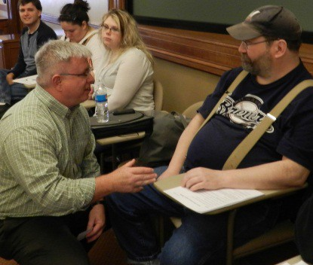
Participants agree to support the core values in the federal Developmental Disabilities Act. Please affirm that you support each value before applying for Partners.
- Disability is a natural part of the human experience and does not diminish people’s rights to live independently, exercise control over their lives and fully participate in and contribute to their communities.
- People with disabilities are people first and must be treated with dignity and respect. This includes the right to be free of abuse and neglect.
- People with disabilities are entitled to the right to free speech. The ability to communicate, with assistance as needed, must be available to everyone.
- People with disabilities have the right to advocate for themselves on every level of the system, from individual services to the state budget to federal laws that affect their lives.
- Self‐determination is essential to full citizenship. People with disabilities must have the freedom to make informed decisions about how they want to live their lives and receive supports.
- People with disabilities must be able to enjoy the full mobility and accessibility that enables active participation in community life.
- People with disabilities need real friendships with a variety of friends, not just paid service workers.
- Schools and communities are stronger when they are inclusive.
- Every person with a disability deserves the right to work in the community at competitive wages, with benefits and the supports necessary to be successful.

For more information or to get help completing your application:
Contact Jenny Neugart at jennifer.neugart@wisconsin.gov or (608) 266‐7707.

Application Deadline is October 4, 2024.

APPLICATION
FORM

Name:
Address:
City/State/Zip:
E-mail:
Cell Phone:
Home Phone:

Female Male Non-Binary

I am a parent/caregiver/sibling of a child with a disability. (If you have more than one family member with a disability please answer for each child.)
Son/daughter ages:
Does your child live at home? Yes No

I have a developmental disability.

Please answer the following questions. Feel free to attach additional sheets of paper if necessary.
- Please tell us a little about yourself and your family.

- Why do you want to participate in Partners in Policymaking?

- What would you most like to change that would improve the lives of children and adults with disabilities?

- Please describe your experience in advocating for yourself, your child, or others with developmental disabilities. Include advocacy or disability related organizations you participate in?

- What kind of work/school are you involved in? (Include volunteer and leadership positions, not just paid work.)

- How do you hope to use your new information and skills after completing this training program?

- Looking at the Core Values, which are the most important to you and why?

- If you were referred by a Partners in Policymaking graduate, please provide their name.

If selected to participate in Wisconsin Partners in Policymaking, please check that you are committing to:
    - Attend ALL 6 sessions. Please make sure the dates work for you before you apply.
    - Complete all homework assignments, including networking, activities, and readings.
    - Make arrangements with your employer and family, as needed, to fully participate.
    - Commit to building a relationship with your state legislators.
    - Support the Core Values of the DD Act as outlined in this application packet.
    - Be prepared to invest time and energy into advocacy between each session.

To ensure you will be able to fully participate in the virtual programming, please check all responses below that apply to you. If you indicate you need help or do not currently have access to technology, we will work with you to remove barriers. Please check all that apply.
- I have access to a computer or tablet that will allow me to participate in online training.
- I have a reliable internet connection that will allow me to participate in online training.
- I will need help finding a computer or tablet to participate in online training.
- I will need help getting a reliable internet connection to participate in online training.
- I do not have access to reliable internet where I live.

Signature: Date: _________________
(Electronic Signature is allowed)

Materials must be submitted by Oct 4, 2024.
Applicants will be notified of their selection by the end of October 2023.

Submit your application:
- Email (preferred) to jennifer.neugart@wisconsin.gov
- Ground mail to:
Wisconsin Partners in Policymaking c/o WI‐BPDD
101 East Wilson St., Room 219 Madison, WI 53703

If you have questions, please contact Jenny Neugart at jennifer.neugart@wisconsin.gov or (608) 266‐7707.

