Partners with Business:

Grant Proposal for Businesses

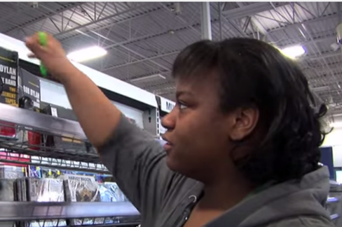
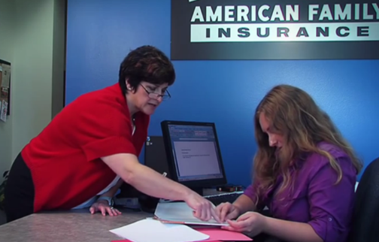
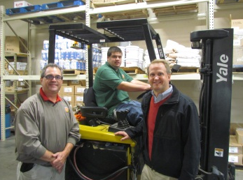

  - Proposals are due by 5:00 p.m. on May 31, 2024.

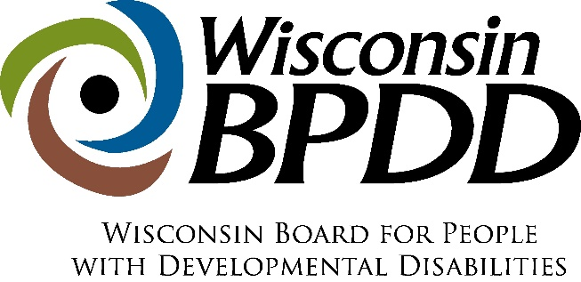

Partners with Business Grant Timeline

Activity: | Date:
Proposals due | 5/31/24
Notice of award | 6/14/24
Contract start date | 7/01/24
End date of contract | 6/30/25

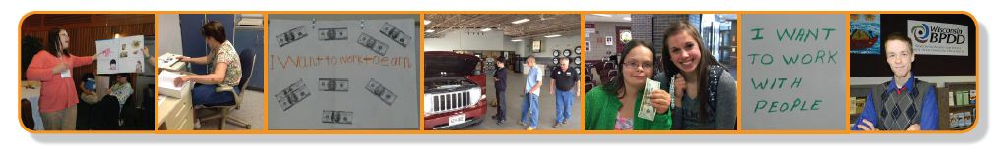

This work is supported by the Administration for Community Living (ACL) of the Department of Health and Human Services (HHS) as part of an award totaling $1,434,492 with $1,305,492 or 91% from federal funding. Grantees undertaking projects with government sponsorship are encouraged to express freely their findings and conclusions. Points of view or opinions do not, therefore, necessarily represent the official views of nor are endorsed by ACL, HHS, or the U.S. Government.
What is a Partners with Business grant?
The Wisconsin Board for People with Developmental Disabilities (WI-BPDD) seeks to partner with businesses interested in hiring more people with intellectual and developmental disabilities (IDD).

- Grant funds are available for WI-based businesses to launch hiring initiatives to employ and support workers with IDD. WI-BPDD is seeking to award up to $15,000 to one or two WI-based businesses for July 1, 2024, through June 30, 2025.
- These grant funds are provided by the State of Wisconsin (Wisconsin Act 323) through a project with the WI-BPDD called "Partners with Business.” We aim to support businesses to tap into new talent and learn best practices for finding, hiring, and supporting workers with IDD. This helps businesses fill workforce shortages and reach diversity and inclusion goals.
- Grantees plan and implement a hiring initiative with technical assistance and training from a WI-BPDD project consultant. The consultant uses a variety of tools to support businesses, including Disability:IN Wisconsin’s Guide to Creating Internal Supports in the Workplace. Technical assistance can include but is not limited to:
- strategic planning to set goals and develop a plan for hiring people with IDD;
- reviewing and revising hiring and onboarding policies and procedures to reduce barriers to job candidates with disabilities;
- conducting a workforce needs analysis;
- disability awareness training;
- finding talent by building external partnerships; and
- developing internal infrastructure to provide workplace supports to people with IDD, including natural supports and paid coworker support models.

What are the requirements for grantees?
- Complete and submit the grant proposal by May 31, 2024.
- Complete a contract agreement and vendor paperwork with BPDD by June 24, 2024.
- Work with BPDD project consultant to develop a work plan that includes hiring 2-4 workers with IDD.
- Receive technical assistance and support to implement your workplan.
- Meet quarterly by phone or Zoom with WI-BPDD staff and project consultant to share updates on activities, upcoming efforts, problem solve barriers, etc. These quarterly calls will serve as your quarterly grant reports. We do not require written reports.
- Partner with the WI-BPDD project consultant to develop materials to share with other businesses about your planning process, lessons learned, and accomplishments. This may include one or two presentations with the WI-BPDD project consultant at employer-focused virtual or in-person events (optional).
- Invoice monthly or quarterly for costs that have incurred.

Who can apply?
- A Wisconsin-based, private sector business with the intention of hiring people with disabilities as pay-rolled employees.
- This funding is not intended for internships.
- This funding is not intended for vocational or employment service agencies or for businesses owned by these service agencies.
- This funding is not intended for social enterprises (businesses with the main purpose of training and/or employing people with disabilities).

How do you apply?
- Submit a completed proposal and budget by e-mail to Molly Cooney at molly.cooney@wisconsin.gov by 5:00 pm on May 31, 2024.
- If you have questions, email or call Molly at 608-266-0266.

Grant Proposal

The completed proposal is due by 5:00 p.m. on May 31, 2024.

Applicant Name:

Name of Business:

Address:

Phone:

Email address:

Lead contact name and email address, if different from applicant:

____________________________________________________________________________
Please answer the questions below (not to exceed 4 single-spaced pages total).
If you are unsure your business is eligible, please contact Molly Cooney before completing the application.

- Tell us about your business. What is your business? What does your business do?

- Why is your business interested in Partners with Business grant funding and technical assistance? (justification)

- Why does your business need this funding and technical assistance? (justification)

- If you receive a grant, what do you want to do or accomplish? How will your business use the funds to launch or grow your hiring initiative or related efforts? (statement of work)

- Why is your business likely to succeed in carrying out these objectives or reaching these goals? (feasibility)

- Does your business have experience hiring and supporting employees with disabilities? If so, please share a little about your experience and what types of positions the employees held.

- Please describe your company’s current level of commitment to hiring and supporting employees with intellectual and developmental disabilities. (i.e. Are there executive level champions for these efforts? Has your company articulated and communicated the business case for hiring employees with disabilities? Is disability part of your company’s Diversity, Equity and Inclusion efforts?)

- WI-BPDD shares the State of Wisconsin's goal to partner more with Minority-Owned Businesses and Service-Disabled Veteran-Owned Businesses. We strive to partner with other traditionally underrepresented communities as well. Is your business at least 51% owned, managed, or controlled by a person who identifies as American Indian, Asian, Black, Hispanic or Latino, Native Hawaiian, LGBTQ+, or disabled?
YES or NO

Budget Worksheet
Grant funds can be used in many ways. If you have questions about using grant funds, please contact Molly Cooney (molly.cooney@wisconsin.gov).

Funds can be used to:
- cover staff time spent working on the hiring initiative
- pay for training or professional development around disability awareness
- costs associated with materials or refreshments needed for trainings or events

Funds cannot be used:
- for vehicles or technology (like computers or phones or other equipment)
- to pay the wages of an employee with a disability
- to pay for services or supports an agency/organization is already charged with providing such as direct services to people with disabilities (like job development or job coaching services)

SAMPLE BUDGET
ITEM (be as specific as possible) | COST
Staff time consulting with partners, phone calls, emails, candidate interviews, meeting preparation (1 staff - 10 hours/week for 48 weeks @ $25/hour = $12,000) | $12,000
Staff time to complete training (10 staff members x 2 hours @25/hour = $500) | $500
Disability awareness training – trainer fees | $1,000
Meeting space rental for 2 educational events ($150 per event x 2 events = $300) | $300
Materials (poster board, markers, post-it notes, copies) | $200
TOTAL | $14,000

YOUR PROJECT’S BUDGET
ITEM (be as specific as possible) | COST
TOTAL

Natural support refers to the support that is typically provided by supervisors and coworkers in the workplace, including supervision and guidance from a supervisor or support that coworkers and teams typically provide to one another. These same types of supports should be provided to workers with IDD. If a worker with IDD needs more support on the job than a supervisor or coworker would typically provide, paid coworker supports within the business could be an option. In a paid coworker support model, one or more coworkers would be identified to provide enhanced support to the worker with IDD. In exchange, the business is provided funding from the Division of Vocational Rehabilitation or long-term care to provide this support. Paid coworker supports are less obtrusive and more cost-effective than relying on outside job coach agencies. Grantees get technical assistance to develop natural support and paid coworker support options for workers with IDD.

