J

Families Supporting Families:

Grant Proposal

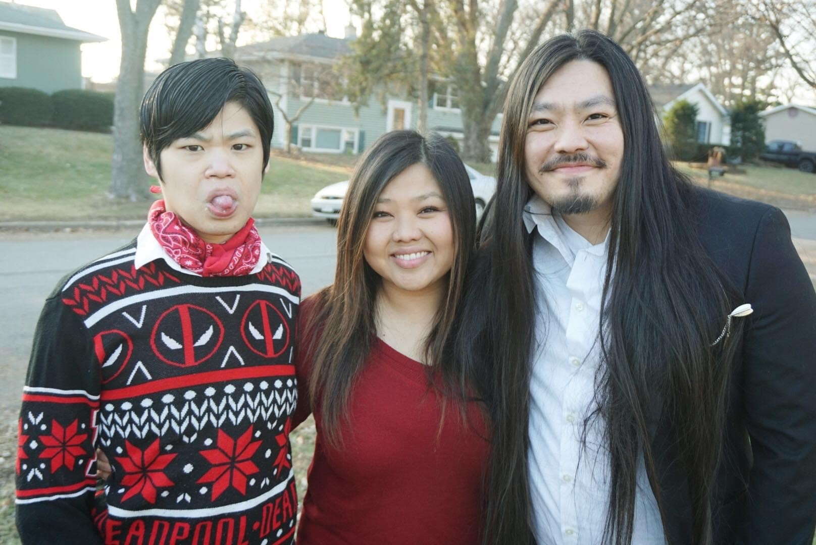

Community members and organizations supporting families   
to live the lives they want

This work is supported by the Administration for Community Living (ACL) of the Department of Health and Human Services (HHS) as part of an award totaling $1,434,492 with $1,305,492 or 91% from federal funding. Grantees undertaking projects with government sponsorship are encouraged to express freely their findings and conclusions. Points of view or opinions do not, therefore, necessarily represent the official views of nor are endorsed by ACL, HHS, or the U.S. Government.

# What are Families Supporting Families grants?

The **Wisconsin Board for People with Developmental Disabilities** (BPDD) and the **Wisconsin Department of Public Instruction** (DPI) want to strengthen their partnerships with Wisconsin’s under-served communities to better support families who have school-aged children with intellectual or developmental disabilities. Intellectual and developmental disabilities include autism, Down Syndrome, Cerebral Palsy, Fragile X Syndrome, and many others.

* We want all families and their children with disabilities in Wisconsin connected to the people, activities, and community resources they need to live the lives they want.

* We recognize that people from a community often know best how to support other members of their community.
* We will provide funding to an individual, community-based organization, or school to launch or expand the work you are doing to support children with disabilities and families.
* We want to hear your ideas on what might work best to support families of children with disabilities in your community. Your activities should be based on what you’ve seen work or what you think might be most useful. Below is a list of what other grantees have done. You can use these ideas or come up with your own.
  + Brought families together for a fun activity in the community that also shares local resources.
  + Hosted virtual or in-person “Parent Hours” that give parents (or other family members) time to connect, share experiences, and practice self-care activities.
  + Brought the broader community together to raise awareness about disability.
  + Hosted workshops for families on topics of interest like building school partnerships, bullying, or health care.
* We currently provide funding to five community-based organizations in Wisconsin. These organizations share information about services and supports with families, create opportunities for families to connect with each other, support families to practice self-care, empower families to advocate for their needs, and support families to advocate for others. You can read more about these organizations in our [annual report](https://wi-bpdd.org/index.php/families-supporting-families/).
* **Grant proposals and budgets are due on 4/19/24. We will notify applicants about their status by 4/30/24.** Projects begin in early May.
* You can request up to $20,000 to be used by September 30, 2025.

# Who is eligible to apply?

* Any individual or a community-based organization connected to an under-served community. Priority will be given to an East Asian, Southeast Asian, South Asian, refugee or other Asian community.
* Ideally, the applicant is a person who identifies as being a member of that under-served community. Or, if an organization is applying, the organization is ideally led by a person who identifies as being a member of that community.

# How do I apply?

* **Complete the Proposal and Budget by April 19, 2024:** Email your completed proposal and budget (see below) to Molly Cooney ([molly.cooney@wisconsin.gov](mailto:molly.cooney@wisconsin.gov)) by 5:00pm on 4/19/24. If you have questions or want to talk through your ideas, please call Molly at 608-266-0266.
* We can translate this application into other languages. Please let us know what language you need.

**हम इस आवेदन का अन्य भाषाओं में अनुवाद कर सकते हैं। कृपया हमें बताएं कि आपको यह किस भाषा में चाहिए।**

我们可以将此申请翻译为其他语言。请让我们知晓您需要哪种语言。

我們可以將此應用程式翻譯成其他語言。請告訴我們您需要的語言。

# What do I need to do if my proposal is selected?

* **Kick-off Meeting:**  Attend a virtual kick-off meeting to get information about logistics like invoicing and contracts, learn about the other organizations participating in this project, develop your workplan, brainstorm outcomes you would like to achieve, and meet DPI and BPDD leadership and staff.
* **Quarterly Check-ins**: Meet quarterly by phone, Zoom or in-person to do a check-in with DPI and BPDD staff. We will meet in April, July, and September 2024. During these check-ins, we will go through a list of questions to:
  + Hear how things are going,
  + Learn if there are actions we can take in our organizations to improve the way services are working for your families,
  + Gather data and stories, and
  + Support you in any way we can.

These check-ins take the place of written reports.

* **Outcomes:** Identify the results or outcomes you hope to achieve. We will work together to find ways to collect this information easily and in a culturally responsive way. We will not collect contact information of the people participating in your activities.
* **Invoice:** After each check-in, you will invoice BPDD.

# Grant Proposal

## The completed proposal and budget are due on 4/19/24 by 5:00p.m.

If you have questions, contact Molly Cooney at 608-266-0266 or [molly.cooney@wisconsin.gov](mailto:molly.cooney@wisconsin.gov)

**Your Name:**

**Address:**

**Phone number:**

**Email address:**

1. Tell us a little about yourself or your organization.
2. Why are you interested in this funding? (justification)
3. What will you do with the funding to support families and their children with disabilities? (statement of work)
4. Are these new activities or are you expanding the work you already do?
5. How will these activities positively impact the community? How many people do you think you’ll reach? (impact)
6. Will these activities specifically impact an Asian community? If so, please explain how. (impact and target community)
7. How much funding are you requesting? You can ask for up to $20,000.
8. WI-BPDD shares the State of Wisconsin's goal to partner more with Minority-Owned Businesses and Service-Disabled Veteran-Owned Businesses. We strive to partner with other traditionally underrepresented communities as well. Is your organization at least 51% owned, managed, or controlled by a person who identifies as American Indian, Asian, Black, Hispanic or Latino, Native Hawaiian, LGBTQ+, or disabled?

Yes or No

# Budget Worksheet

You can use the funds in many ways. If you have questions about using grant funds, please contact Molly Cooney at 608-266-0266 or [molly.cooney@wisconsin.gov](mailto:molly.cooney@wisconsin.gov).

Funds **can** be used to:

* pay yourself or staff for time spent working with families,
* pay for event space, food, or materials for meetings or events, and
* pay for a speaker to present to your group.

Funds cannot be used:

* for vehicles or technology (like computers or phones or other equipment),
* to pay for services or supports an agency/organization is already charged with providing like direct services to people with disabilities, and
* staff time already covered by another agency, organization, or grant.

**SAMPLE BUDGET**

|  |  |
| --- | --- |
| **ITEM** (be as specific as possible) | **COST** |
| Meeting space rental for 6 events ($125 per event x 6 events = $750) | $750 |
| Refreshments for 6 events ($100 x 6 events = $600) | $600 |
| Transportation for 6 events | $1,000 |
| Staff fees (8 hours/week for 24 weeks @ $25/hour = $4,800) | $4,800 |
| Stipends for family participation (5 families x $50 stipend = $250) | $250 |
| Materials (wall board, markers, post-it notes, copies) | $1,000 |
| **Total** | **$8,400** |

**YOUR PROJECT’S BUDGET**

|  |  |
| --- | --- |
| **ITEM** (be as specific as possible) | **COST** |
|  |  |
|  |  |
|  |  |
|  |  |
|  |  |
|  |  |
| **TOTAL** |  |