Partners with Business
--
Grant Proposal for Beyond 18 Transition Programming

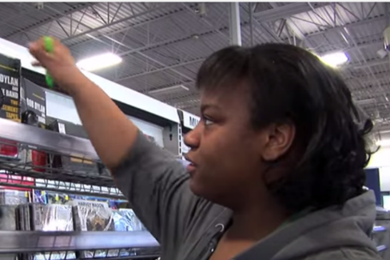
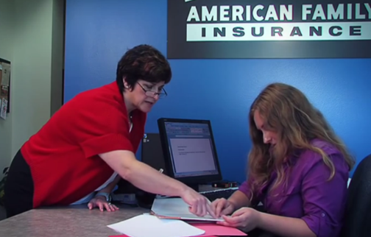
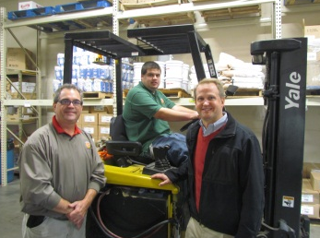

Proposals are due 5:00 p.m. on Friday, May 17, 2024.

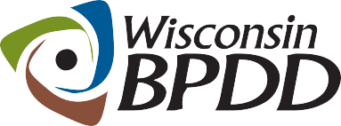
A Project of

Partners with Business Grant Timeline

Activity: | Date:
Proposals due | 5/17/2024
Notice of award | 5/31/2024
Contract start date | 7/1/2024
End date of contract | 6/30/2025

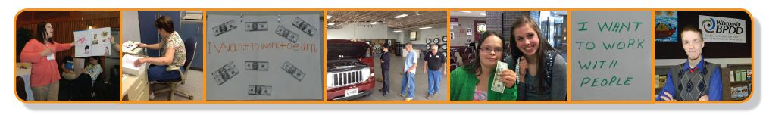
A Project of

What is a Partners with Business grant?
The Wisconsin Board for People with Developmental Disabilities (BPDD) seeks to partner with high schools interested in improving employer engagement practices and employment outcomes for young adults with disabilities in their Beyond 18 Transition programming. Grant funds and technical assistance are available.

- These grant funds are provided by the State of Wisconsin (Wisconsin Act 323) through a project with the BPDD called “Partners with Business.” The goal of Partners with Business is to support businesses to tap into new talent and learn best practices for finding, hiring, and supporting workers with intellectual and developmental disabilities (IDD). This helps businesses fill workforce shortages and reach diversity and inclusion goals.

- BPDD is making grant funds available to high school Beyond 18 School Transition programming to implement capacity building strategies within their Beyond 18 transition services and with employers. Many schools and Supported Employment service providers are struggling to hire job coaches. These grant funds provide an opportunity to take new or creative approaches to reduce the need for job coaching through better job matching and customization, employer engagement, systematic instruction, natural supports, and paid coworker support options. These capacity building efforts can improve employment outcomes for youth with disabilities and meet the needs of community employers.

- Awardees can receive up to $5,000 to carry out capacity building activities. These activities can include:
  - Building relationships with business by joining and attending meetings with civic groups (e.g. Kiwanis, Lions, Rotary, etc.) and business groups (e.g. Chamber of Commerce, Partners in Education, etc.)
  - Hosting an Amazing Race with students and businesses
  - Hosting a Community Conversation with young adults and their families and business leaders
  - Building collaborations with the district’s Career and Technical Education (CTE) Coordinator and Academic & Career Planning (ACP) Coordinator to advance employment outcomes for Beyond Age 18 youth.
  - Increasing involvement of youth with IDD in Youth Apprenticeship opportunities.
  - Implementing DPI's Employability Skills Certificate Program with youth with IDD
  - Covering the time of subs for teachers and/or the teacher’s time to contact, meet, and coordinate businesses to bring in speakers and set up job shadows, tours, work experiences and mentorship opportunities.
  - Covering the time of subs for teachers and/or the teacher’s time to enhance partnerships with Division of Vocational Rehabilitation and other service partners involved in transition and employment.
  - Covering time subs for teachers and/or the teacher’s time for outreach/awareness activities to share youth/young adult employment programming and outcomes in the news, social media, and at local events.
  - Training time and costs to enhance staff knowledge and capacity to deliver high quality employment planning services and supports to youth/young adults with IDD (e.g. Customized Employment, employer engagement and job negotiation, Systematic Instruction, etc.)

- Awardees will receive technical assistance from a Partners with Business grant coach to meet their workplan goals to improve employer engagement practices and employment outcomes. Examples of technical assistance include, but are not limited to, targeted assistance to:
  - analyze current service trends and practices to identify strengths and areas of improvement.
  - plan an Amazing Race, Community Conversation, or other business outreach events and activities.
  - provide small group or 1:1 guidance or field-based mentoring to staff.
  - identify resources and training options for building staff competencies.

- Grant funds can be used to cover training expenses, training materials, travel costs, and staff time for training and implementation of project activities, as well as costs for an Amazing Race, Community Conversation, or other employer-focused events. Grant funds cannot be used to purchase vehicles, technology, nor can they be used to supplant or duplicate funding for services provided by schools, Home and Community-Based Services (HCBS), or the Division of Vocational Rehabilitation.

- The project period is July 1, 2024-June 30, 2025.

What are the requirements for agencies that are awarded a grant?
- Complete a contract agreement with BPDD by June 21, 2024.
- Work with BPDD project consultant to develop or refine goals and work plan.
- Receive technical assistance and support to implement your workplan.
- Track and report employer engagement activities and Beyond 18 transition student employment outcomes and on-the-job support (both paid and natural support). We will support your efforts to do this. Our goal is to demonstrate a reduction in the need for on-the-job support through effective student and employer engagement. We will include this data in the Act 323 Annual Report to the Legislature.
- Meet every other month by phone or Zoom with BPDD staff and project consultant to share updates on activities, upcoming efforts, problem solve barriers, etc. These will serve as your grant reports.
- Partner with the BPDD project consultant to develop materials to share with others about your planning process, lessons learned, stories, and accomplishments.
- Invoice monthly or quarterly for costs that have been incurred.

Who can apply?
- Any high school with Beyond 18 Transition programming supporting young adults in Competitive Integrated Employment positions in the general business sector. This funding is not intended for school-based enterprises or student employment outcomes within businesses owned by Community Rehabilitation Programs.
- If you have questions about whether your organization is eligible to apply, please contact Molly Cooney at 608-266-0266 or molly.cooney@wisconsin.gov

How do you apply?
- Submit a completed proposal and budget by e-mail to Molly Cooney at molly.cooney@wisconsin.gov by 5:00 pm on May 17, 2024.

A Project of | Partners with Business Grant Proposal

The completed proposal is due by 5:00 p.m. on May 17, 2024.

Applicant(s) Name:

Name of High School:

Address:

Telephone:

Email address:

Lead contact name and email address, if different from applicant:

____________________________________________________________________________
Please answer the questions below (not to exceed 4 single-spaced pages total). If you are unsure if your organization is eligible, please contact Molly Cooney before completing the application.

- Why are you applying for funding and technical assistance? Please describe your school’s current need and reason for applying for this grant opportunity. (justification)

- What do you want to accomplish if you receive a grant? Please describe the activities you will implement, including a timeline. (statement of work)

- Please provide a description of your project budget, including items purchased, activities and staff time, and estimated dollar amounts.

- Why do feel your school will be successful in carrying out your objectives and reaching your goals? How will you know you have achieved success? (feasibility)

- This grant requires schools to track and report employer engagement activities and student employment outcomes and on-the-job support (both paid and natural support). Please describe how you will track and report these.

If chosen for the grant, as a Partners with Business Grantee, I agree to:

 | Yes | No
1) Receive technical assistance and coaching from a WI BPDD Partners with Business project coach.

2) Track and report employer engagement activities and student employment outcomes and on-the-job support (both paid and natural support).
3) Meet virtually with BPDD every other month to report progress, share lessons learned and participant experiences.

