Partners with Business
--
Grant Proposal for Service Providers

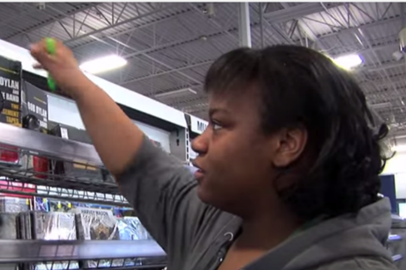
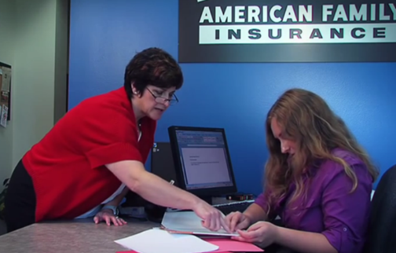
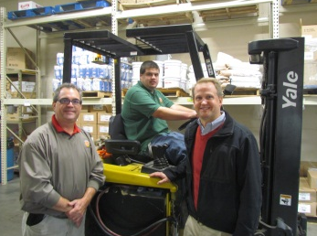

Proposals are due 5:00 p.m. on Friday, May 26, 2023.

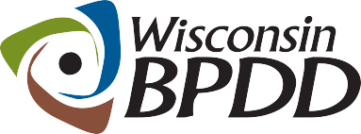
A Project of

Partners with Business Grant Timeline

Activity: | Date:
Proposals due | 5/26/23
Notice of award | 6/6/23
Contract start date | 7/1/23
End date of contract | 6/30/24

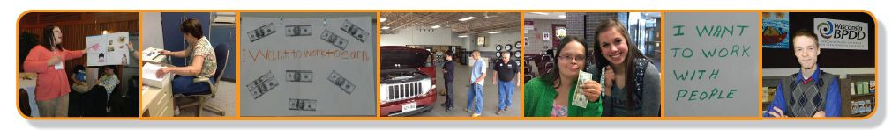
A Project of

What is a Partners with Business grant?
The Wisconsin Board for People with Developmental Disabilities (BPDD) seeks to partner with Supported Employment service providers interested in improving their approach with employers to reduce on-site job coaching services. Grant funds and technical assistance are available.

- These grant funds are provided by the State of Wisconsin (Wisconsin Act 323) through a project with the BPDD called “Partners with Business.” The goal of Partners with Business is to support businesses to tap into new talent and learn best practices for finding, hiring, and supporting workers with IDD. This helps businesses fill workforce shortages and reach diversity and inclusion goals.

- BPDD is making grant funds available to Supported Employment service providers to implement capacity building strategies within their agencies and with employers. Many Supported Employment agencies are struggling to hire job coaches. These grant funds provide an opportunity to take new or creative approaches to reduce the need for job coaching through better job matching and customization, employer engagement, systematic instruction, natural supports and paid coworker support options. These capacity building efforts can reduce waiting lists and meet the needs of job seeker with disabilities and employers.

- Awardees can receive up to $7,500 for any of the following activities to reduce on-site job coaching:
  - Provide training/mentoring for employment specialists on best practices in providing supported employment services, including but not limited to employer engagement, job development/job matching, job and task analysis, systematic instruction, developing natural supports, Assistive Technology, positive behavior supports in the workplace, and family engagement.
  - Obtain ACRE, CESP or Customized Employment certification for staff.
  - Inform and educate employers on the benefits of hiring and supporting workers with disabilities.
  - Develop business advisory committees or business-led groups that educate and mentor other businesses on hiring and supporting workers with disabilities.
  - Conduct an analysis of all your agency’s current Supported Employment job sites and implement action plans to reduce job coaching supports.
  - Implement paid co-worker supports at any number of job sites (Note: we will provide training and technical assistance on how to do this).
Focusing on job coach competencies and building natural supports with employers for us has been a large part of our answer to creating more capacity for services because we've become more effective and more efficient at what we do.
-- Kayla Countney, Goodwill of North Central Wisconsin – a Partners with Business Grantee

  - Increase the use of Assistive Technology and remote support (Note: grant funds cannot be used to buy technology devices. Funds can be used to provide assistive technology training and technical assistance to staff, staff time to learn and implement AT or remote support solutions).
  - Propose other creative strategies to reduce the need for ongoing/on-site job coach support.
- Awardees are required to demonstrate 25% reductions in on-site job coaching support. We will include this data in the Act 323 Annual Report to the Legislature. This can be accomplished by tracking overall Supported Employment program job coach data over the course of the grant period or by establishing and tracking data with a pilot group of individuals. Agencies who participated in the Partners with Business grant over the past 3 years have demonstrated, on average, a 43% reduction in the need for Medicaid funded job coaching support hours for employees with disabilities with whom they’ve implemented best practices.

- Awardees will receive technical assistance from a Partners with Business grant coach to meet their workplan goals and to increase use of natural supports on the job. Examples of technical assistance include, but are not limited to, targeted assistance to:
  - analyze current service trends and practices to identify strengths and areas of improvement.
  - provide small group or 1:1 guidance or field-based mentoring to agency staff.
  - identify resources and training options for building staff competencies.
  - provide feedback on the development of marketing, informational or training materials.

- Grant funds can be used to cover training expenses, training materials, travel costs, and staff time for training and implementation of project activities, as well as costs for employer advisory group meetings and employer events. Grant funds cannot be used to purchase vehicles, technology, nor can they be used to supplant or duplicate funding for services provided by Home and Community-Based Services (HCBS), Vocational Rehabilitation or schools.

- The project period is July 1, 2023-June 30, 2024.

What are the requirements for agencies that are awarded a grant?
- Complete a memorandum of understanding with BPDD project consultant by June 23, 2023.
- Work with BPDD project consultant to develop or refine goals and work plan.
- Receive technical assistance and support to implement your workplan.
- Track and report reductions in job coach time at targeted job sites.
- Meet every other month by phone or Zoom with BPDD staff and project consultant to share updates on activities, upcoming efforts, problem solve barriers, etc. These will serve as your grant reports.
- Partner with the BPDD project consultant to develop materials to share with others about your planning process, lessons learned, stories, and accomplishments.
- Invoice monthly or quarterly for costs that have been incurred.

Who can apply?
- Any Supported Employment service provider supporting people in Competitive Integrated Employment positions in the general business sector. This funding is not intended for social enterprises or businesses owned by employment service providers.
- If you have questions about whether your organization is eligible to apply, please contact Molly Cooney at 608-266-0266 or molly.cooney@wisconsin.gov

How do you apply?
- Submit a completed proposal and budget by e-mail to Molly Cooney at molly.cooney@wisconsin.gov by 5:00 pm on May 26, 2023.

A Project of | Partners with Business Grant Proposal

The completed proposal is due by 5:00 p.m. on May 26, 2023.

Applicant(s) Name:

Name of Supported Employment Organization:

Address:

Telephone:

Email address:

Lead contact name and email address, if different from applicant:

____________________________________________________________________________
Please answer the questions below (not to exceed 4 single-spaced pages total). If you are unsure if your organization is eligible, please contact Molly Cooney before completing the application.

- Why are you applying for funding and technical assistance? Please describe your agency’s current need and reason for applying for this grant opportunity. (justification)

- What do you want to accomplish if you receive a grant? Please describe the strategies you will implement, including a timeline. (statement of work)

- Please provide a description of your project budget, including items purchased, activities and staff time, and estimated dollar amounts.

- Why do feel your agency will be successful in carrying out your objectives and reaching your goals? How will you know you have achieved success? (feasibility)

- This grant requires agencies to track and report reductions in job coach hours. Please describe how you will track and report these reductions.

- Is your agency led by an Executive Director, CEO or Board Chair who is a person with a disability or a person of color?

If chosen for the grant, as a Partners with Business Grantee, I agree to:

 | Yes | No
1) Receive technical assistance and coaching from a WI BPDD Partners with Business project coach.

2) Track and report reductions in job coach hours because of grant funded activities.
3) Meet virtually with BPDD every other month to report progress, share lessons learned and participant experiences.

