2022 – 23
Voting Grants for WI High Schools

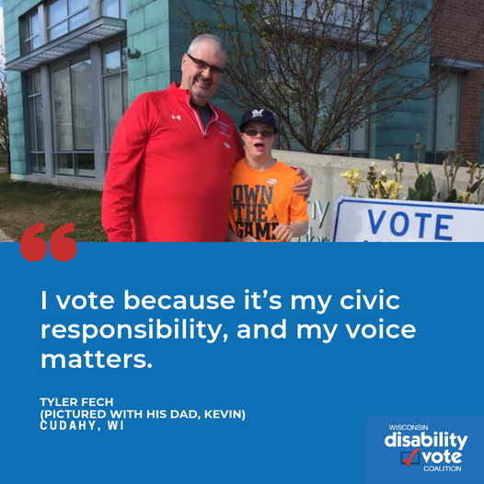
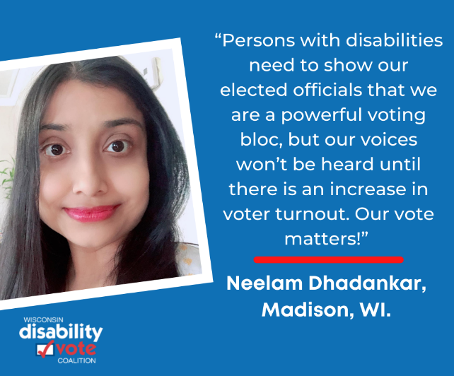
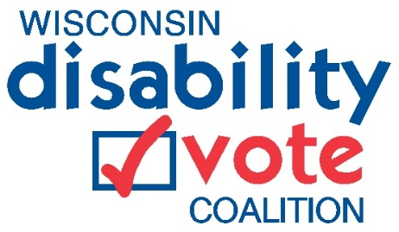
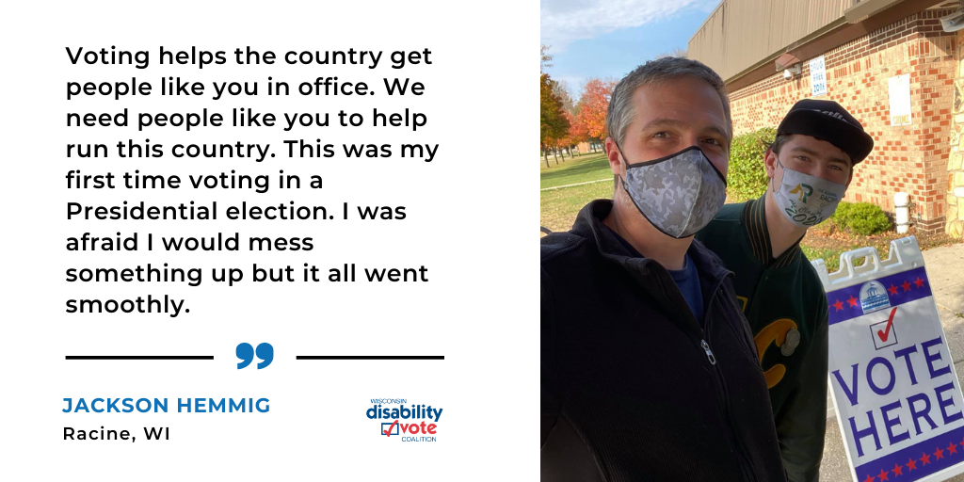

Apply by Friday, December 12, 2022

Grant Timelines

Activity: | Date:
Applications Due | December 12, 2022
Start date | January 2, 2023
End date | June 30, 2023

What is the purpose of these grants?

Students with disabilities often do not receive the same civic instruction to help them understand their voting rights and responsibilities. The purpose of these grants is to
- find creative ways that educators can inform students with (and without) disabilities to register and become active voters,
- inform students of potential barriers to voting (i.e. photo ID, transportation) so they are better prepared to handle them if they come up; and,
- empower students with an understanding of their voting rights and how to advocate for themselves when needed.

What are some examples of what I can do with this grant?

- Have a demonstration of an accessible voting machine for students with and without disabilities to try out.
- Host a registration drive at your school with student helpers.
- Work the Disability Vote Coalition materials into existing lessons.
- Update civic requirements to include disability specific information regarding voting.
- Create an outline or lesson plan(s) on the disability vote.
- Use the Wisconsin Elections Commission videos and lesson plans geared toward high school students: https://elections.wi.gov/101

What is the Disability Vote Coalition?

The Wisconsin Disability Vote Coalition (WDVC) is a non-partisan effort to help ensure full participation in the entire electoral process of voters with disabilities, including registering to vote, casting a vote, and accessing polling places.

What are the 2023 Election Dates?
February 21 (Spring Primary, if required) & April 4 (Spring Election)

What can you expect from the DVC?

You do not need to know the ins and outs of voting to be awarded a grant or spend hours doing research. The DVC will provide the resources and expertise and you provide the students and opportunity. We will be your partner throughout the grant cycle. We are looking for schools who are willing to try new ways for students with disabilities to understand the voting process, their voting rights and how to advocate for those rights.

What are you committing to?
- Identify and implement a voting project that you think would work in your school with your resources.
- Complete the project by June 30, 2023.
- Share your project outcomes and materials with the DVC so we can encourage other schools to use the information.

Who can apply?

Public, private or alternative high schools in the State of Wisconsin can apply. Students with disabilities must be the primary audience; however, project ideas the include students with and without disabilities will be given priority.

How much funding can you request?

We will offer a minimum of 4 grants that are $500 each.

How do you apply?

- Answer the following questions below and email it to jennifer.neugart@wisconsin.gov by December 12.
- If you would like to discuss a project idea, contact Jenny Neugart jennifer.neugart@wisconsin.gov or (608) 266-7707.

How will projects be chosen?
- Applications will be reviewed and scored by a review team of no less than 3 people.
- Each member will read and score each proposal independently, discuss each proposal jointly, and then submit final results for tabulation.
- The scores from each reviewer will be averaged and a final score will be assigned to the proposal. Scores will be ranked from highest to lowest scores. The highest ranked proposals will be funded. We reserve the right to discuss modifications to the proposal.

Questions? Contact jennifer.neugart@wisconsin.gov or at (608) 266-7707.

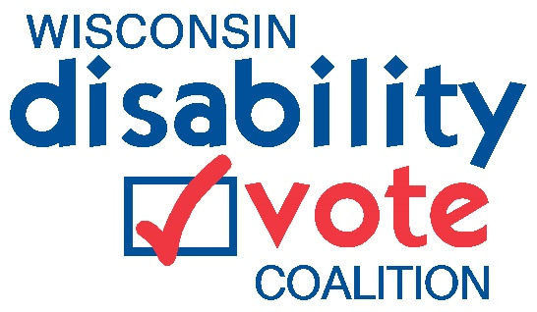 | APPLICATION  FORM

Submission Deadline: December 12, 2022

Applicant Name and School:

City:

Telephone:

Email address:

- Please tell us what you would like to do with this grant.

- How do you think your idea will lead to more students with disabilities becoming registered and active voters?

- Please list anyone else who will be part of the project other than yourself (e.g. school leadership, special education teachers, regular education teachers, parents, students with and without disabilities, etc.)

- What will you use the budget funds for? Note: The DVC can supply all voting materials including pens, bracelets, totes, stickers, and buttons. You may have other items you are interested in; however, we anticipate most of the funding will be used for staff time to coordinate and implement the project.

- How will you know that your project was successful? For example, how many new voters did you register?

