2022 – 23
SPARKS:
Building Community Connections

GRANTS
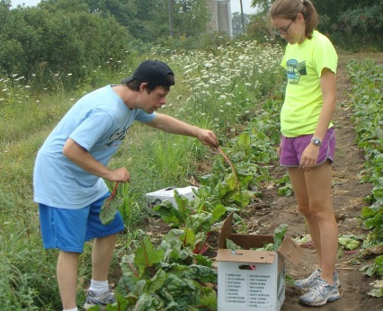
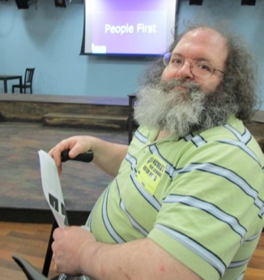
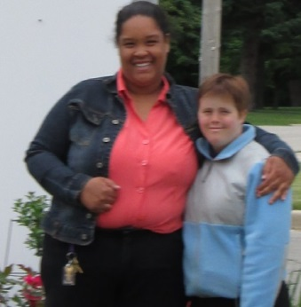
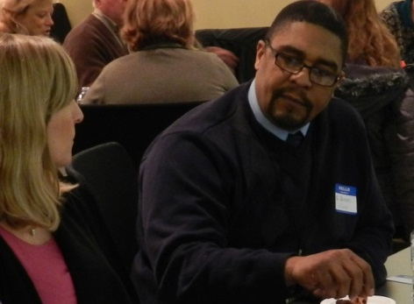
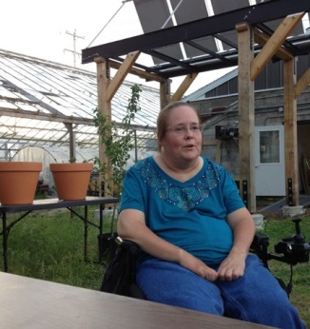

Spark a change in your community with a SPARKS Grant!

Apply by Friday, September 2, 2022

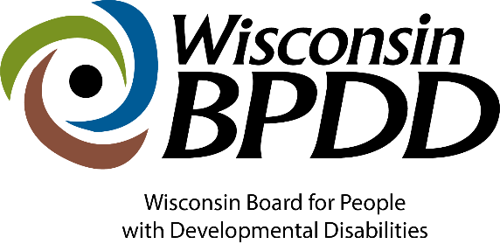

This work is supported by the Wisconsin Board for people with Developmental Disabilities, in part by grant number 2001NJSCDD-02, from the U.S. Administration for Community Living (ACL), Department of Health and Human Services (HHS), Washington, D.C. 20201 as part of a financial assistance award totaling $1,305,492 with 91% funded by ACL/HHS and 9% funded by the State of WI. Grantees undertaking projects with government sponsorship are encouraged to express freely their findings and conclusions. Points of view or opinions do not, therefore, necessarily represent official ACL policy and do not necessarily represent the official views of, nor an endorsement, by ACL/HHS, or the U.S. Government.

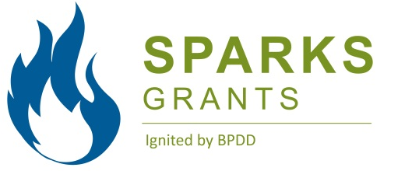 | SPARKS Grants Application Timeline

Activity: | Date:
Applications released | June 15, 2022
Applications Due | Sept. 2, 2022
Review process complete/applicants notifed no later than | Sept. 21, 2022
SPARKS Kick-off event (via Zoom)  Participation is mandatory to receive grant. | Sept. 30, 2022
Start date of contract | Oct. 1, 2022
End date of contract | Sept. 30, 2023

Questions? Contact Jenny Neugart at jennifer.neugart@wisconsin.gov or at (608) 266-7707.

*Diverse Identities refers to people of various races, cultural and ethnic heritages, genders, gender identities, gender expressions, sexual orientations, ages, and religions from diverse socio-economic and geographic backgrounds
The term “unserved and underserved” includes populations such as individuals from racial and ethnic minority backgrounds, disadvantaged individuals, individuals with limited English proficiency, individuals from underserved geographic areas (rural or urban), and specific groups of individuals within the population of individuals with developmental disabilities, including individuals who require assistive technology in order to participate in and contribute to community life.

What are the Sparks Building Connections Grants?

The purpose of these grants are to:
- Provide people with disabilities more social connections by participating in inclusive, meaningful community activities.
- Help individuals and organizations understand how to offer and implement more inclusive programming.
- Encourage community members to get to know someone with a disability and improve overall attitudes about people with disabilities.
In writing your grant application, consider the following inclusion model…
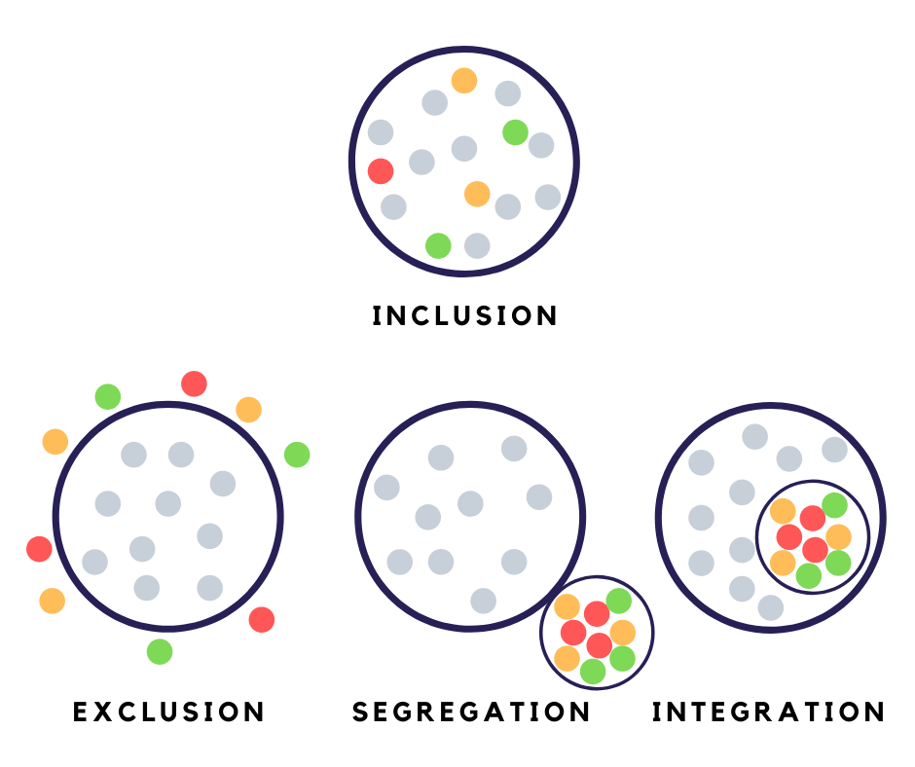

Examples of what you can do with the grant.
- Make school extracurriculars accessible to students with disabilities and be intentional about inviting them to participate.
- Host a community conversation to talk about ways to meaningfully include people with disabilities in community programs and then work on an idea or two over the next year.
- Implement innovative ways to make families with children with disabilities feel welcome in their faith community.
- Create inclusive recreation programs instead of separate, adaptive programs for people with disabilities.

What can you expect from BPDD?

Grant recipient will receive ongoing coaching/technical assistance to help you get started on your project as well as throughout your project. You will also have opportunities to share your project ideas and resources with other grant recipients from around the state.

What are you committing to?
- Attend the mandatory Virtual Kickoff on September 30, 2022 via Zoom. This event will focus on:
  - strategies for projects to be successful
  - sharing ideas with other projects
  - reviewing grant expectations
  - confirming contracts
- Start the project no earlier than October 1, 2022 and complete the work plan by September 30, 2023.
- Provide quarterly updates throughout the year.
- Submit monthly or quarterly requests for reimbursements, along with required receipts for all expenses.

- Share information on the project, including any public events that are planned and photos that can be used in BPDD social media.

- Conduct targeted outreach with people of diverse identities and/or individuals who are underserved.

Who can apply?
An ideal grantee would be any individual or group who wants to be more inclusive of people with disabilities but are not sure how to do it. Traditionally underserved groups are especially encouraged to apply. Examples include:
- Faith-based, civic and nonprofit groups
- School districts
- Municipalities or local governments such as community recreation programs
- Family groups
- Individuals or groups with strong connections to their community

How much funding can you request?

A minimum of 4 grants will be awarded in the range of $500 - $5,000. A detailed budget must accompany all grant proposals (a budget template is included in the application packet).

How do you apply?
- Complete and submit the Building Connections application packet (application, budget, and work plan). If you need assistance or writing is difficult, contact Jenny Neugart at jennifer.neugart@wisconsin.gov or (608) 266-7707 to set up a phone interview.
- Application materials are due by 12:00 p.m. on September 2, 2022.
- Application materials can be submitted via email (preferred) or regular mail.
  - To submit via email, please send to jennifer.neugart@wisconsin.gov
  - To submit via regular mail, please send to:
Sparks Grants
c/o WI-BPDD
101 East Wilson St, Rm 219
Madison, WI 53703

How will projects be chosen?
- Applications will be reviewed and scored by a review team of no less than 3 people.
- Proposals that target individuals with I/DD who have diverse identities and/or individuals who are underserved will be given priority.
- Each member will read and score each proposal independently, discuss each proposal jointly, and then submit final results for tabulation.
- The scores from each reviewer will be averaged and a final score will be assigned to the proposal. Scores will be ranked from highest to lowest scores. The highest ranked proposals will be funded. We reserve the right to discuss modifications to the proposal.

Glossary of Terms for Project Work Plan

Goal: A goal states the best possible outcome for people. Goals are simple, clear and optimistic – e.g., More people with disabilities will participate in park and rec programs in their community.

Objective: Objectives are steps needed to reach the goal. They describe a concrete change in people’s actions or condition. Objectives are concrete, measurable, optimistic, but realistic – e.g., The number of people with disabilities participating in park and rec programs will double by the end of the grant.

Outcome: Results of an activity, plan process or program, accomplishment/impact – e.g., Increase the number of people with disabilities participating in park and rec programming.

Project Work Plan: A project work plan defines the tasks you need to complete in order to fulfill the requirements/deliverables of the project. The written plan includes: project purpose, goals, objectives, specific activities, outcomes, deliverable and target dates.
APPLICATION
FORM

Application materials (application form, budget, and work plan) are due by 12:00 p.m. on September 2, 2022.

Lead Applicant Name and/or Organization:

Address:

Telephone:

Email address:

- Please describe your project idea in 8 to 10 sentences. What will you actually do?

- How will this project make your community more inclusive?

- Successful projects will build on community strengths to address community problems. What strengths does your community have that you will build on (e.g. active community engagement, strong partners already in place, support from local elected officials, etc.)?

- Please list the people, agencies, organizations, etc. that will work on this project with you.

- Successful projects include team members with disabilities who provide guidance and perspective through their lived experience. How will your project team meaningfully include people with disabilities from the planning stage through implementation?

- How will your project work with people who have diverse identities and/or individuals who are underserved.

- How will you know that your project was successful?

- How will you continue these activities without project funding next year?

BUDGET
WORKSHEET

BPDD has allocated a total of $20,000 funds for the SPARKS grants. Funding for individual grants ranges between $500 - $5,000. A detailed budget must accompany all applications.

Funding cannot be used for vehicles, technology equipment, to pay for things an agency/organization is already charged with providing or staff time already being paid by an agency/organization.

SAMPLE BUDGET
ITEM (be as specific as possible) | COST
Meeting supplies (wall board, markers, post-it notes, copies) | $300.00
Materials for rec program (i.e. sensory items) | $500.00
Refreshments ($100 x 6 meetings) | $600.00
Staff time (5 hrs/wk for 25 weeks @ $18/hr) | $2,250.00
Event t-shirts 100 @ $5/ea. (rest of the shirts were donated) | $500.00
TOTAL | $4,150.00
In-kind contributions
Volunteers at 2 events (10 people for 4 hours x 2 events) | 80 hours
Event t-shirts (donated from ABC org.) 50 shirts x $5.00 each | $250.00

YOUR PROJECT’S BUDGET
ITEM (be as specific as possible) | COST
TOTAL
In-kind contributions

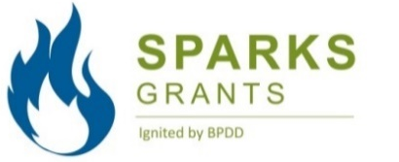 | PROJECT  WORK PLAN
Primary Project Contact Person:  Project Title: |  | Contact Info (address, phone number, email):
Project Goal(s):

Work Plan
Project Objectives/Activities:  (What will you do?) | Outcomes:  (What will you achieve?) |  | Deliverables/Products:  (What will you develop/create?) | Target Date:  (When will it be done?)
EXAMPLE: Create an inclusive soccer program for kids ages 3 to 5 years old. | EXAMPLE: 5 youth with disabilities will play soccer with their nondisabled peers in the community. |  | EXAMPLE: Tip sheet or guide on how to include people with disabilities in existing rec programs. | EXAMPLE: 7/1/23

