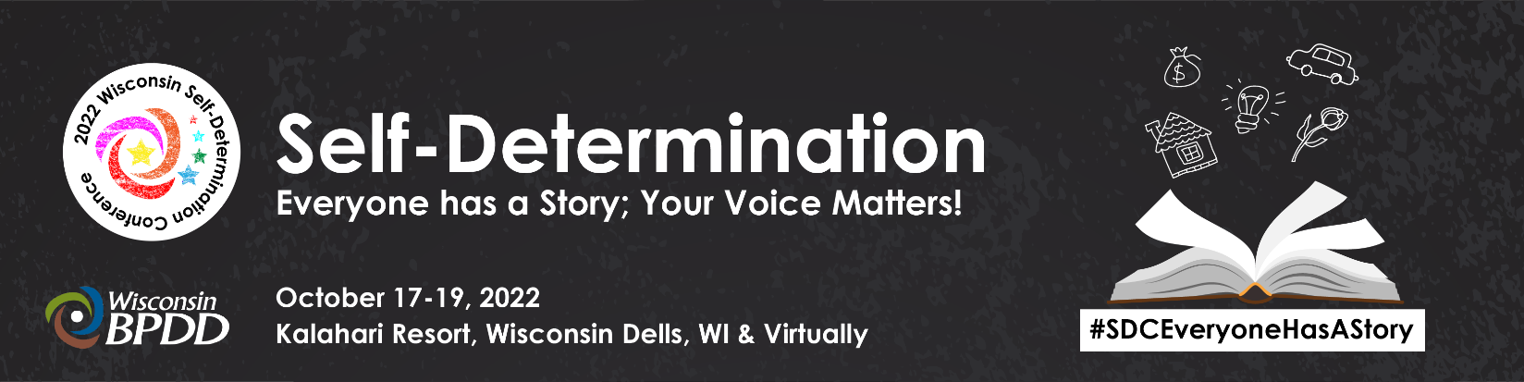

DIEHARD AWARD NOMINATION FORM

Entry Deadline: 12 pm Noon, August 15, 2022

GENERAL INFORMATION:

Please Check one:
PROFESSIONAL ADVOCATE
SELF-ADVOCATE/GRASSROOTS ADVOCATE

Nominee’s Name: Click here to enter text.

Nominee's Address: Click here to enter text.
Nominee's Phone Number: Click here to enter text. Email: Click here to enter text.
Role/Job Title: Click here to enter text. Years of Service: Click here to enter text.

Nominator’s Name: Click here to enter text.

Nominator's Address: Click here to enter text.
Nominator's Phone Number: Click here to enter text. Email: Click here to enter text.
Affiliation to Nominee: Click here to enter text.

NOMINATION NARRATIVE:

Nominees must demonstrate some or all of these characteristics:
- Excellence in advocacy toward Self-Determination and Self-Direction principles, activities, and outcomes.
- Excellence in leadership on systems change in areas of community living, employment, housing, healthcare, education, and technology that enhance the lives of individuals with disabilities and their families throughout Wisconsin.

- Sets a high standard of excellence that promotes values of independence, productivity, inclusion, and self-determination for people with disabilities and their families.
- Commitment to growing Self-Advocacy in Wisconsin.
- Commitment to ensuring people in unserved or underserved communities from diverse cultural and economic backgrounds have a voice.

Nomination Narrative Questions
Please answer all questions. Narrative cannot be longer than 2 pages (including questions).

- Tell us how the nominee has demonstrated leadership, creativity, and expertise that have benefited others and/or their community. Describe his/her accomplishments and commitment to advocacy. Click here to enter text.

- Tell us why the nominee is a positive role model for others. Click here to enter text.
- Share one story or example that demonstrates why this person is a Diehard Click here to enter text.

Signature: __________________________________________ Date: ______________________

Submit your completed form no later than noon on August 15, 2022 to:
Mail: BPDD/Awards, 101 E. Wilson St., Room 219 ** Madison, WI 53703
Fax: 608-267-3906 ** Email: fil.clissa@wisconsin.gov

