Partners with Business
--
Grant Proposal for Businesses

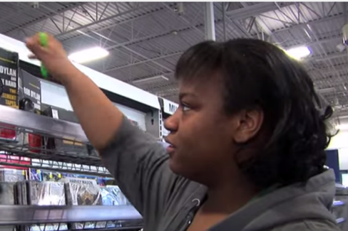
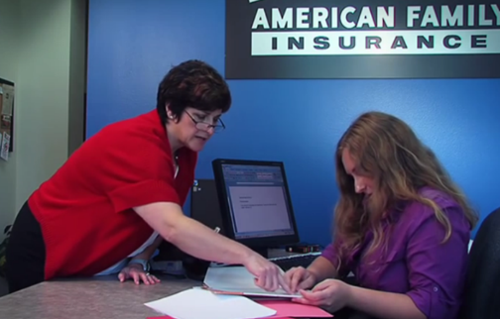
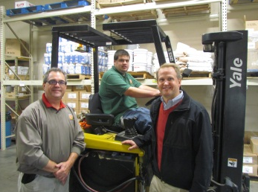

Proposals are due by 5:00 p.m. on June 17, 2022.

A Project of

Partners with Business Grant Timeline

Activity: | Date:
Proposals due | 6/17/22
Notice of award | 6/24/22
Contract start date | 7/01/22
End date of contract | 6/30/23

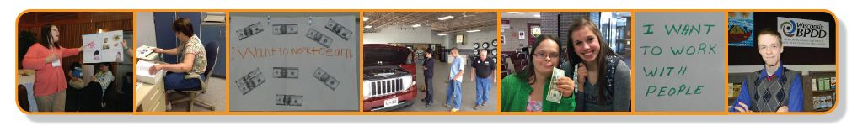
A Project of

What is a Partners with Business grant?
The Wisconsin Board for People with Developmental Disabilities (WI BPDD) seeks to partner with businesses interested in hiring more people with intellectual and developmental disabilities (IDD).

- Grant funds are available for WI-based businesses to launch hiring initiatives to employ and support workers with IDD. WI BPDD is seeking to award up to $25,000 to a WI-based business for July 1, 2022, through June 30, 2023, with the possibility of a second year of grant funding from July 1, 2023, through June 30, 2024.

- These grant funds are provided by the State of Wisconsin (Wisconsin Act 323) through a project with the WI-BPDD called "Partners with Business.” The goal of the Partners with Business project is to support businesses to tap into new talent and learn best practices for finding, hiring, and supporting workers with IDD. This helps employers fill workforce shortages and reach diversity and inclusion goals.

- Grantees receive technical assistance and training from a WI BPDD project consultant to plan and implement their hiring initiative. The BPDD project consultant uses a variety of tools to support participating businesses, including Disability:IN Wisconsin’s Guide to Creating Internal Supports in the Workplace. Technical assistance can include but is not limited to:
  - strategic planning to set overall goals and develop a plan for hiring people with IDD;
  - conducting a workforce needs analysis;
  - disability awareness training;
  - finding talent by building external partnerships; and
  - developing internal infrastructure to provide workplace supports to people with IDD, including natural supports and paid coworker support models.

What are the requirements for grantees?
- Complete and submit the grant proposal by June 17, 2022.
- Complete a contract agreement and vendor paperwork with WI BPDD by June 30, 2022.
- Work with BPDD project consultant to develop overall goals and 1 to 2-year work plan to hire 5-10 workers with IDD.
- Receive technical assistance and support to implement your workplan.
- Meet quarterly by phone or Zoom with WI BPDD staff and project consultant to share updates on activities, upcoming efforts, problem solve barriers, etc. These quarterly calls will serve as your quarterly grant reports.
- Partner with the BPDD project consultant to develop materials to share with other employers about your planning process, lessons learned, and accomplishments. This may include one or two presentations with the BPDD project consultant at employer-focused events (virtual or in-person).
- Invoice monthly or quarterly for costs that have been incurred.

Who can apply?
- A Wisconsin-based, private sector business committed to hiring and supporting workers with intellectual and developmental disabilities.
- This funding is not intended for internships.
- This funding is not intended for vocational service agencies.

How do you apply?
- Submit a completed proposal and budget by e-mail to Molly Cooney at molly.cooney@wisconsin.gov by 5:00 pm on June 17, 2022.

A Project of | Partners with Business Hiring Initiative Proposal

The completed proposal is due by 5:00 p.m. on June 17, 2022.

Applicant(s) Name:

Name of Business:

Address:

Telephone:

Email address:

Lead contact name and email address, if different from applicant:

- Why is your business interested in the Partners with Business grant funding and technical assistance?

- Does your business have experience hiring and supporting employees with disabilities? If so, please share a little about your experience and what types of positions the employees held.

- How will your business use the funds to launch or grow your hiring initiative or related efforts?

- Please describe your company’s current level of commitment to hiring and supporting employees with intellectual and developmental disabilities. (i.e. Are there executive level champions for these efforts?; Has your company articulated and communicated the business case for hiring employees with disabilities?; Is disability part of your company’s Diversity, Equity and Inclusion efforts?)
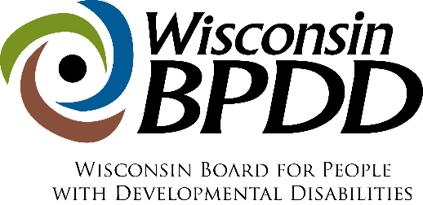
BUDGET
WORKSHEET

Grant funds can be used in many ways, such as covering staff time spent working on the hiring initiative; training or professional development around disability awareness or other related topics; costs associated with materials or refreshments needed for trainings or events; etc.

Funds cannot be used for vehicles or technology (like computers or phones or other equipment). Funds cannot pay for services or supports an agency/organization is already charged with providing like direct services to people with disabilities. Funds cannot be used to pay the wages of an employee with a disability.

If you have questions about using grant funds, please call Molly Cooney at 608-266-0266.

SAMPLE BUDGET
ITEM (be as specific as possible) | COST
Staff fees (15 hours/week for 48 weeks @ $25/hour = $18,000) | $18,000
Disability awareness training – trainer fees | $1,000
Meeting space rental for 2 educational events ($125 per event x 2 events = $250) | $250
Refreshments for 2 events ($100 x 2 events = $200) | $200
Materials (poster board, markers, post-it notes, copies) | $200
Total | $19,650

YOUR PROJECT’S BUDGET
ITEM (be as specific as possible) | COST
TOTAL

PROJECT
WORK PLAN
Name:  Organization Name: |  | Contact Info (address, phone number, email):
Work Plan
Project Objectives/Activities:  (What will you do?) | Outcomes:  (What will you achieve?) |  | Deliverables/Results:  (What will you develop/create?) | Target Date:  (When will it be done?)
EXAMPLE: Identify leadership team and department champions | EXAMPLE: People who will help champion and guide the hiring initiative are identified and invested in the effort |  | EXAMPLE:  List of leadership team  Meeting agenda and notes | EXAMPLE: 8/1/2022
1.
2.
3.
4.
5.
6.

Natural support refers to the support that is typically provided by supervisors and coworkers in the workplace, including supervision and guidance from a supervisor or support that coworkers and teams typically provide to one another. These same types of supports should be provided to workers with IDD. If a worker with IDD needs more support on the job than a supervisor or coworker would typically provide, paid coworker supports within the business could be an option. In a paid coworker support model, one or more coworkers would be identified to provide enhanced support to the worker with IDD. In exchange, the business is provided funding from the Division of Vocational Rehabilitation or long-term care to provide this support. Paid coworker supports are less obtrusive and more cost-effective than relying on outside job coach agencies. Grantees will be provided technical assistance to develop natural support and paid coworker support options for workers with IDD.

