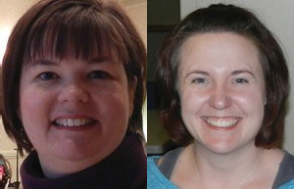
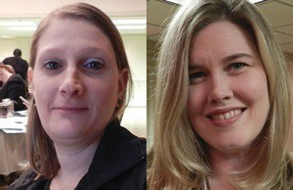
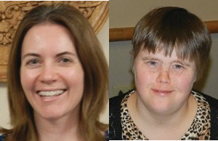
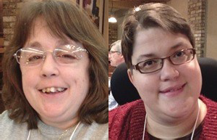
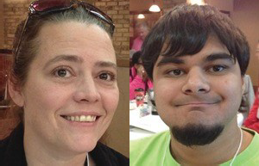
2021-2022 Wisconsin Partners in Policymaking
Application Packet

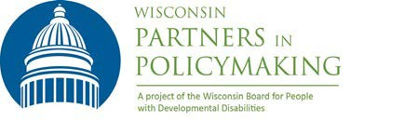
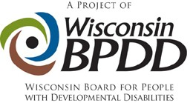

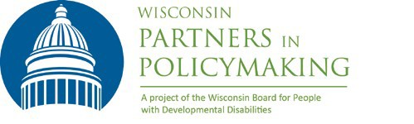

Become A Leader in Changing State Policies and Practices!
Applications due October 1, 2021 by noon

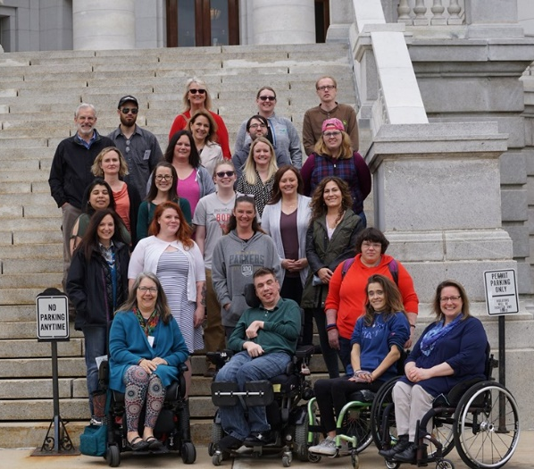
Wisconsin Partners in Policymaking is a six‐session advocacy and systems change training program that develops future leaders across the state who are able to work with legislators and communities on policies and initiatives that will support the full participation and inclusion of people with developmental disabilities in all aspects of life.

Become part of a nationwide network of nearly 27,000 graduates who are community leaders and decision‐ makers serving on policymaking committees, commissions, and boards at all levels.

Who can apply?
Individuals who are highly motivated to create more inclusive communities AND are:
- Parents or primary caregivers of children under the age of 21 who have developmental disabilities
- Adults with developmental disabilities
- Adult siblings or family members of individuals with developmental disabilities
We are seeking cultural and geographic diversity within the guidelines above. The selection of participants is made by a team of parents, self‐advocates, and professionals.

What are some of the topics covered in Partners?
“Partners educated me regarding issues affecting people with disabilities and how I can have an impact on public policy.”
- Partners Graduate
- History of the disability rights movement
- Self‐determination and self‐advocacy
- Disability policy and systems change
- Community engagement and grassroots advocacy
- School inclusion, integrated employment, community supported living.

What is expected of participants?

- Participate in all two‐day sessions and complete all homework assignments. Attendance at all sessions is required, from Friday at 12:30 p.m. to Saturday at 3 p.m. Partners will continue to offer the training virtually. Only individuals selected to participate in the program will be able to attend (with supports as needed). Aside from attendant care, additional family members and friends cannot attend sessions or stay at the hotel with participants.

Dates for the Class of 2021/2022 are:

- October 29 & 30, 2021
- December 3 & 4, 2021
- January 14 & 15, 2022
- February 25 & 26, 2022
- April 8 & 9, 2022
- May 6 & 7, 2022

- Participate in networking, advocacy activities, interviews, readings (some available in alternative formats), and other projects.

- Commit to developing a relationship with your state legislators.

- Arrange for any 1 on 1 support needed to participate, including arranging any training needed for caregivers to meet your support needs. Remember: support people are not Partners participants and should limit their role during the program to the direct supports of participants.

What is the cost?
Partners is funded by BPDD, which covers all costs associated with the training including, lodging, meals, and materials.

“I joined the Down Syndrome Society Board! I plan to join some special education parent advocacy groups in my school district too.”
- Partners Graduate

Core Values
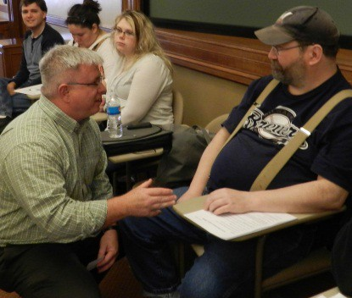
Participants agree to support core values laid out in the federal Developmental Disabilities Act. Please affirm that you support each value before applying for Partners.
- Disability is a natural part of the human experience and does not diminish people’s rights to live independently, exercise control over their lives and fully participate in and contribute to their communities.
- People with disabilities are people first and must be treated with dignity and respect. This includes the right to be free of abuse and neglect.
- People with disabilities are entitled to the right to free speech. The ability to communicate, with assistance as needed, must be available to everyone.
- People with disabilities have the right to advocate for themselves on every level of the system, from individual services to the state budget to federal laws that affect their lives.
- Self‐determination is essential to full citizenship. People with disabilities must have the freedom to make informed decisions about how they want to live their lives and receive supports.
- People with disabilities must be able to enjoy the full mobility and accessibility that enables active participation in community life.
- People with disabilities need real friendships with a variety of friends, not just paid service workers.
- Schools and communities are stronger when they are inclusive.
- Every person with a disability deserves the right to work in the community at competitive wages, with benefits and the supports necessary to be successful.

For more information or get help completing your application:
Contact Jenny Neugart at jennifer.neugart@wisconsin.gov or (608) 266‐7707.

Apply by noon on October 1, 2021.

APPLICATION
FORM

Name:
Address:
City/State/Zip:
E-mail:
Primary Phone:
Alternate Phone:

Female Male Non-Binary

I am a parent/caregiver/sibling of a child with a disability. (If you have more than one family member with a disability please answer for each child.)
Son/daughter ages:
Does your child live at home? Yes No

I have a developmental disability.

Please answer the following questions. Feel free to attach additional sheets of paper if necessary.
- Please tell us a little about yourself and your family.

- Why do you want to participate in Partners in Policymaking?

- What would you most like to change that would improve the lives of children and adults with disabilities?

- Please describe your experience in advocating for yourself, your child, or others with developmental disabilities?

- What advocacy or disability related organizations do you participate in? What is your role?

- What kind of work/school are you involved in? (Include volunteer and leadership positions, not just paid work.)

- How do you hope to use your new information and skills after completing this training program?

- Looking at the Core Values, which are the most important to you and why?

- Please provide a reference who can speak about your experience as a disability advocate.
Name:
City:
Phone: Email:

- If you were referred by a Partners in Policymaking graduate, please provide their name.

- I will attend In person Virtually

If selected to participate in Wisconsin Partners in Policymaking, please check that you are committing to:
    - Attend ALL sessions. Please make sure the dates work for you before you apply.
    - Complete all homework assignments, including networking, activities and readings.
    - Make arrangements with my employer and family, as needed, to fully participate.
    - Commit to building a relationship with your state legislators.
    - Support the Core Values of the DD Act as outlined in this application packet.
    - Be prepared to invest time and energy into advocacy between each session.

Signature: Date: _________________

Materials must be submitted by noon on Friday, October 1, 2021.
Applicants will be notified of their selection by October 6, 2021.

If you have questions, please contact Jenny Neugart at jennifer.neugart@wisconsin.gov or (608) 266‐7707.

Submit your application materials in one of 3 ways:
- Email (preferred) to jennifer.neugart@wisconsin.gov
- Fax to (608) 267‐3906.
- Ground mail to:
Wisconsin Partners in Policymaking c/o WI‐BPDD
101 East Wilson St., Room 219 Madison, WI 53703

