Want to Sponsor Wisconsin’s Self-Determination Conference?
October 18-20, 2021 In Person and Virtual!

The Self-Determination Conference is one of Wisconsin’s biggest events for people with disabilities and the people who support them. Last year over 1300 people attended the conference virtually! Your support will help us provide even more opportunities for self-advocates, to attend the conference!
Your support will help provide scholarships, interpreter and translation services, conference kits to all attendees (mailed), support local watch parties, technology and a high quality in-person and virtual experience. Please help us continue to empower Self-Advocacy and Self-Direction in Wisconsin.
Sponsorship Levels
Blossom: Seeing the full  potential of Self-Direction  and want to advance Self-  Determination. | $20,000  and  above | Includes exhibitor booth, full page ad/recognition in the conference program and option to include stuffers in the conference packets.
Sunshine: Shining a light  on Self-Determination. Let’s  keep shining! | $10,000 | Includes exhibitor booth, and a half page ad/recognition in the conference program.
Roots: you know what it  takes to make our  communities stronger. | $5,000 | Includes quarter page ad/recognition in the conference program.
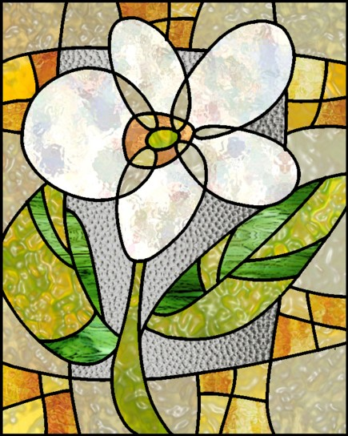  Seedlings: Sprouting more  Self-Determined. | $2,000 | Includes business card size ad/recognition in the conference program.
Watch Party: support local watch parties to enhance the conference experience in local communities. | $1,000 | Includes recognition in the conference program.
If you would like to sponsor or host an activity or event at the Conference, please contact us.

To sponsor the Self-Determination Conference,
or if you have questions about sponsorship,
contact Fil Clissa at fil.clissa@wisconsin.gov.
Door prizes and Conference Kit items will also be accepted.

Sponsorship Application
First Name: Click or tap here to enter text. |  | Last Name: Click or tap here to enter text.
Organization: Click or tap here to enter text.
Address: Click or tap here to enter text.
City: Click or tap here to enter text. | State: Click or tap here to enter text. |  |  | ZIP Code: Click or tap here to enter text.
Email: Click or tap here to enter text. |  |  | Phone #: Click or tap here to enter text.
☐ Please attach your organization’s mission, vision, and value statement

Contribution Amount: | $ Click or tap here to enter text.
Ad sizes:
½ Page: 5” x 7” Horizonal
¼ Page: 5” x 3.5” Can be vertical or horizontal
Business card: 2” x 3.75” Can be vertical or horizontal

NOTE:
- Ads must be submitted by August 1, 2021 to be in the program. Late submission cannot be guaranteed.
- Spanish translation versions are also required.

For Questions, payment information, or to submit the Sponsorship form contact:
Fil Clissa at WI-BPDD, by email: fil.clissa@wisconsin.gov

