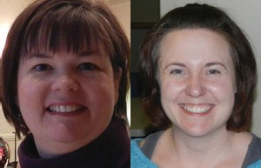
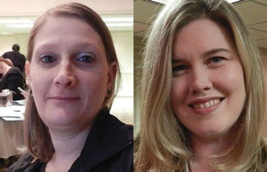
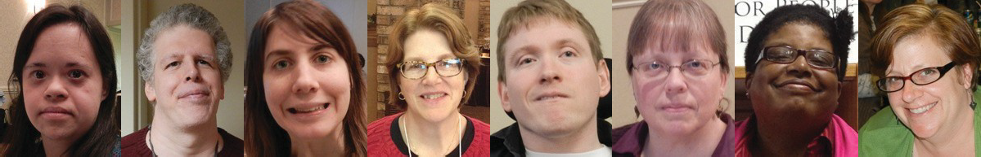
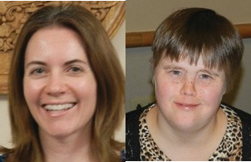
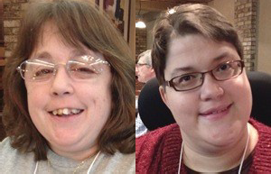
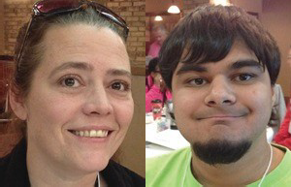
\
2020-2021 Wisconsin Partners in Policymaking
Application Packet

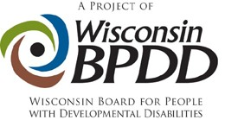

We are offering the 2020-2021 Partners in Policymaking class virtually! If either transportation or coming to Madison overnight six times a year have been barriers to you participating, this is the year for you!

Applications are due by noon on September 11, 2020

Wisconsin Partners in Policymaking is an advocacy and systems change training program designed to develop a group of future leaders across the state who are able to work with legislators and communities on policies and initiatives that will support the full participation and inclusion of people with developmental disabilities in all aspects of life.

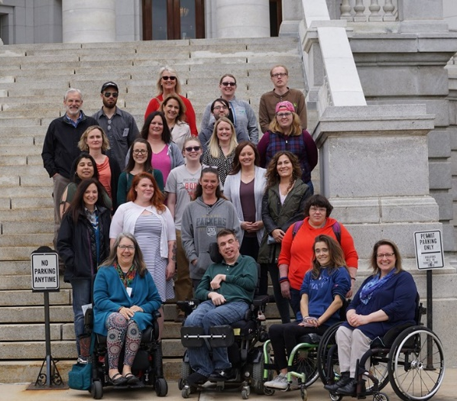
Partners is an initiative of the Wisconsin Board for People with Developmental Disabilities (BPDD). Nationwide, nearly 27,000 graduates are part of a growing network of community leaders and decision‐ makers serving on policymaking committees, commissions, and boards at local, state, and national levels.

For more information:
If you have questions or would like more information about the Partners in Policymaking program, please contact Jenny Neugart at jennifer.neugart@wisconsin.gov or (608) 266‐7707.

Who can participate?
Individuals who are highly motivated to create more inclusive communities AND are:

Adults with developmental disabilities

Adult siblings of individuals with developmental disabilities

Parents/primary caregivers of children and youth with developmental disabilities ages birth to 21.

We are seeking cultural and geographic diversity within the guidelines above. The selection of participants is made by a team of parents, self-advocates and professionals.

What is expected of participants?
- Attend all sessions as outlined below and complete all homework assignments. Attendance at all sessions is required. Only individuals selected to participate in the program will be able to attend (with supports as needed). Aside from attendant care, additional family members and friends do not attend the in-person sessions in March and May.
Dates/times for the 2020-21 sessions are:
Friday, Oct 2, 2020 12:30 – 4:30 pm  Saturday, Oct 24, 2020 8:30 – 12:30 pm  Friday, Nov 13, 2020 12:30 – 4:30 pm  Saturday, Dec 12, 2020 8:30 – 12:30 pm  Friday, Jan 8, 2021 12:30 – 4:30 pm | Saturday, Jan 30, 2021 8:30 – 12:30 pm  Friday, Feb 26, 2021 12:30 – 4:30 pm  Friday, Mar 19, 2021 IN MADISON 10 – 4 pm  Saturday, April 17, 2021 8:30 – 12:30 pm  Friday, May 14, 2021 IN MADISON 10 – 4 pm
All sessions will be done via Zoom except for March 19 and May 14. If it is safe to do so, these sessions will take place in Madison, WI. A hotel room will be provided for those traveling from a distance.

- Participate in networking, advocacy activities, interviews, readings (some available in alternative formats), and other projects.
- Develop and implement a project that results in systems change that will improve the lives of people with disabilities and their families.
- It is your responsibility to arrange for any 1-on-1 support needed to participate, including arranging any training needed for caregivers to meet your support needs. Remember: support people are not Partners participants and should limit their role during the program to the direct supports of participants.

What is the cost?
Partners is funded by BPDD, which covers all costs associated with the training including, lodging and meals for in person meetings and materials.

What are some of the topics covered in Partners?
- History of the disability rights movement
- Self‐determination, self‐advocacy, and person‐centered planning
- Disability policy and systems change
- Community engagement, organizing, and grassroots advocacy
- School inclusion, integrated employment, community supported living
- The legislative process and legislative advocacy

Core Values
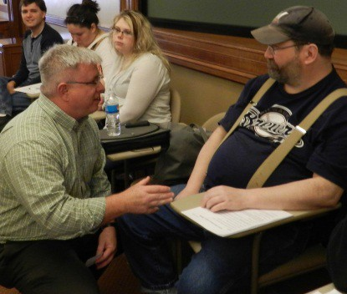
Participants agree to support core values laid out in the federal Developmental Disabilities Act. Please affirm that you fully support each value before applying for Partners.

- Disability is a natural part of the human experience and does not diminish people’s rights to live independently, exercise control over their lives and fully participate in and contribute to their communities.
- People with disabilities are people first and must be treated with dignity and respect. This includes the right to be free of abuse and neglect.
- People with disabilities are entitled to the right to free speech. The ability to communicate, with assistance as needed, must be available to everyone.
- People with disabilities have the right to advocate for themselves on every level of the system, from individual services to the state budget to federal laws that affect their lives.
- Self‐determination is essential to full citizenship. People with disabilities must have the freedom to make informed decisions about how they want to live their lives and receive supports.
- People with disabilities must be able to enjoy the full mobility and accessibility that enables active participation in community life.
- People with disabilities need real friendships with a variety of friends, not just paid service workers.
- Schools and communities are stronger when they are inclusive.
- Every person with a disability deserves the right to work in the community at competitive wages, with benefits and the supports necessary to be successful.

“It has been such a wonderful and empowering experience... it absolutely changed my life.”
- Partners Graduate

APPLICATION
FORM

Name:
Address:
City/State/Zip:
State:
Zip:
E-mail:
Home Phone: |  | Cell Phone:
Check one: Female _____ Male _____ Non-binary _____

Prefer to self-describe __________________________________________________________________________
I am a parent/caregiver/sibling of a child with a disability. (If you have more than one family member with a disability please answer for each child.)
Son/daughter ages:
Does your child live at home? Yes No

I have a developmental disability.

Please answer the following questions. Feel free to attach additional sheets of paper if necessary.

  - Please tell us a little about yourself and your family.

  - Why do you want to participate in Partners in Policymaking?

  - What would you most like to change that would improve the lives of children and adults with disabilities in Wisconsin?

  - How could participating in Partners in Policymaking help you achieve the goal you described above?

  - Please describe your experience in advocating for yourself, your child, or others with developmental disabilities?

  - What advocacy or disability related organizations do you participate in? What is your role?

  - What kind of work/school are you involved in? (Include volunteer and other leadership positions, etc., not just paid work)

  - How do you hope to use your new information and skills after completing this training program?

  - Looking at the Core Values, which are the most important to you and why?

  - Please provide a reference of someone who can speak about your experience as a disability advocate.

Name: City: Phone: E‐mail:

  - Were you referred by a graduate of a previous Partners in Policymaking class? If so, who referred you?

  - Please provide your preferred newspaper ______________________________________________,

Radio station____________________________ and TV station______________________________

If selected to participate in Wisconsin Partners in Policymaking, I am committing to:
(please check all)
    - Attend ALL session dates listed on page 3.
    - Complete all homework assignments, including networking, activities, and limited readings.
    - Make arrangements with my employer and family, as needed to fully participate. For example, even though most sessions are done via Zoom, it’s important for arrangements to be made for children so your full attention will be on the session.
    - Support the Core Values of the DD Act as outlined on page 4 of this application.
    - Be prepared to invest time and energy into advocacy between each session.

To ensure you will be able to fully participate in the virtual programming, please check all responses below that apply to you. If you indicate you need help or do not currently have access to technology, we will work with you to remove barriers.
- I have access to a computer or tablet that will allow me to participate in online training.
- I have a reliable internet connection that will allow me to participate in online training.
- I will need help finding a computer or tablet to participate in online training.
- I will need help getting a reliable internet connection to participate in online training.
- I do not have access to reliable internet where I live.
- I have used Zoom before and had no problems logging in.
- I have never used Zoom before and would need to test it out to see if it would work for me.
- I have used Zoom but, may need help logging on and using its features.

Signature: Date: _________________

Materials must be submitted by September 11, 2020.

Application materials can be submitted via email (preferred) or regular mail. Applicants will be notified of their selection by October 21, 2020.

If you have questions or need help completing your application, please contact Jenny Neugart at jennifer.neugart@wisconsin.gov or (608) 266‐7707.
- To submit via email, email your application materials to jennifer.neugart@wisconsin.gov lea
- To submit via regular mail, mail your application materials to:
WI Board for People with Developmental Disabilities (or WI-BPDD)
101 E. Wilson St, Room 219
Madison, WI 53703

