2020 WI Youth

Leadership Forum
July 19 – 24, 2020
Edgewood College Campus, Madison, WI

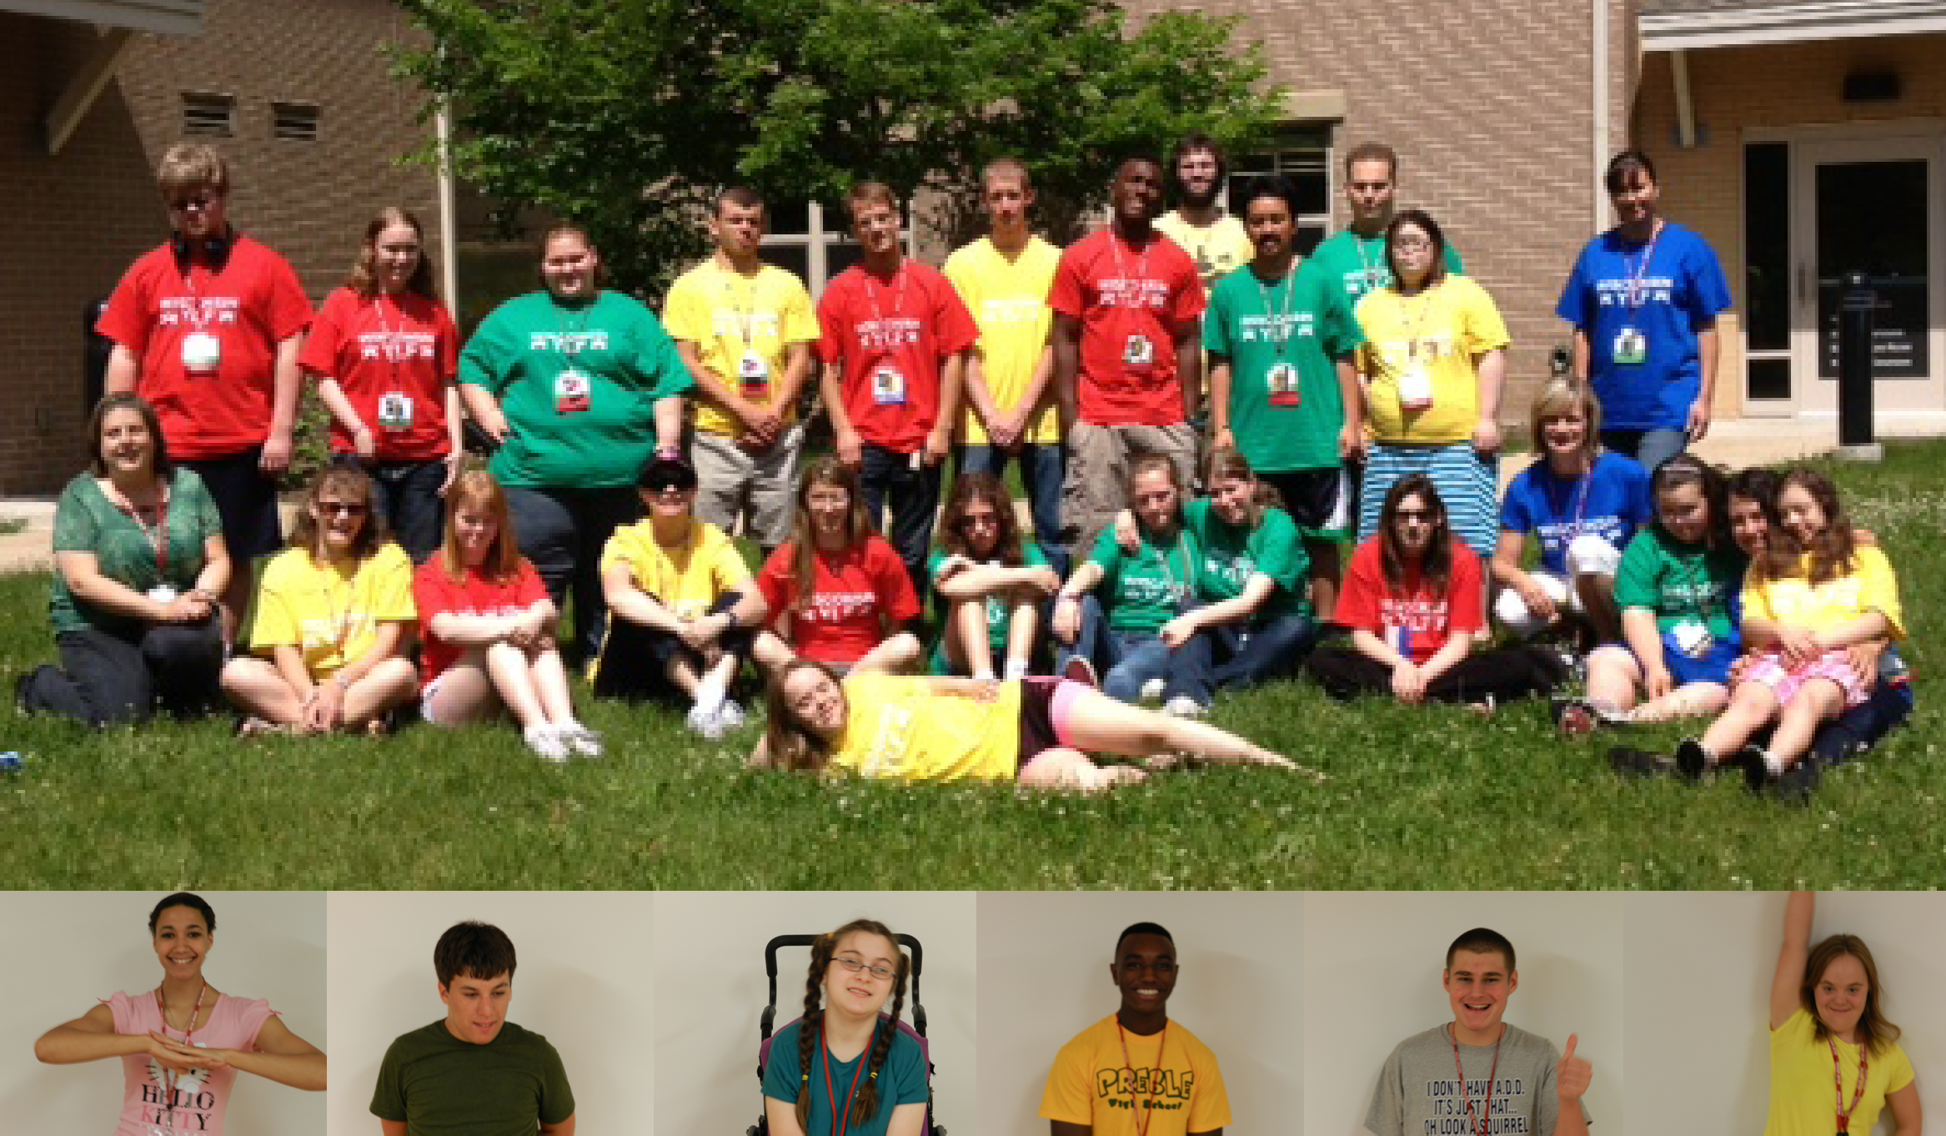
Leadership training and career awareness program for
high school students with disabilities
A Project of

Wisconsin Board for People with Developmental Disabilities

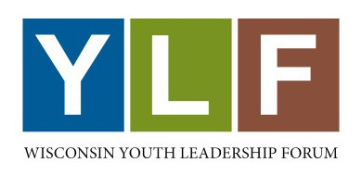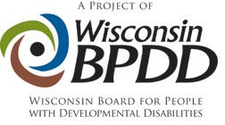

The Wisconsin Youth Leadership Forum (YLF) is a week-long leadership training and career awareness program for high school sophomores, juniors and seniors with disabilities. It provides training in leadership, self-advocacy skills, and career awareness to approximately 25 students with disabilities from throughout the state of Wisconsin. YLF is a project of the Wisconsin Board for People with Developmental Disabilities.

The Wisconsin Youth Leadership Forum is for:
- Students who show leadership potential by being active in their school and community
- Students who have a disability (physical, learning, intellectual, emotional, sensory, etc.)
- Wisconsin residents
- Students who are currently sophomores, juniors or seniors

Why Attend the Youth Leadership Forum?
- To give you a place to meet other students your age who are experiencing similar issues and concerns.
- To help you increase your leadership skills so you can further your future goals and reach them.
- To assist you in becoming a leader in your school and community.

WHERE: Edgewood College, Madison, WI
WHEN: July 19 – 24, 2020
COST: FREE*
- There is NO CHARGE to attend the YLF. General program expenses are paid for by the Wisconsin Board for People with Developmental Disabilities (WI-BPDD) and other sponsors.

If I’m interested, what do I do next?
  - Complete the application
  - Get 3 letters of recommendation that highlight your leadership skills
  - Complete two essay questions

Submit your application before Wednesday, April 1, 2020 (April Fool’s Day!).

If you have questions or for more information about YLF contact Jenny at Jennifer.neugart@wisconsin.gov or call 608-266-7707.

To find out more information about YLF go to: http://wi-bpdd.org/index.php/wisconsin-youth-leadership-forum/

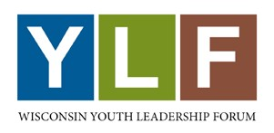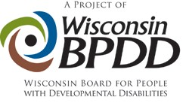

Frequently Asked Questions
(Keep this page for your information)

When is the application due?
Your application must be postmarked no later than Wednesday, April 1, 2020 (April Fool’s Day). Email your application to Jennifer.neugart@wisconsin.gov or mail it to:
Jenny Neugart
WI BPDD
101 E. Wilson St., Room 219
Madison, WI 53703

What should I do if I need help filling out the application?
Ask a friend, sibling, parent/guardian, teacher or contact Olivia Johnston, YLF Director at (920) 539-5640 or wisconsinylf@gmail.com.

How do you decide who is invited to attend?
Applications will be scored by a panel of judges. The scores will be averaged, and the top 25 to 30 students will be invited to attend the Forum.
When will I know if I was selected?
All applicants will be notified by email as to whether or not they were selected to attend the Forum in May 2020.
What happens if I’m selected?
You will need to fill out a confirmation form and provide additional information to the Forum such as health insurance, accommodations you may need, etc.
Do I have to pay to attend the YLF?
No, the cost for attending YLF is paid for through donations and sponsors. Your food, lodging and materials are paid for through the program. After you have completed the YLF, we would like you to talk to a service club (eg. Lions Club, Rotary, Kiwanis, etc.) in your community about your experience and ask them to support someone else who would like to attend in the future. This type of assistance will help you use your leadership skills immediately and will ensure the YLF continues for many years.

Being selected to attend the YLF is a distinct honor that you can be very proud of. Please take the time to apply – you’ll have the time of your life!

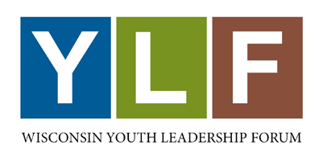 | 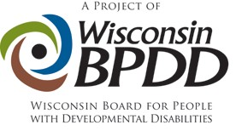

Wisconsin Youth Leadership Forum (YLF) Application

For High School Students with Disabilities
July 19 – 24, 2020 at Edgewood College, Madison, WI

Applicant
Student’s Full Name: |  |  |  |  |  | Birth Date:
 | Last |  |  | First | M.I.
Residence Address:
 |  | Street Address |  |  |  |  |  | Apartment/Unit #

 | City | State | ZIP Code

Mailing Address
(if different from above):

 |  |  | Street Address |  |  | Apartment/Unit #

 | City |  |  | State | ZIP Code
Home Phone: |  | *Email:

I check my email regularly? | YES ☐ | NO ☐
*All information about the YLF, including whether or not you were selected will go to the email address entered above.

School
Name of High
School:
 | City & State
School  Counselor’s Name: |  | School Counselor’s Email:

Grade Level on January 1, 2020: |  | Expected Graduation Date (Month/Year):

Please tell us about your plans for after you graduate from high school:

Other

If you are currently a client of the Division of Vocational Rehabilitation (DVR), please list:
Rehabilitation Counselor’s Name:
Rehabilitation Counselor’s Email:

State Senate Representative’s Name:
District Number:

State Assembly Representative’s Name:
District Number:
Name of Local Newspaper(s) (please list at least one):

Newspaper 1
Street Address

 | City | State | ZIP Code

Newspaper 2
Street Address

 | City | State | ZIP Code

School and Community Involvement

Below, please briefly list your involvement with your school and community. This may include:
- club memberships | - offices you held
- work or volunteer experiences | - after school activities

List the name of the activity, the dates you were involved, the name of an adult you worked with, and the grade level you were in at the time of participation (use additional pages if necessary).

School Activities:
Name of  Activity 1: |  | Dates:

Adult Contact: |  | Grade Level:

Name of  Activity 2: |  | Dates:

Adult Contact: |  | Grade Level:

Name of  Activity 3: |  | Dates:

Adult Contact: |  | Grade Level:

Community Activities:

Name of  Activity 1: |  | Dates:

Adult Contact: |  | Grade Level:

Name of  Activity 2: |  | Dates:

Adult Contact: |  | Grade Level:

Name of  Activity 3: |  | Dates:

Adult Contact: |  | Grade Level:

Letters of Recommendation

Please provide three letters of recommendation from individuals who can describe your leadership skills and leadership potential.

- At least two letters must be from persons NOT related to you

Please list those individuals contact information below.

Name: |  | Position or Title:

Phone: |  | Email:

Relationship to applicant:

Name: |  | Position or Title:

Phone: |  | Email:

Relationship to applicant:

Name: |  | Position or Title:

Phone: |  | Email:

Relationship to applicant:

Required Essays

Your answers to the following two questions will be used to assess your readiness to participate in this leadership and career awareness forum.

  - Write or type your responses in a separate document and attach it to your completed packet.
  - Your total response should not exceed one typewritten, double-spaced page, per question.
- Alternative formats are welcome. Please limit video or audiotapes to no more than 6-8 minutes per question.

- The Youth Leadership Forum is designed to teach you skills to increase the leadership potential you already possess. If you are selected to represent your school and community at the YLF, what is one community or educational issue you would like to see improved or put into action in your hometown? Examples of such issues could include: accessibility barriers, creating disability awareness, school bullying, or better services for students with disabilities.

- What is one thing you have done in your life that you are really proud of? What did this experience teach you about leadership?

Finish

How or from who (name and title) did you obtain this application from?

Applicant Signature: | X | Date:

Please keep a photocopy for your records. Application materials and applications using alternative formats will not be returned.

Applications are due on Wednesday, April 1, 2020 (April Fool’s Day).

Mail or email completed applications to:

Jenny Neugart - YLF
101 East Wilson St., Rm. 219
Madison, WI 53703
(608) 266-7707
jennifer.neugart@wisconsin.gov

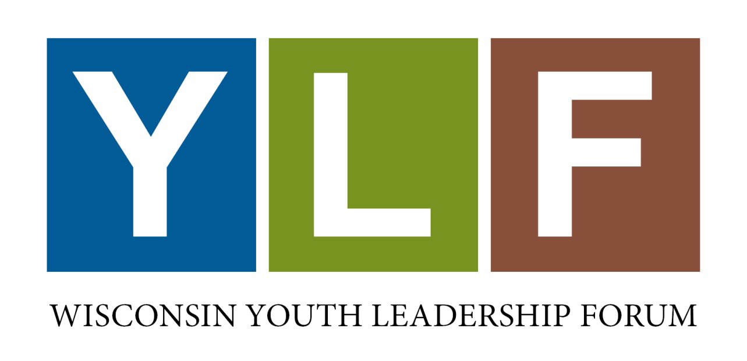

For more information, see https://wi-bpdd.org/index.php/wisconsin-youth-leadership-forum/

