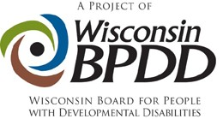

Core Values

Participants agree to support core values laid out in the federal Developmental Disabilities Act. Please affirm that you support each value before applying for Partners.

- Disability is a natural part of the human experience and does not diminish people’s rights to live independently, exercise control over their lives and fully participate in and contribute to their communities.
- People with disabilities are people first and must be treated with dignity and respect. This includes the right to be free of abuse and neglect.
- People with disabilities are entitled to the right to free speech. The ability to communicate, with assistance as needed, must be available to everyone.
- People with disabilities have the right to advocate for themselves on every level of the system, from individual services to the state budget to federal laws that affect their lives.
- Self‐determination is essential to full citizenship. People with disabilities must have the freedom to make informed decisions about how they want to live their lives and receive supports.
- People with disabilities must be able to enjoy the full mobility and accessibility that enables active participation in community life.
- People with disabilities need real friendships with a variety of friends, not just paid service workers.
- Schools and communities are stronger when they are inclusive.
- Every person with a disability deserves the right to work in the community at competitive wages, with benefits and the supports necessary to be successful.

