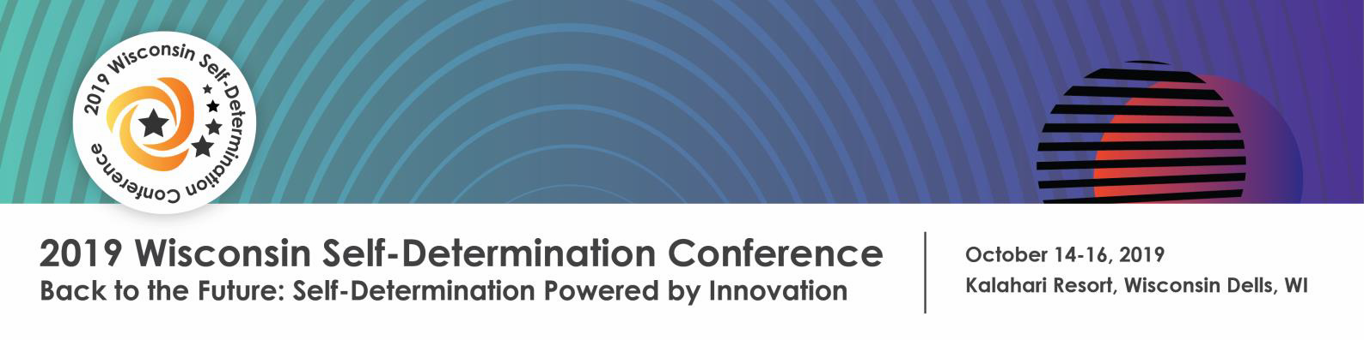

2019 Self-Determination Conference Registration Form
Contact Information
First Name: Click or tap here to enter text. Last Name: Click or tap here to enter text.
Email: Click or tap here to enter text. Phone: Click or tap here to enter text.
Street Address: Click or tap here to enter text.
City: Click or tap here to enter text. | State: Click or tap here to enter text. | Zip Code: Click or tap here to enter text.

Choose Registration Type and Fee Amount (Early bird rates available until August 15th)
- Consumer $90 (Early Bird $75) $
- Direct Care Provider $100 (Early Bird $85) $
- Family Member $100 (Early Bird $85) $
Professional/Other $250 (Early Bird $200) $
☐
- Pre-conference session (see rates below) $
TOTAL AMOUNT DUE $
Pre-Conference Events (Monday, October 14th)
PRE-CONFERENCE LABS are from 1-4 PM. Registration is required.

Please check which pre-conference session you would like to attend:
Story Slam [$10] Innovation Station [$10]
☐
☐

YouTube Channel [$10] Self-Determination Conference 101 [No Charge]
☐
☐

I will not attend a pre-conference Lab
☐

KICK-OFF EVENT: I will attend Yes No
☐
☐
Dinner and a Movie, 5-9 PM (This event is free, but you must register. Light meal provided) Featured Movie: Intelligent Lives a film by Dan Habib | Followed by an interactive Scavenger Hunt

Hotel Information
The Kalahari Resort is holding a block of guest rooms for October 14 & 15, 2019. Room rates are $82/single and $129 double/triple/quad.
For reservations, call (877) 253-5466 and ask for the 2019 Self-Determination Conference room block or reserve online at https://book.passkey.com/e/49887464.
Kalahari room block will be available until Friday, September 13, 2019.
Conference Participation
- Yes ☐ No This is my first time attending the Self-Determination Conference.
- I understand pictures may be taken during the conference and may be used for publicity and/or other media for future events. If you do not want to be photographed, please let someone know when you arrive at the conference.
Conference Accommodations Conference Center is wheelchair accessible
Meal Choice  Regular Vegetarian Gluten Free  Other: Click or tap here to enter text. | Conference Accommodations  None Large Print  Sign Language Interpreter Other
Other Conference Accommodations (please specify): Click or tap here to enter text.

Payment Information
Paying by Check Make checks payable to: InControl Wisconsin
Mail this form and payment to: InControl Wisconsin 2935 S. Fish Hatchery Road, Ste 233, Madison, WI 53711

Paying by Credit Card
Name on Credit Card: Type of Card (Visa, Am Ex): Credit Card Number: Exp Date (mo/year): / Signature: Date:
What is Your Race/Ethnicity (optional)?
Providing this information will help us better ensure we are growing our capacity to engage diverse communities and will not be used for any other purpose.
- White ☐ Hispanic/Latino ☐ Two or more races
- Black ☐ Asian ☐ Race Unknown
- American Indian/Alaska Native ☐ Pacific Islander
Additional Information/Questions
Registration Deadline: September 27, 2019. Early Bird rates are available until Aug. 15th.

QUESTIONS: Please contact Michelle Roach at 920-723-5571 or email at selfdetermined@incontrolwisconsin.org.

