2019 Employment First Partner
Grant Application

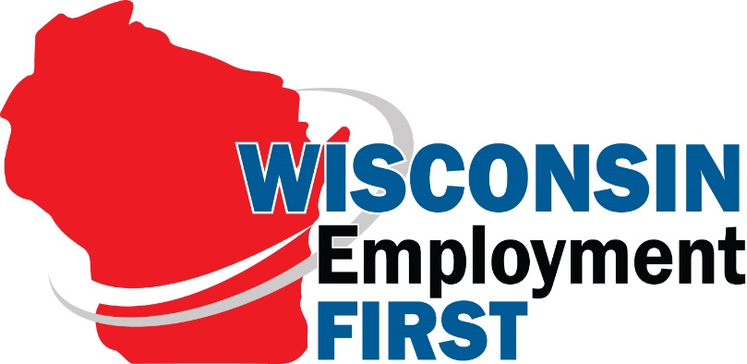

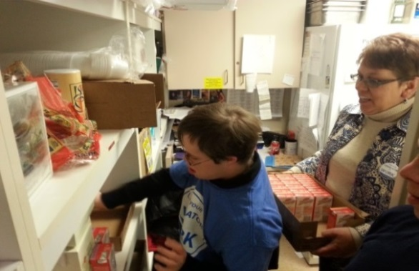
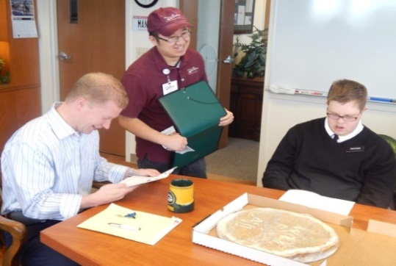
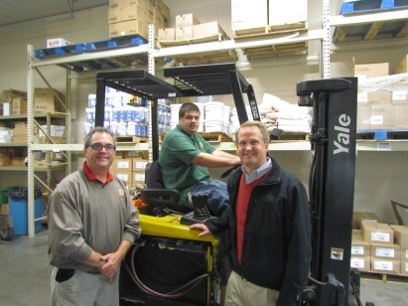

Increase integrated employment opportunities for people with disabilities in Wisconsin!

Applications due by 5:00 p.m. on Friday, August 30, 2019

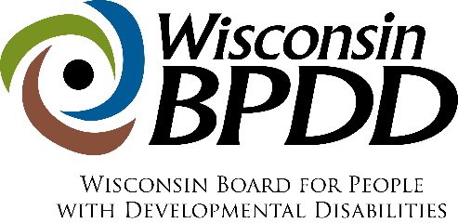
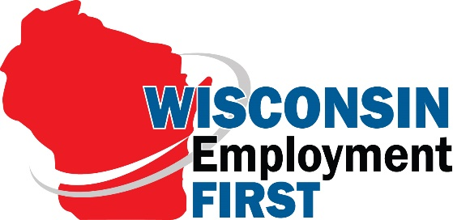 | Grant Application  Timeline

Activity: | Date:
Application released | Wednesday, May 15, 2019
Applications due | Friday, August 30, 2019
Notice of Award | Friday, September 13, 2019
Contract start date | Tuesday, October 1, 2019
EF Partner kick off meeting in Madison | Thursday, October 3, 2019
End date of contract | Wednesday, September 30, 2020

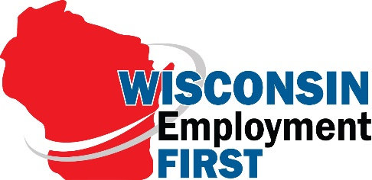 | 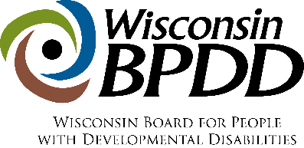

What are Employment First (EF) Partner Grants?
WI Employment First, funded through the Wisconsin Board for People with Developmental Disabilities, is seeking partners to engage in community outreach activities in local communities that lead to increased community, integrated employment opportunities for people with intellectual and developmental disabilities (IDD) including people with diverse identities and/ or people who are underserved**. Grant activities include:
- Gathering a team of stakeholders to plan and host a Community Conversation focused on addressing barriers to employment and increasing employment outcomes for people with IDD;
- Presenting to employer groups such as the Kiwanis, Rotary, Lions, Chamber, etc. on Employment First, and the business case for hiring people with IDD;
- Connecting family members—through a community conversation or other approach—who may be unsure about integrated employment with family members who are committed to integrated employment to share experiences and alleviate worries (family-to-family mentoring).
- Engaging and empowering individuals with IDD and their families who do not speak English to pursue integrated employment;
- Hosting a legislative breakfast to engage local representatives and community stakeholders in a presentation and discussion on integrated employment.
- Providing training and supporting implementation of best practices in supported employment (e.g. job matching, systematic instruction, natural supports, etc.) for direct support staff (paraprofessionals, job coaches).
Successful grant recipients also may use other creative methods designed to increase collaboration and awareness about integrated employment for people with IDD, such as: job tours for employers and/or family members, disability employment film festivals, transition outreach events, etc.
WI Employment First will partner with up to 8 grant recipients by providing a grant for up to $2,000, plus coaching and presentation materials to engage in outreach activities.

**Diverse Identities refers to people of various races, cultural and ethnic heritages, genders, gender identities, gender expressions, sexual orientations, ages, and religions from diverse socio-economic and geographic backgrounds.
The term “unserved and underserved” includes populations such as individuals from racial and ethnic minority backgrounds, disadvantaged individuals, individuals with limited English

proficiency, individuals from underserved geographic areas (rural or urban), and specific groups of individuals within the population of individuals with developmental disabilities, including individuals who require assistive technology in order to participate in and contribute to community life.

What are EF Partnership Requirements?
- Review and agree to the WI Employment First Partnership Commitments (below).
- Coordinate and host at least one community engagement/stakeholder event by September 30, 2020.
- Attend the EF Partner Grant Kick Off meeting on October 3, 2019 in Madison.
- Recruit and support at least two Employment First Ambassadors (refer to page 6 for EF Ambassador description). EF Partners must co-present with EF Ambassador(s) a minimum of four times to local groups that could include: businesses, legislators, People First or other local advocacy groups, parent support groups, Rotaries, High schools, Chambers. PowerPoint presentations and other resources that can be used during the presentations will be provided as part of the BPDD technical assistance. Ambassadors will be paid a stipend of $50.00 for each presentation. A minimum of $200 must be allotted in your project budget to cover stipends for four Ambassador presentations.
- Conduct targeted outreach and partner with at least one group of individuals with diverse identities and/or individuals who are underserved.
- Communicate your plans to and receive technical assistance and coaching from a BPDD Employment First consultant.
- Use agreed upon materials provided by WI Employment First (as well as materials you choose/create) for your event.
- Share resources and information to other EF Partners as appropriate.
- Notify BPDD no less than 30 days prior to the date of the event and provide electronic copies of the marketing and presentation materials to be used for review.
- Share information about any media cover/press releases that occur leading up to, during, or after the event with BPDD.
- Take photos at the event and send to BPDD during or right after the event for BPDD to use on social media. BPDD can provide assistance seeking media coverage as desired by your group.
- Participate in the BPDD Take Your Legislator to Work Campaign (TYLTW) by submitting 2 or more applications with employees with disabilities in your area that are willing to host legislative visits.
- Participate in a breakout session(s), if requested, at the annual WI Employment First Conference scheduled for May 19, 2020.
- Provide quarterly updates to the BPDD project consultant and complete the quarterly BPDD evaluation survey.

Who Can Apply?
- Anyone committed to expanding integrated employment opportunities for individuals with disabilities in their local community (e.g., Individuals with disabilities, family members, service providers, schools).
- Individuals (or groups) with IDD who have diverse identities and/or individuals who are underserved are strongly encouraged to apply.
- Any person, group, school, or agency that has received only one year of funding through EF Partner grants thus far. An entity can only receive EF Partner grant funds for two years maximum.

How Do You Apply?
- Submit a completed application by e-mail to Molly Cooney at molly.cooney@wisconsin.gov by 5:00 pm, Friday, August 30, 2018.
- To submit via fax, fax your application materials to (608) 267-3906.
- To submit via regular mail, mail your application materials to:
EF Partner Grant
c/o Wisconsin Board for People with Developmental Disabilities
101 East Wilson Street, Room 219
Madison, WI 53703

How Much Funding Can You Request?
- Requests can be made up to $2,000. A budget of how the money will be spent must accompany your application.

How Will Projects Be Chosen?
- Proposals that target individuals with IDD who have diverse identities and/or individuals who are underserved will be given priority.
- Proposals that support family leadership and family peer mentors will be given priority.
- Applications will be reviewed and scored by a review team of at least 3 people.
- Each member will read and score each proposal independently, discuss each proposal jointly, and then submit final results for tabulation.
- The quantitative score from each member will be averaged and a final score will be assigned to the proposal. Scores will be ranked from highest to lowest scores. The highest ranked proposals will be funded.

If you need application materials in an alternative format and/or language, contact:
- Molly Cooney at 608-266-0266 or molly.cooney@wisconsin.gov

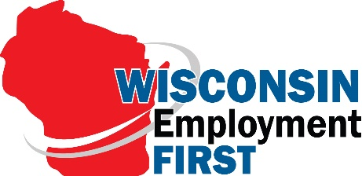

Employment First Ambassador Role

Employment First (EF) Ambassadors are individuals with intellectual and developmental disabilities (IDD) who have jobs in their communities and/or family members who are champions of integrated employment. EF Ambassadors understand the importance of advocating for policies and services that will help everyone with disabilities get jobs in their communities.

EF Ambassadors support the principles of Employment First and believe that:
- Everyone can work and there is a job for everyone
- Everyone has something to contribute
- Schools, families, and businesses must raise their expectations about work
- Employment is not a social service
- Not working should be the exception
- People are healthier, safer, and happier when they work
- Integrated employment is good for the employers, individuals, and the economy

EF Ambassadors will be asked to:
- Get training about the Employment First Initiative
- Meet with legislators and policy-makers to tell them why it is important for them to support the Employment First Initiative
- Share their personal employment stories by presenting at conferences, meetings, and community events
- Meet with employers to talk about why they work and like their jobs and why hiring people with disabilities is a win-win
- Meet with families unsure about integrated employment to share their own experiences about how community-based employment has benefited themselves or their family member, their family, and their community
- Be part of videos and Public Service Announcements to help educate others about the importance of Employment First

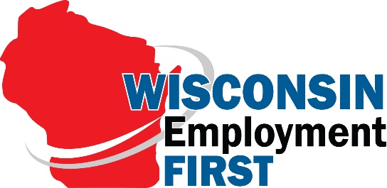 | EF Partner Grant: Application

The completed application is due by 5:00 p.m. on Friday, August 30, 2019. Late applications will not be accepted.

Applicant(s) Name:

Organization(s):

Lead Contact Information

Name: Click or tap here to enter text.

Address:

Telephone:

Email address:

- Describe what local community events/activities you will engage in that will lead to increased community, integrated employment opportunities for individuals with intellectual and developmental (IDD) disabilities.

- Describe what steps you will take to engage individuals with diverse identities and/or individuals who are underserved in your activities.

- Describe how your community events/activities will expand integrated employment opportunities for individuals with IDD in your community, including individuals with diverse identities and/or individuals who are underserved.

- What stakeholders/groups will be participating in planning/hosting activities? What groups that include individuals with diverse identities and/or underserved will be participating?

- How will you recruit and support at least two Employment First Ambassadors? What audiences do you plan to support the EF Ambassadors in presenting to (e.g., local High Schools, businesses, and legislators)?

- How will you know that your activities/events were successful?

- What is your plan to continue your efforts to expand integrated employment opportunities for individuals with disabilities after the grant ends?

- WI Employment First Partnership Commitments:
Do you believe: (please check to “agree” to the statements that apply):
☐That people with disabilities can and should be contributing members in their communities?
☐That everyone deserves the opportunity to find and develop their best talents and contributions?
☐That businesses can benefit from employees who are enthusiastic and well-matched to their business needs?
☐That local economies benefit from workers who purchase more goods and services and pay taxes?
☐That many of us need assistance to find our talents and to find ways to use them in our communities?
☐That dedicated, well-trained employment service providers can effectively match individual worker talents with business needs?
☐That workers, families, businesses, schools, employment agencies and entire communities CAN come together to include people with disabilities as productive members in the workplace?
☐ That integrated employment should be the number one priority for all working age citizens with disabilities, regardless of level of disability?

- How will your efforts help drive your community toward understanding and fulfilling these commitments?

SAMPLE BUDGET

ITEM (be as specific as possible) | COST
EF Ambassador Presentation Stipend (4@$50.00)--required | $200.00
Meeting space rental ($100/event x 2 events) | $200.00
Refreshments ($100 x 2 meetings) | $300.00
Transportation | $500.00
Marketing/outreach materials | $100.00
Total | $1300.00
In-kind contributions
Volunteers at 2 events (10 people for 4 hours x 2 events) | 80 hours
Event t-shirts (donated from ABC org.) 50 shirts x $5.00 each | $250.00

YOUR PROJECT’S BUDGET

ITEM (be as specific as possible) | COST
TOTAL
In-kind contributions

Project Workplan

Project Contact Person:  Project Title: |  |  |  | Contact Information (address, phone number, e-mail address):
Sample Work plan

Project Activities: | Target Date: | Outcomes: | Deliverables/Products: |  | Target Date:
Host a legislative breakfast to engage local representatives and community stakeholders in a presentation and discussion on integrated employment. | 1/25/19 | Legislators will have increased knowledge about:  - Benefits of integrated employment for individuals with disabilities.  - Actions they can take to support expansion of IE options for individuals with disabilities  - Resources to learn more about IE  Legislators who attended will participate in BPDD Take Your Legislator to Work Project | List/contact information for all attendees  Power point on integrated employment targeted to legislators  Informational materials/resources on integrated employment geared towards legislators  Photos of event posted to social media |  | 2/22/19

Project Contact Person:  Project Title: |  |  |  | Contact Information (address, phone number, e-mail address):
Employment First Partner Work plan

Project Activities: | Target Date: | Outcomes: | Deliverables/Products: |  | Target Date:

