Partners with Business
Grant Application

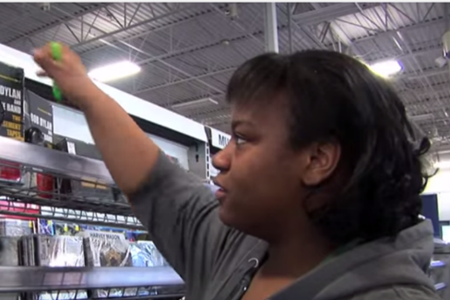
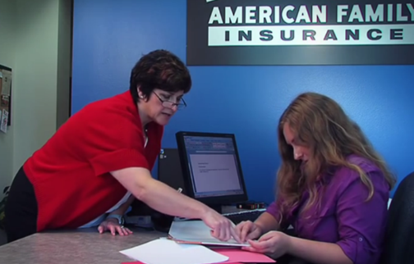
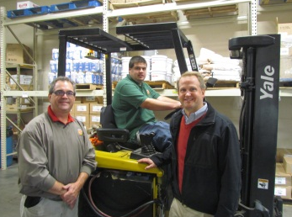

Applications are due by 5:00 p.m. on March 15, 2019.

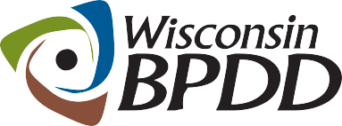
A Project of

Partners with Business Grant Timeline

Activity: | Date:
Application released | 2/07/19
Application extended due date | 3/15/19
Notice of award | By 4/5/19
Contract start date | 5/1/19
Mandatory PWB Kick Off meeting in Madison | 5/21/19 from 10:00am to 2:00pm
End date of contract | 6/30/20

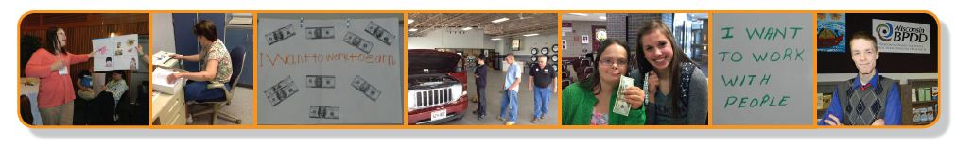
A Project of

What is a Partners with Business grant?
The Wisconsin Board for People with Developmental Disabilities (WI BPDD) is seeking five (5) grantees to partner with the WI BPDD and a project consultant to successfully implement the Partners with Business model of employment supports.

Partners with Business is a way to support workers with intellectual and developmental disabilities to achieve long-term success on the job by using a creative combination of natural and formal supports, both of which are provided by the employer. Partners with Business reduces reliance on job coach staff, builds the capacity of a school or vocational agency to increase the number of people supported in community jobs, empowers employers to provide supports, and saves scarce public resources.

In the Partners with Business support model, a school or vocational service agency works with an employer to provide initial job training for a worker with disabilities and develops on-the-job supports through co-workers. Once co-worker supports have been developed and the initial job training is complete, the employer may receive funds from the long-term care system (i.e. Family Care, IRIS, or county) or other sources to designate co-worker(s), instead of agency-provided job coaches, to provide necessary ongoing supports.

A vocational support agency continues to provide regular check-ins and back-up assistance as needed. In a traditional supported employment model, ongoing supports would be provided by a job coach from a vocational support agency but in the Partners with Business model, the employer is reimbursed for providing this extra support. More information about the Partners with Business model can be found at: www.letsgettoworkwi.org/index.php/for-employers/partners-with-business-toolkit.

WI BPDD will provide mini-grants to five (5) entities. Eligible applicants include: public schools;
care management organizations that administer Family Care or the Family Care Partnership Program; consultant agencies that assist enrollees of the IRIS self-directed services option;
employment service providers for the state's long-term care programs; and private businesses.

Awardees will receive technical assistance and project funds of $4,999 (for each grant site) to successfully implement the Partners with Business support model with least three to five (3-5) individuals with intellectual/developmental disabilities in competitive jobs.

These mini-grants are part of the 2017 Wisconsin Act 323, passed on April 16, 2018. To view the statutory language, visit: https://docs.legis.wisconsin.gov/2017/related/acts/323.

What are the Partners with Business grantee requirements?
- Complete and submit the grant application by March 15, 2019.
- If awarded, complete a contract agreement with WI BPDD by April 30, 2019.
- Attend a Partners with Business project kick off meeting to learn about the model and discuss implementation on May 21, 2019 from 10am to 2pm in Madison.
- Receive technical assistance and support from a WI BPDD project consultant to implement the model.
- Successfully implement the Partners with Business model with three to five (3-5) people with intellectual/developmental disabilities.
- Obtain necessary Release of Information and media releases for project participants.
- Gather and report participant data for outcome tracking and complete required reporting documents.
- Collaborate with WI BPDD project consultant to host a community conversation event on employment for people with disabilities.
- Share information and work with the WI BPDD consultant to develop project deliverables and materials, including but not limited to project evaluation and lessons learned, employer/participant stories, documents for the Partners with Business toolkit, conference presentations, website, videos, etc.
- Participate with WI BPDD in legislative activities to promote Partners with Business and assist at least two of the Partners with Business employees to submit Take Your Legislator to Work applications http://wi-bpdd.org/takeyourlegislatorwork/.

Who Can Apply?
- Any school, organization, or business committed to working with individuals with disabilities, employers, and funders to successfully implement and promote the Partners with Business model, including
- Public schools;
- Care management organizations that administer Family Care or the Family Care Partnership Program;
- Consultant agencies that assist enrollees of the IRIS self-directed services option;
- Employment services providers for the state's long-term care programs;
- Private businesses.
How Do You Apply?
- Submit a completed application form by e-mail (preferred method) to Molly Cooney at molly.cooney@wisconsin.gov by 5:00 pm on March 15, 2019.
- To submit via ground mail, send your application materials to:
Molly Cooney
WI-BPDD
101 E. Wilson St., Rm 219
Madison, WI 53703

What Will You Get From These Grants?
- Training and technical assistance on essential Partners with Business strategies including effective job development and Customized Employment strategies, systematic instruction and fading supports, facilitating workplace inclusion and natural supports, and negotiating paid coworker supports. Grant recipients are expected to work closely with a BPDD Partners with Business project consultant to assist in carrying out their projects.
- Up to $4,999 to cover the cost of staff time to engage in project activities and successfully implement the Partners with Business model. Sites will invoice as costs are incurred. Funds cannot be used for direct services that can be covered by another entity (Division of Vocational Rehabilitation, long-term care, public school system).
- Funding for and assistance with planning a community conversation or employer engagement event.
- At the end of the contract year, sites that have met project deadlines and outcomes that would like to continue tracking outcome data on participants and receiving technical assistance for an additional year can continue in the project. These sites will complete a memorandum of understanding, track outcomes, receive technical assistance, and participate in an end-of-project interview for a $1,000 bonus payment.

How Will Projects Be Chosen?
- Applications will be reviewed and scored by a review team of at least 3 people.
- Each member will read and score each proposal independently, discuss each proposal jointly, and then submit results for tabulation.
- The quantitative score from each member will be averaged and a final score will be assigned to the proposal. Scores will be ranked from highest to lowest scores. The highest ranked proposals will be funded.

A Project of | Partners with Business Mini-Grant Application

The completed application is due by 5:00 p.m. on March 15, 2019. Late applications will not be accepted.

Applicant(s) Name:

Organization(s):

Lead Contact Information

Name:

Address:

Telephone:

Email address:

Please provide a written response to the questions below (not to exceed 8 single-spaced pages total).

- Why is your organization interested in participating in the Partners with Business project?

- What experiences does your organization have hiring and supporting individuals with disabilities on the job?

- In what ways would your organization benefit from technical assistance/coaching on hiring and supporting people with disabilities?

Partners with Business Grant Application, Page 1

- What makes your organization a strong candidate for the Partners with Business grant?

If chosen for the grant, as a Partners with Business Grantee, I agree to:

 | Yes | No
1) Receive training, technical assistance and coaching from a WI BPDD Partners with Business project consultant.

2) Implement the Partners with Business model with at least three to five (3-5) employees with intellectual/developmental disabilities.

3) Complete reporting requirements and share participant experiences and lessons learned using the Partners with Business model to the WI BPDD.

5) Participate with and assist employees to submit Take Your Legislator to Work applications. The visits will be facilitated by the WI BPDD.

Partners with Business Grant Application, Page 2

