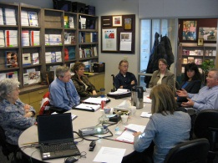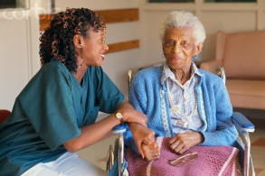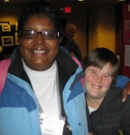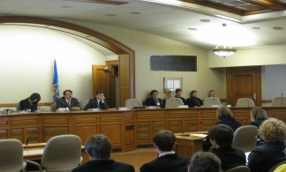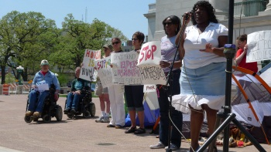

|  |
| --- |
| **Free: State Budget Trainings for the Disability Community** |
| **March 27, 2019**  **Options for Independent Living**  **1555 Country Club Road**  **Green Bay, WI 54313  5:00 – 6:30 PM** |

**What will the training provide?**

* Up-to-date information about the WI State Budget and how it will affect individuals with disabilities and their families.
* Advocacy tools to give you a voice during the process.
* An opportunity to ask questions.

**To Register:**

<https://www3.thedatabank.com/dpg/579/mtglistproc.asp?formid=Budget-Training&caleventid=4465>

**Questions:**

Contact Sally Flaschberger at [Sally.Flaschberger@drwi.org](mailto:Sally.Flaschberger@drwi.org) or 414-292-2737.

**Disability-Related Accommodations:**

To request additional accommodations, please contact [Jeanie.parker@drwi.org](mailto:Jeanie.parker@drwi.org) at Disability Rights Wisconsin or at (608) 309-2657. Place your request as soon as possible, and at least one week prior to the training date. We will make every effort to meet your accommodation needs.

**