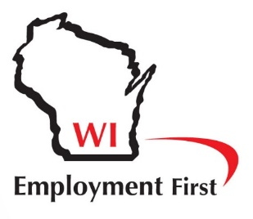
Building Full Lives Initiative Data Tracking Plan

Reporting Cycle: Semi-Annually - January through June (Report in July) July through December (Report in January) and January 15th
Service Snapshot – For All Adult Programs
Total number of people currently supported in adult service programs (FBPV, FBD, CBPV, BFL, ongoing SE)

Total number of people receiving Facility Based Prevocational services (FBPV)

Total Number of people receiving Facility Based Day services (FBD)

Total number of people receiving Community-Based Prevocational services (CBPV)

Total number of people receiving BFL model services

Total number of people receiving ongoing Supported Employment services (i.e. post-transfer to long term support)

Total number of currently active DVR consumers (Supported/Customized Employment only)

Community Partnerships and Contribution – For People Participating in BFL Model Only
Number of volunteer sites your organization supports people at

Number of people volunteering in the community

Average # of hours spent volunteering each week

Number of other community partners (businesses, organizations, clubs, groups) providing regular opportunities for people to learn, exercise, connect, etc.

Skill Acquisition & Connecting – For People Participating in BFL Model Only
Aggregate average score from BFL model skills for independence or self-reliance assessments

Number of people in BFL Services who achieved one or more of their service plan goals in the last 6 months

Number of people who have reduced their BFL service hours due to fading, connecting and natural supports within the last 6 months

Competitive Integrated Employment - for People in BFL Model Only
Number of businesses currently employing people supported by your organization

Total # of people your organization currently supports in community jobs

Average # of work hours each week for all people in community jobs

Average wage for all people in community jobs

Number of people participating in BFL model services who obtained a community job within the last 6 months

Average number of months between DVR Referral and Job Hire – For People Participating in BFL Model Only

Number of people who are working and continue to participate in BFL model services for some portion of the week

Participant Experiences/Quality of Life:
- BFL Pilot Interview questions prior to starting BFL model services and annually thereafter (BPDD)
- BFL Data sheets prior to starting BFL model services and annually thereafter (BPDD)
- Individual and family satisfaction surveys (as determined by service provider)

