2018 – 19
SPARKS
GRANTS
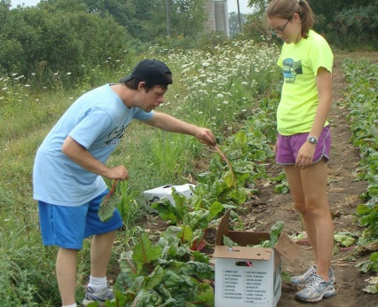
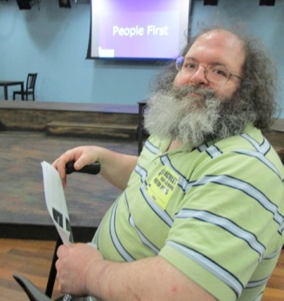
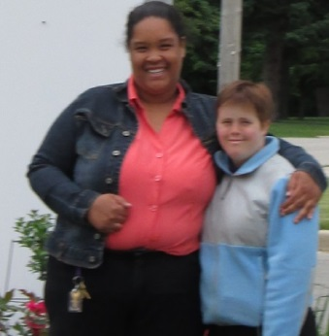
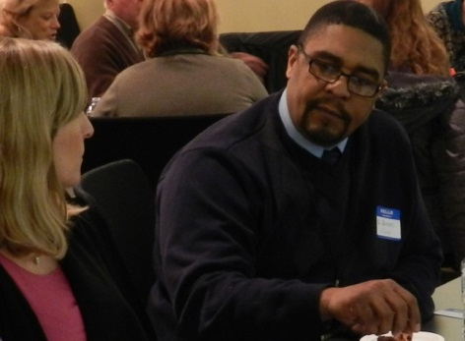
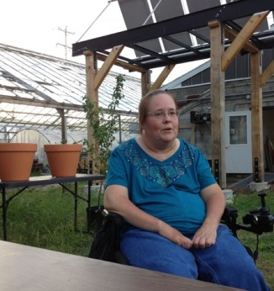

Spark a change in your community with a SPARKS Grant!

Apply by August 31, 2018

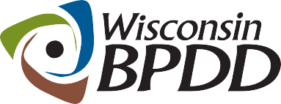
A Project of

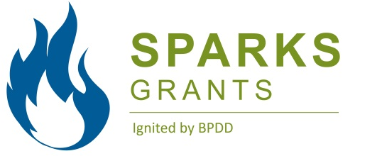 | SPARKS Grants Application Timeline

Activity: | Date:
Applications released | June 15, 2018
Applications Due | August 31, 2018
Review process complete/applications ranked | September 14, 2018
Start date of contract | October 1, 2018

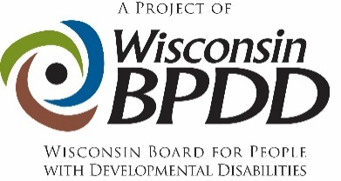

What are SPARKS Grants?
The purpose of SPARKS Grants is to organize local grassroots groups to make changes in their communities that result in a positive impact on the lives of people with intellectual and developmental disabilities (I/DD), including individuals with diverse identities and/or individuals that are underserved. *

Grassroots community organizing means groups that are led by individuals with disabilities together with their allies, who are working for positive community change for individuals with I/DD on issues that are important to them.

Priority activities for 2018-19 SPARKS Grants are:
- Increasing transportation options for people with I/DD
- Increasing the number of people with I/DD voting

What have been some of the accomplishments of past SPARKS Grants?
SPARKS grants started in 2010 and have had many positive results, including:
- Creation of an accessible parks in Oshkosh and Glendale.
- Expansion of the bus transportation system in the Wausau area.
- Development of unique job opportunities at local organic farms in Kickapoo, WI.
- Creation of an accessible garden, community room and kitchen in Stevens Point.

What can you expect from BPDD?
Each SPARKS Grant recipient will receive ongoing coaching/technical assistance to help you get started on your project as well as throughout your project. You will also have opportunities to share your project ideas and resources with other grant recipients from around the state.

*Diverse Identities refers to people of various races, cultural and ethnic heritages, genders, gender identities, gender expressions, sexual orientations, ages, and religions from diverse socio-economic and geographic backgrounds
The term “unserved and underserved” includes populations such as individuals from racial and ethnic minority backgrounds, disadvantaged individuals, individuals with limited English proficiency, individuals from underserved geographic areas (rural or urban), and specific groups of individuals within the population of individuals with developmental disabilities, including individuals who require assistive technology in order to participate in and contribute to community life.

What are SPARK grant recipients committing to?
- Attend the SPARKS Kickoff event in September (date TBD). This event will focus on:
  - strategies for projects to be successful
  - sharing ideas with other projects
  - reviewing grant expectations
  - signing contracts
- Start the project no later than October 1, 2018 and complete the work plan by September 30, 2018.
- Communicate your plans to and receive technical assistance from the SPARKS Coordinator.
- Provide monthly updates throughout the year. A final, annual report will be due no later than Oct. 31, 2019.
- Submit monthly requests for reimbursements, along with required receipts, etc. for all expenses.

- Share information on the project, including any public events that are planned and photos that can be used in BPDD social media.

- Conduct targeted outreach and partner with at least one group of individuals with diverse identities and/or individuals who are underserved.
Who can apply?
- Individuals with I/DD and family members that want to make a change in their community that will have a positive impact on the lives of individuals with I/DD.
- Individuals (or groups) with I/DD who have diverse identities and/or individuals who are underserved are strongly encouraged to apply.

How do you apply?
- Complete and submit the SPARKS application packet (application form, budget worksheet, and work plan).
- Application materials (i.e., application form, budget worksheet, and work plan) are due by 12:00 p.m. on August 31, 2018.
- Application materials can be submitted via email, fax, or regular mail.
  - To submit via email, email your application materials to jennifer.neugart@wisconsin.gov
  - To submit via fax, fax your application materials to (608) 267-3906.
  - To submit via regular mail, mail your application materials to:
Sparks Grants
c/o WI-BPDD
101 East Wilson St, Rm 219
Madison, WI 53703

How much funding can you request?
Individual grants range from $500 - $3,000. A detailed budget must accompany all grant proposals (a budget template is included in the application packet).

How will projects be chosen?
- Applications will be reviewed and scored by a review team of at least 3 people.
- Proposals that target individuals with I/DD who have diverse identities and/or individuals who are underserved will be given priority.
- Proposals that address the priority areas of transportation and self-determination will also be given priority.
- Each member will read and score each proposal independently, discuss each proposal jointly, and then submit final results for tabulation.
- The scores from each member will be averaged and a final score will be assigned to the proposal. Scores will be ranked from highest to lowest scores. The highest ranked proposals will be funded.

If you have any questions, contact:
- Jenny Neugart at jennifer.neugart@wisconsin.gov or 608-266-7707

Glossary of Terms for Project Work Plan

Goal: A goal states the best possible outcome for people. Goals are simple, clear and optimistic – e.g., All people with disabilities will have integrated jobs in their community.

Objective: Objectives are steps needed to reach the goal. They describe a concrete change in people’s actions or condition. Objectives are concrete, measurable, optimistic, but realistic – e.g., The number of people with disabilities working in integrated jobs in the community will double by 2018.

Outcome: Results of an activity, plan process or program, accomplishment/impact – e.g., Increase the number of individuals registered to vote.

Project Work Plan: A project work plan defines the tasks you need to complete in order to fulfill the requirements/deliverables of the project. The written plan includes: project purpose, goals, objectives, specific activities, outcomes, deliverable and target dates.

APPLICATION
FORM

Application materials (application form, budget worksheet, and work plan) are due by 12:00 p.m. on August 31, 2018.

Applicant Name:

Project Title:

Address:

Telephone:

Email address:

1. Please describe your project idea in 5 to 6 sentences.

2. How will your project change your community? What problem are you addressing?

3. Successful Sparks projects will build on community strengths to address community problems. What community strengths will you build on (e.g. active community engagement, strong partners already in place, support from local elected officials, etc.)?

4. Please list the people, agencies, organizations, etc. that will work on this project with you.

5. How will individuals/groups who have disabilities be meaningfully included throughout the project?

6. Please describe how your project will work with people who have diverse identities and/or individuals who are underserved.

7. How will your project make the lives of people with disabilities better, especially for people with diverse identities and/or individuals who are underserved?

8. How will your project address the identified priority activities of increasing transportation options for individuals with I/DD, and/or increasing voter turnout for people with I/DD?

9. How will you know that your project was successful?

10. How will the positive change/impact continue after your grant ends?

**Diverse Identities refers to people of various races, cultural and ethnic heritages, genders, gender identities, gender expressions, sexual orientations, ages, and religions from diverse socio-economic and geographic backgrounds
The term “unserved and underserved” includes populations such as individuals from racial and ethnic minority backgrounds, disadvantaged individuals, individuals with limited English proficiency, individuals from underserved geographic areas (rural or urban), and specific groups of individuals within the population of individuals with developmental disabilities, including individuals who require assistive technology in order to participate in and contribute to community life.

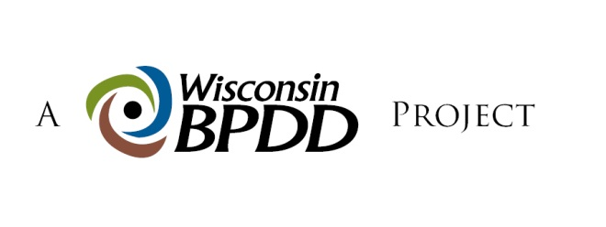
BUDGET
WORKSHEET

BPDD has allocated a total of $20,000 funds for the SPARKS grants. Funding for individual grants ranges between $500 - $3,000. A detailed budget must accompany all applications.

Funding cannot be used for infrastructure (e.g., computers, printers) or to pay for salaries.

SAMPLE BUDGET
ITEM (be as specific as possible) | COST
Meeting supplies (wall board, markers, post-it notes, copies) | $150.00
Meeting space rental ($100/event x 2 events) | $200.00
Refreshments ($100 x 2 meetings) | $200.00
Transportation (Cab fare 20 consumers ($25 ea.) x 2 meetings) | $1000.00
Stipends for 10 youth speakers at $25 each | $250.00
TOTAL | $1800.00
In-kind contributions
Volunteers at 2 events (10 people for 4 hours x 2 events) | 80 hours
Event t-shirts (donated from ABC org.) 50 shirts x $5.00 each | $250.00

YOUR PROJECT’S BUDGET
ITEM (be as specific as possible) | COST
TOTAL
In-kind contributions

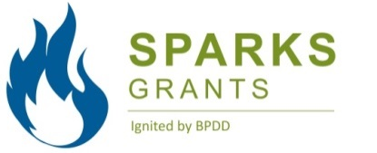 | PROJECT  WORK PLAN

Project Contact Person:  Project Title: |  |  |  | Contact Information (address, phone number, e-mail address):
Project Goal(s):
Project Objective(s):
Project description/rationale:

Sample Work plan
Project Activities:  (What will you do?) | Target Date: (When will activities be done) | Outcomes:  (What will you achieve?) | Deliverables/Products:  (What will you develop?) |  | Target Date:  (When will products be done?)
Develop a video to teach people their rights under Wisconsin voting law. | 11/12/17 | People will be prepared to vote and know what their rights are | Voting Video, written summary of community conversations and work plan to implement strategies, dissemination plan. |  | 1/12/17

SPARKS Project Work plan
Project Activities:  (What will you do?) | Target Date: (When will activities be done) | Outcomes:  (What will you achieve?) | Deliverables/Products:  (What will you develop?) | Target Date:  (When will products be done?)

