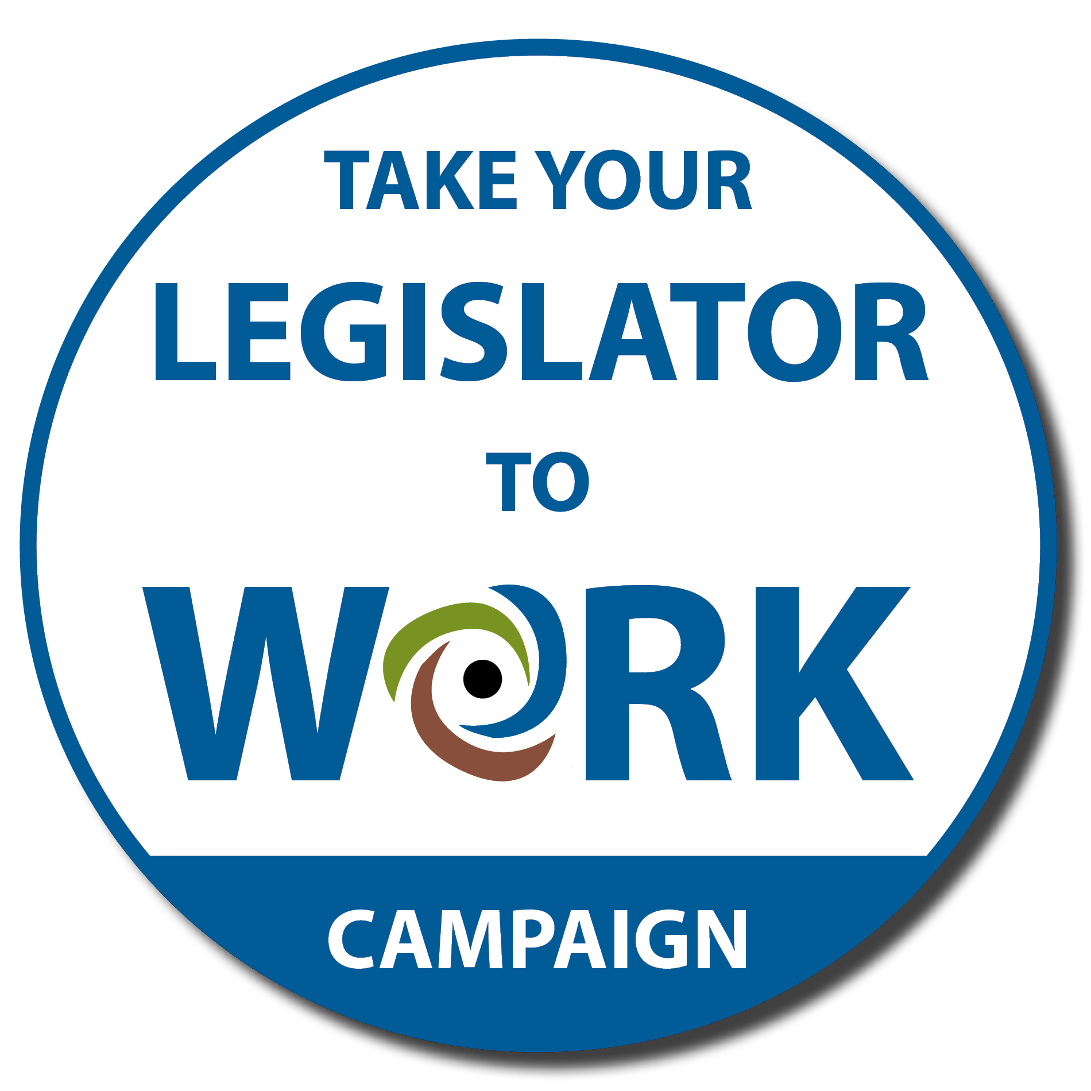 | GET STARTED KIT!

Be a part of the Take Your Legislator to Work Campaign!
Invite your legislator to:
- tour your workplace,
- meet your co-workers and
- learn why your job is important!

Get started!
To participate, just follow the steps below:

☐ Step 1: Give your supervisor the Employer Letter on the next page and
ask for approval to invite your legislator to visit you at your job in the community.

☐ Step 2: Fill out and mail or email the Participant Application to:
Beth Moss
c/o BPDD
101 E. Wilson St., Room 219
Madison, WI 53703

Beth.Moss@Wisconsin.gov

☐ Step 3: BPDD will call or email you.

Employer
LETTER

THANK YOU for employing a person with a disability!

Your employee is interested in participating in the 6th annual Take Your Legislator to Work Campaign, a project of the Wisconsin Board for People with Developmental Disabilities (BPDD).

During the campaign, employees with disabilities invite their legislator to visit them at work and see first-hand the value of jobs in the community that pay market wages. During a visit, your employee may
- give his or her legislator a tour of the workplace,
- introduce them to co-workers, and
- discuss why a job in the community that pays market wages is important to him or her.

Please support your employee’s enthusiasm for participating in this campaign by allowing a legislator to visit your business. Hundreds of employers have participated over the years.
Facts about employment of people with disabilities in their community for market wages:
- 87% of customers say they would prefer to patronize businesses employing people
with disabilities. (Siperstein, Romano, Mohler, Parker, 2005)

- The turnover rate for employees with disabilities is 8% in comparison to 45% for
other workers. (Crain’s Chicago Business Survey, Washington Mutual, Inc. Study, 2003)

A visit usually takes less than an hour and provides an excellent opportunity to show how employing people with disabilities strengthens the workforce and community. You also will receive a Certificate of Appreciation to display at your business.

You can learn more about the campaign at www.wi-bpdd.org.
Participant APPLICATION

Participant Information
The participant is the person with a disability who has a community-integrated job.
Name:
Street address:
City: WI Zip:
Email address:
Phone number: Cell number:
Have you participated in Take Your Legislator to Work before? Yes No
T-shirt size: S M L XL XXL XXXL
I give BPDD permission to use my picture from my visit.

Employer/Business Information
Do you have permission from your employer to bring your legislator to work? Yes No
Name of Business:
Business street address:
City: WI Zip:
Name of your supervisor:
Your supervisor’s email address:
Your supervisor’s phone number: Cell number:

over

Facilitator Information (if applicable)
A facilitator is someone who is helping you set up your visit.
Name:
Email address: Street Address: Click here to enter text.
Daytime number: Cell number:
Relationship to participant: Parent Guardian Job coach Other:

About Your Job

Do you have a job in your community? Yes No
Is your job paid?
Yes, at minimum wage or higher
Yes, below minimum wage
No, I am a volunteer
How many hours per week do you work? Your job title:
How long have you worked there?
What do you do at your job? (If you need more space to answer any question, use the back of this form)

What do you like about your job?

How did you get your job?

Send your completed Participant Application by:
- email to Beth.Moss@Wisconsin.gov
- fax to (608) 267-3906 or
- mail to Take Your Legislator to Work Campaign c/o BPDD
101 E. Wilson St., Room 219
Madison, WI 53703

