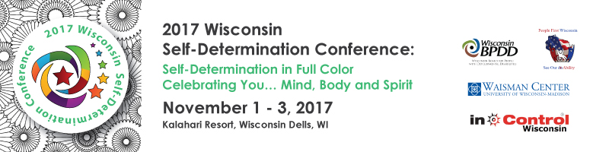
Conference Presentation Proposal Announcement
Are you interested in presenting at the 10th Anniversary of the Self-Determination Conference? We are seeking session presentations for Thursday, Nov. 2 & Friday, Nov. 3.
- Proposals must include a self-advocate(s) as a lead or co-presenter.
- Panels should be limited to no more than 3 people.
- Conference sessions must support Self-Determination and Self-Directed principles.
- Presentations must include an activity and tools that can be used at the session and as a takeaway. Presentations should focus on practical, take-home strategies that people can implement in their work and lives.
- Sessions should not promote specific agencies or products.
- Repeat or similar sessions from previous conferences will not be considered.
- Sessions will be 1.5 hours in length.
- A typical session has an audience of 50-75 attendees.
- If your session is accepted, presenters will be provided with a one day pass on the day of your presentation. If you would like to attend the entire conference, you must register. Self-advocate presenters can apply for a scholarship.

Handouts: Presenters are required to email a copy of the PowerPoint and other handouts to jennifer.neugart@wisconsin.gov by October 2, 2017. Handouts will be converted to PDFs and placed on a secured website for conference attendees to access after the conference. You are responsible for providing 50-75 copies of your materials for your session and for providing any other materials you may need such as flip chart paper, markers, etc.

Equipment: One Screen, A/V Cart, LCD Projector, and microphone will be provided in each breakout session room. Bring your presentation on a flash drive or use your own laptop.

Please complete the proposal form and submit it by noon on April 21, 2017 to:
Jenny Neugart at Jennifer.neugart@wisconsin.gov or mail to BPDD, 101 E. Wilson St., Room 219, Madison, WI 53703.
Conference Presentation Proposal Form

Please complete the form and return by noon on April 21, 2017. A self-advocate(s) must be included.

Lead Presenter: | Click here to enter text. |  | Click here to enter text.
 | First |  | Last
Co-Presenter: | Click here to enter text. |  | Click here to enter text.
 | First |  | Last
Organization: | Click here to enter text.
Address: | Click here to enter text.
 | Street
 | Click here to enter text. | Click here to enter text. |  | Click here to enter text.
 | City | State |  | Zip
Email: Click here to enter text. Phone: Click here to enter text.

Learning topics will support Self-Determination and all aspects of living in the community. Sessions focused on health and well-being will be given preference (check all that apply): Be creative!!!
New & Innovative Ideas on Self-Direction: |  |  | Health and Well-Being Session Ideas:
☐ Transition (high school to adulthood) |  | ☐ Mental Health
☐ Transportation |  | ☐ Aging
☐ New Changes to the Long Term Care  System |  | ☐ Living with Chronic Illness (diabetes,  cancer, heart disease)
☐ Community Living |  | ☐ Healthy Lifestyles (exercise, nutrition)
☐ Housing |  | ☐ Obesity
☐ Creating a Full Life |  | ☐ Grief/End of life
☐ Diversity |  | ☐ Faith Based
☐ Employment |  | ☐ Stress Management
☐ Supported Decision-Making |  | ☐ Mindfulness
☐ Exercising Your Rights as a Citizen |  | ☐ Health & Fitness Technology
☐ Financial Planning and Literacy |  | ☐ Emergency Preparedness
☐ Supporting Caregivers |  | ☐ Advocating for your Health Care Needs
☐ Other _____________________________________________________________________
Title of Presentation (Please try to tie your title to this year’s theme: Celebrating You – Mind, Body and Spirit. Please limit to 15 words or less.): Click here to enter text.
Presentation Description (125 words max, to be included in the program. Be as specific and detailed as possible.): Click here to enter text.
Please describe the Interactive Activity you will do in your session: Click here to enter text.
Please list 3 specific things participants will learn or take away from your session.
1. Click here to enter text.
2. Click here to enter text.
3. Click here to enter text.

Bios: (Please remember, at least one presenter must be a self-advocate. Bios may be revised due to limited space in the program.)

Lead Presenter: | (50 words max.) :Click here to enter text.
Co-Presenter(s): | (50 words max.) : Click here to enter text.
Or Panel Members

All proposals are due by 12 p.m. on Friday, April 21, 2017.

Please submit your completed proposal form to:
Jenny Neugart at jennifer.neugart@wisconsin.gov or mail to BPDD, 101 E. Wilson St., Room 219, Madison, WI 53703.

