Building Full Lives in the Community
Application
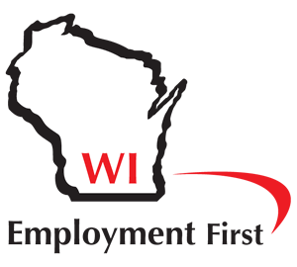

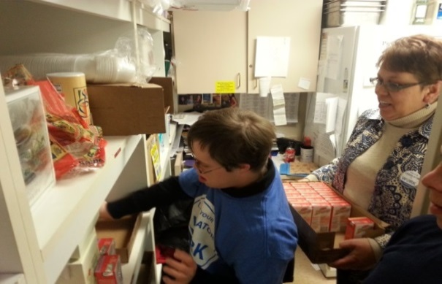
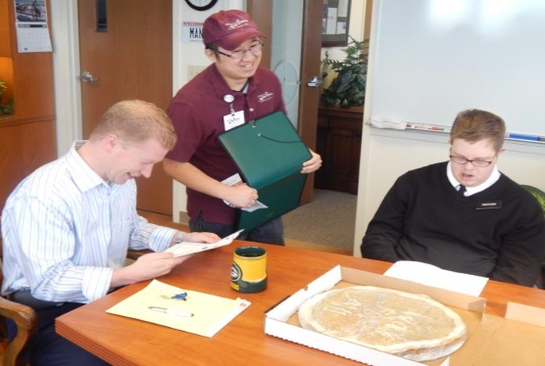
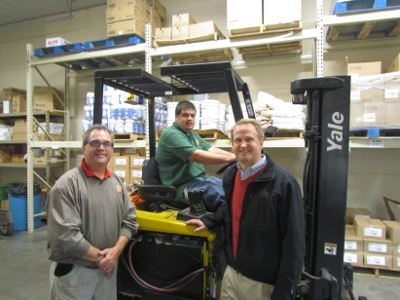

Just Like You and Me: Building Full Lives in the Community!

Applications are due by June 7, 2019

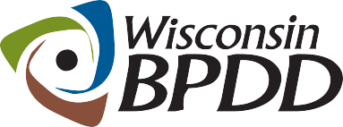
A Project of

Application
Timeline

Activity: | Date:
Application Out | May 13, 2019
Applications Due | June 7, 2019
Notice of Award | June 14, 2019
Project Memorandum of Understanding (MOU) start date | June 24, 2019
Mandatory Kick Off Video Conference | June 25, 2019
Mandatory Training in Madison | July 16, 2019
End date of MOU | September 30, 2020

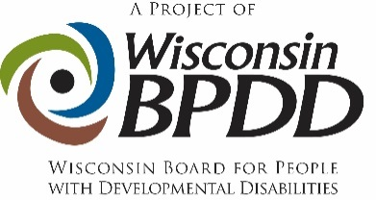

Purpose
This application provides an opportunity for three (3) organizations to be supported in their service transformation efforts through the Building Full Lives in the Community initiative.

What is Building Full Lives in the Community?
Building Full Lives in the Community is an initiative coordinated by the Wisconsin Board for People with Developmental Disabilities (BPDD) with vocational and day service providers who want to engage in service transformation to decrease or eliminate facility-based services and increase individualized, meaningful community-based services and Competitive Integrated Employment for people with intellectual and developmental disabilities (I/DD).

Over the past three years, BPDD has engaged fourteen service providers in a Learning Collaborative to exchange ideas and provide training and technical assistance opportunities with state and national subject matter experts to implement a new model of community-based day services and learn about organizational change. Three of these service providers have made great strides in their transformation efforts and are poised to mentor three organizations selected through this competitive application process.

The Building Full Lives in the Community initiative is centered on the following principles:
- Respect: People are respected and valued by others in the community, not just paid staff.
- Community Participation: People are involved in a growing network of relationships; this is a relationship network beyond paid staff and disability professionals.
- Competent Contribution: People are assisted to understand their gifts, talents, knowledge, and abilities; and to use these personal assets to make a living through work and giving back to others.
- Choice: People are assisted to make as many choices about their day as possible, including both small choices (e.g. what to wear) and big choices (e.g. where to work).
- Employment First: People are engaged in the same types of activities as others who live in the same community. For working-age adults with disabilities, publicly funded services should prioritize competitive integrated employment as the preferred outcome.

What will organizations receive if chosen for the Building Full Lives in the Community awards?
While there are no grant funds awarded with this initiative, each organization will receive a substantial amount of training and technical assistance funded by the BPDD, including:

Learning Collaborative Membership: Selected organizations will join the Learning Collaborative with the other organizations that have been participating in the Building Full Lives initiative for the past three years. The Learning Collaborative holds three, full-day in-person meetings and three, one-hour learning collaborative calls each year to review progress, exchange ideas, and engage in strategy discussions to address challenges.

Strategic Planning, Coaching and Mentoring: Selected organizations will complete and review an agency self-assessment with a project coach. The project coach will match each organization with a mentor organization and conduct two days of Lean Value Stream Mapping, training and action planning with the organization. The project coach and mentors will provide support to the organizations while implementing their action plan.

Training and Technical Assistance: Selected organizations will receive tools, training (in person and via webinar) and technical assistance to:
- Engage in community opportunity mapping
- Replicate a person-centered community-based day service model
- Improve and expand Competitive Integrated Employment services
- Develop program budgets
- Effectively communicate change to individuals, families and other partners
- Manage change within the organization
- And more, based on the needs of the organizations involved in the initiative

What are Building Full Lives initiative requirements?
- Engage in all activities listed above and maintain active communication and collaboration with project coach and mentors through the contract period.
- Complete the organizational assessment and Lean Value Stream Mapping process to develop and implement an action plan for service transformation. Value Stream Mapping and action planning require two full-days of strategic planning involving several staff, from leadership to DSPs, from the organization.
- Send at least five staff to a full-day Meaningful Day training with Sara Murphy from TransCen on July 16th in Madison at the Department of Administration located at 101 E. Wilson St., St. Croix Room.
- Commit to work with MCOs to get contracts in place for Building Full Lives model of community-based services within first 6 months of the project.
- Engage in project evaluation and data collection, including participant interviews, on-line surveys, and capturing and reporting program data.

Who Can Apply?
- Any organization that has Executive level leadership commitment to shifting their business model from segregated to fully integrated, community-based services that are individualized, full of choices, and built around the dreams and aspirations of people with disabilities.
- An organization that is invested in establishing a braided service model that includes customized employment and integrated community support.

- Organizations that have a contract to provide services with a county or a Managed Care Organization (MCO) and Division of Vocational Rehabilitation (DVR).
- Organizations that support individuals with I/DD who have diverse identities and/or individuals that are underserved* are encouraged to apply.

How do you apply?
- Submit a completed application form by e-mail to Molly Cooney at mollly.cooney@wisconsin.gov by June 7, 2019.
- To submit via fax, fax your application materials to (608) 267-3906.
- To submit via regular mail, mail your application materials to:
WI BPDD
101 East Wilson Street
Room 219
Madison, WI 53703

How will organizations be chosen?
- Applications will be reviewed and scored by a review team of at least 3 people.
- Each member will read and score each proposal independently, discuss each proposal jointly, and then submit final results for tabulation.
- The quantitative score from each member will be averaged and a final score will be assigned to the proposal. Scores will be ranked from highest to lowest scores. The highest ranked proposals will be chosen to be involved in the BFL initiative.
If you need application materials in an alternative format and/or language, contact:
mollly.cooney@wisconsin.gov
.

 | Building Full Lives  Initiative Application | APPLICATION  FORM

The completed application is due by 5:00 p.m. on Friday, June 7, 2019.
Please limit application responses to 5 pages total.

Applicant(s) Name:

Organization(s):

Lead Contact Information

Name:

Address:

Telephone:

Email address:

- Why is your organization interested in being part of the Building Full Lives in the Community initiative?

- Please describe the level of awareness and commitment your Board of Directors and Executive leadership have about applying for this opportunity and engaging in service transformation. List the names of Executive leadership sponsoring your organization’s efforts with this initiative.

- What assets and experience does your organization have that makes you a strong candidate for the Building Full Lives initiative?

- What efforts has your organization already taken to transform your organization away from facility-based services?

- How many LTC entities (e.g. MCOs, counties) do you have a contract with to provide services? What type of services do you currently provide?

- Please describe your partnership and the type of services you provide with DVR.

- What do you think will be your organization’s biggest obstacles or concerns for transforming your services? How will you address these?

- If you are chosen to be part of the Building Full Lives initiative, what will be your first steps to building a community-based day and employment service model?

- What outcomes would you like to achieve by participating in the BFL initiative? How will you know when you meet these outcomes?

*Diverse Identities refers to people of various races, cultural and ethnic heritages, genders, gender identities, gender expressions, sexual orientations, ages, and religions from diverse socio-economic and geographic backgrounds.
The term “unserved and underserved” includes populations such as individuals from racial and ethnic minority backgrounds, disadvantaged individuals, individuals with limited English proficiency, individuals from underserved geographic areas (rural or urban), and specific groups of individuals within the population of individuals with developmental disabilities, including individuals who require assistive technology in order to participate in and contribute to community life.

