2019 Joint Committee on Finance - Members

Senate Members | Assembly Members
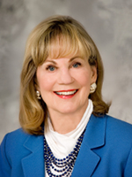  Sen. Alberta Darling, Co-Chair, (R-8)  1325 West Dean Road  River Hills, WI 53217  Sen.Darling@legis.wisconsin.gov  Room 317 East, State Capitol  (608) 266-5830 | 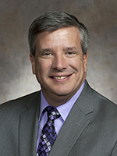  Rep. John Nygren, Co-Chair, (R-89)  Rep.Nygren@legis.wisconsin.gov  Room 309 East, State Capitol  (608) 266-2343
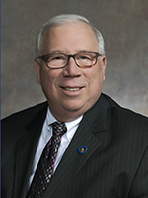  Sen. Luther Olsen, Vice-Chair, (R-14)  1023 Thomas Street  Ripon, WI 54971  Sen.Olsen@legis.wisconsin.gov  Room 122 South, State Capitol  (608) 266-0751 | 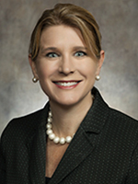  Rep. Amy Loudenbeck, Vice-Chair, (R-31)  10737 S. State Rd. 140  Clinton, WI 53525 Rep.Loudenbeck@legis.wisconsin.gov  Room 304 East, State Capitol  (608) 266-9967; (888) 529-0031
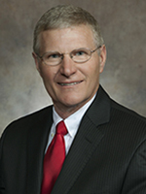  Sen. Howard L. Marklein, (R-17)  S11665 Soeldner Rd.,  Spring Green, WI 53588 Sen.Marklein@legis.wisconsin.gov  Room 8 South, State Capitol  (608) 266-0703 | 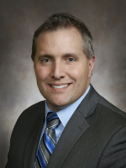  Rep. Shannon Zimmerman, (R-30)  429 Jefferson Street  River Falls, WI 54022 Rep.Zimmerman@legis.wisconsin.gov  Room 320 East, State Capitol  (608) 266-1526; (888) 529-0030
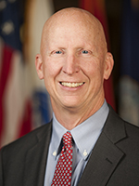  Sen. Duey Stroebel, (R-20)  2428 Covered Bridge Road  Saukville, WI 53080 Sen.Stroebel@legis.wisconsin.gov  Room 18 South, State Capitol  (608) 266-7513 | 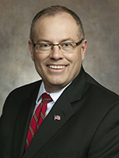  Rep. Terry Katsma, (R-26)  705 Erie Ave.  Oostburg, WI 53070 Rep.Katsma@legis.wisconsin.gov  Room 306 East, State Capitol  (608) 266-1526; (888) 529-0026
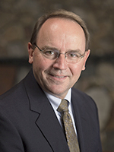  Sen. Thomas Tiffany, (R-12)  9463 Backwoods Lane  Minocqua, WI 54548 Sen.Tiffany@legis.wisconsin.gov  Room 316 South, State Capitol  (608) 266-2509 | 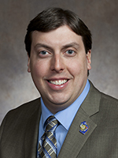  Rep. Mark Born, (R-39)  121 Franklin St.  Beaver Dam, WI 53916 Rep.Born@legis.wisconsin.gov  Room 324 East, State Capitol  (608) 266-2540; (888) 534-0039
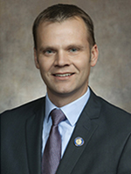  Sen. Devin LeMahieu, (R-9)  21 S 8th Street  Oostburg, WI 53070 Sen.LeMahieu@legis.wisconsin.gov  Room 409 South, State Capitol  (608) 266-2056 | 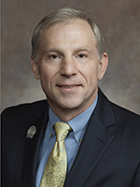  Rep. Mike Rohrkaste, (R-55)  1417 Mahler Blvd.  Neenah, WI 54956 Rep.Rohrkaste@legis.wisconsin.gov  Room 321 East, State Capitol  (608) 266-5719; (888) 534-0055
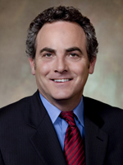  Sen. Jon Erpenbach, (D-27)  2316 Clark Street  Middleton, WI 53562 Sen.Erpenbach@legis.wisconsin.gov  Room 415 South, State Capitol  (608) 266-6670 | 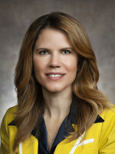  Rep. Chris Taylor, (D-76)  Madison, WI 53704  Rep.Taylor@legis.wisconsin.gov  Room 306 West, State Capitol  (608) 266-5342
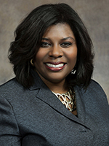  Sen. LaTonya Johnson, (D-6)  2363 N. 54th St.  Milwaukee, WI 53707 Sen.Johnson@legis.wisconsin.gov  Room 19 South, State Capitol  (608) 266-2500 | 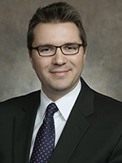  Rep. Evan Goyke, (D-18)  2734 W. State St.  Milwaukee, WI 53208 Rep.Goyke@legis.wisconsin.gov  Room 304 East, State Capitol  (608) 266-0645; (888) 534-0018

