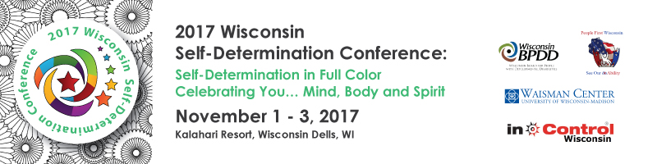
Exhibitor/Microenterprise Application Request

Exhibit tables will be available on Thursday, Nov. 2 and Friday, Nov. 3, 2017. Space is limited and only applications from exhibitors that directly support self-determination and self-direction in WI will be accepted. All applications will be reviewed by a committee and selected based on interest, needs, variety and mission of the conference.

Company Name:
Click here to enter text.
Attendee Name:
1. Click here to enter text.
2. Click here to enter text.

Contact Name (if different from above):
Click here to enter text.

Address (street, city, state, zip):
Click here to enter text.

Phone: Click here to enter text.
Email: Click here to enter text.

Products and/or services to be promoted:
Click here to enter text.

Please do not send money with your application. You will receive a notice from us on whether or not your request has been approved.

Applications must be submitted by Friday, April 14, 2017
(Space may fill up before this date.)

Exhibitor Options and Fees: (check all that apply): Fee includes one 6-foot skirted table, two chairs, conference materials, and meals for one person.

☐ Organization supporting
self-direction – $500.00 $________
☐ Persons with a disability operating
their own business – $50.00
(Business owner must attend) $________
☐ Electricity- $50.00 $________
☐ Additional conference meals
$80.00 for microenterprises
$100.00 for all other exhibitors
(One additional person only): $________
Total Due (if Accepted): $________

Really Cool Door Prize Drawing
☐ Yes! I would like to donate an item and have my business name announced in the closing session.

Please bring prizes to the conference. (Do not mail)

Please submit application to:
Jenny Neugart at
Jennifer.neugart@wisconsin.gov or mail to BPDD, 101 E. Wilson St., Rm 219,
Madison, WI 53703

Additional Information:
- No wall space is available (for hanging).
- Additional space must be pre-approved.
- Set-up time will be 7 am on Thurs., Nov 2 and breakdown by 2 pm on Fri., Nov 3.

